Hint Cards
Hint 1  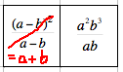 |  | Hint 2  How many dominoes have an end equivalent to:  a²+b²?
Hint 3

How many dominoes have an end equivalent to:
a²b?

