Bochap Sudoku
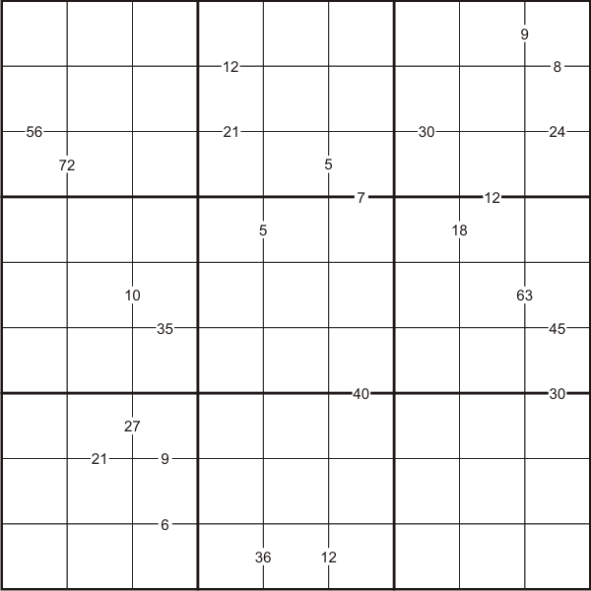

Like the standard Sudoku, this puzzle has the basic rule: Each column, each row and each box (3x3 subgrid) must have the numbers 1 through 9.

The puzzle can be solved with the help of small clue-numbers which are either placed on the border lines between selected pairs of neighbouring squares of the grid or placed after slash marks on the intersections of border lines between two diagonally adjacent squares.

Each small clue-number is the result produced in any order by a pair of digits in the two squares that are horizontally or vertically or diagonally adjacent to each other, using the mathematical operation indicated: addition (+), subtraction (−), multiplication (×), and division (÷). The position of each pair of diagonally adjacent squares is indicated by either two forward slash marks // or two backward slash marks \\.

After finding the values of all the unknown digits, the puzzle is solved by the usual sudoku technique and strategy.

