Cut out the pieces and rearrange them to form a coherent proof.

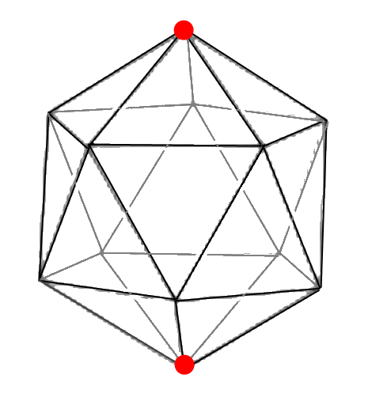  This leaves only vertex L at the bottom which can be coloured red. | G, H, I, J, K form a pentagon.  If G is coloured red, F and B end up with two red neighbours (A and G)  If H is coloured red, B and C end up with two red neighbours (A and H)  The same argument applies to I, J and K.  So none of G, H, I, J, K can be coloured red.
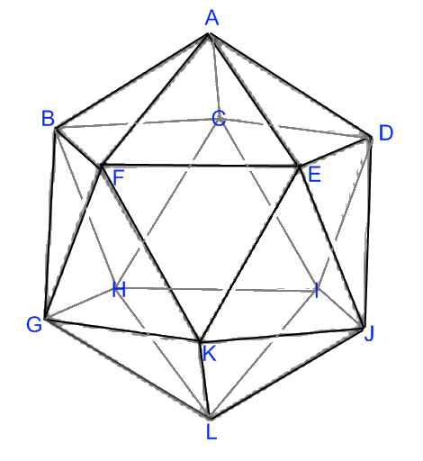  Label the vertices: | So if an icosahedron has three red vertices, at least one vertex must have two red neighbours.
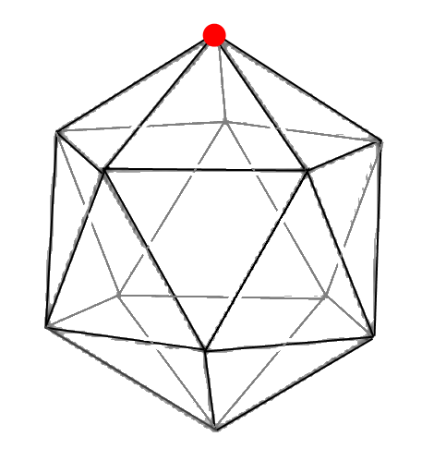  Choose any vertex and colour it red. Rotate the icosahedron so this vertex is at the top of the shape. | We are going to colour the vertices of an icosahedron red in such a way that no vertex has two red neighbours.
Therefore if I colour the icosahedron in such a way that no vertex has two red neighbours then I can have at most two (opposite) vertices coloured. | B,C,D,E,F form a pentagon.  If B is coloured red, F and C end up with two red neighbours (A and B).  If C is coloured red, B and D end up with two red neighbours (A and C).  The same argument applies to D, E and F.  So none of B,C,D,E and F can be coloured red.

