Treasure Hunt
Strategy-
1.First, choose a corner like 0,12 12,12 0,0 or 12,0.
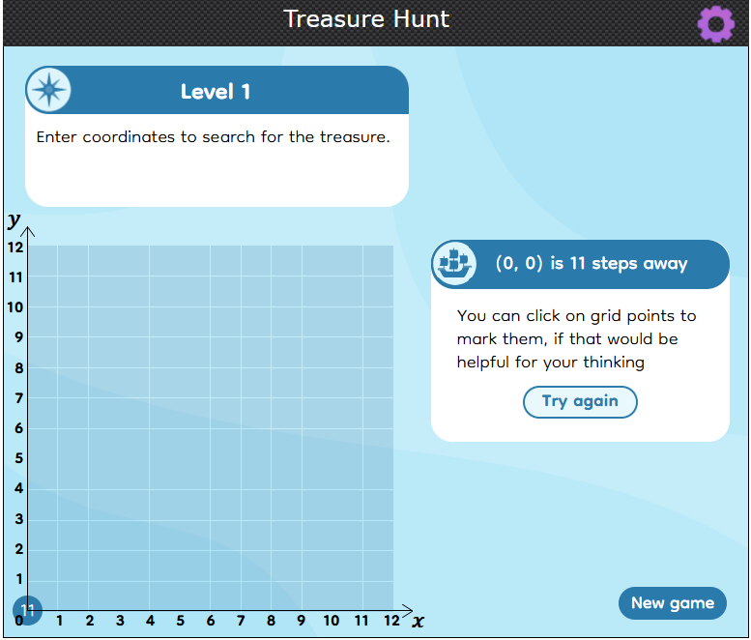
2.Now these are the points where the treasure can be.
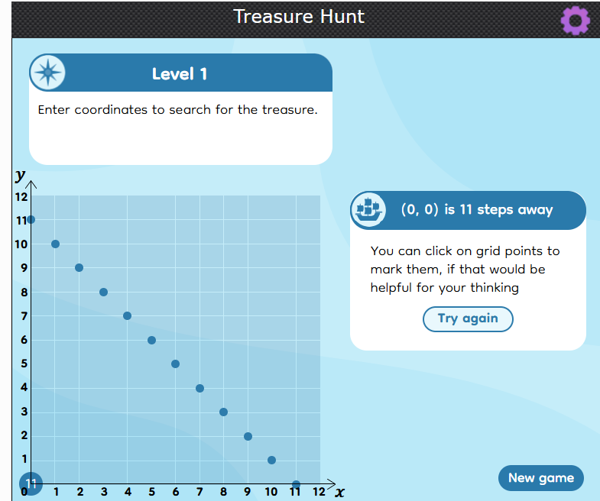
3.Next, you take the corner dot of this line so every point is at a different distance.
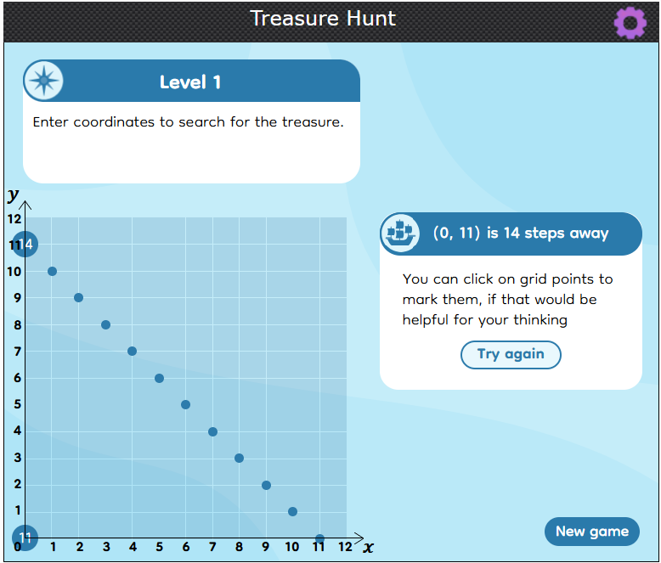
4.The only dot 14 steps away from 0,11 is 7,4 so that is the position of the treasure.
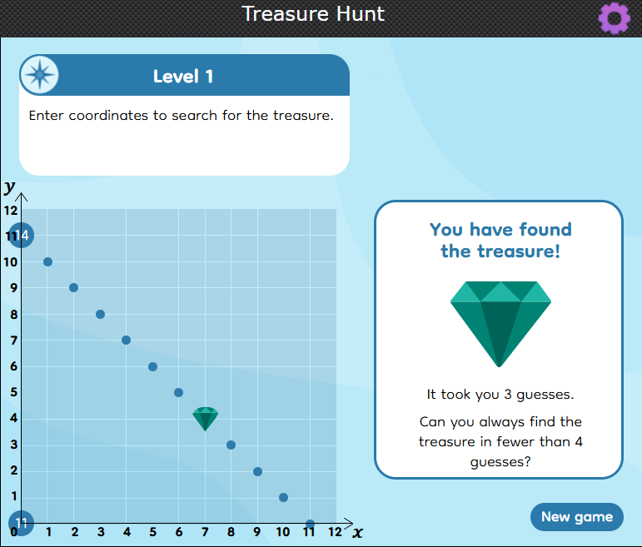
Note: for level 2,instead of 0,12 12,0 0,0 and 12,12 the corners are -8,7 -8,-5 4,-5 and 4,7.The rest of the strategy does not change.

