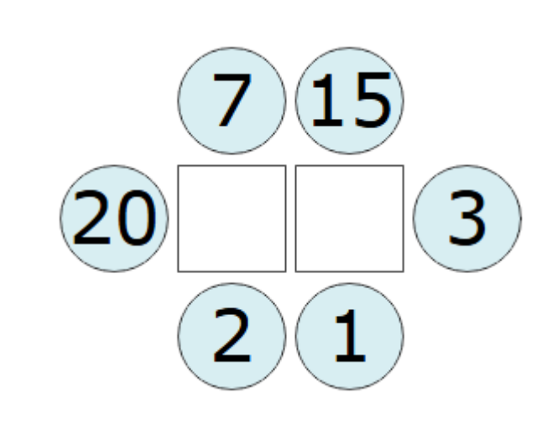1.the answer for this would be 7 on the right and 9 on the left since on the left 5 is not possible but 9 is and it will give mean 7 for the right
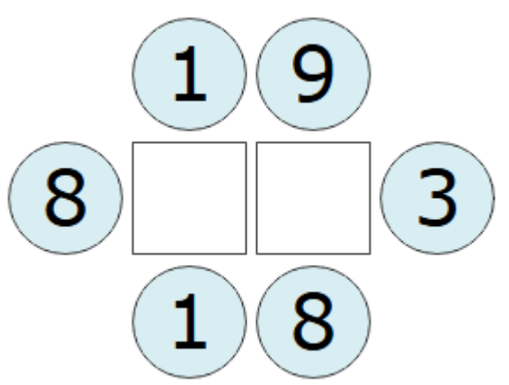
2.The answer is 4 on the left and 6 on the right since you put 4 to get 6 as the mean on the right and the 6 will work so that the mean will be 4
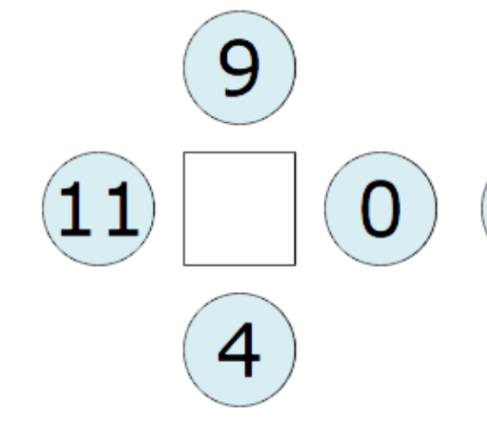
3. The answer for this is 6 since the mean of the four digits is 11+9+4=24
24/4=6

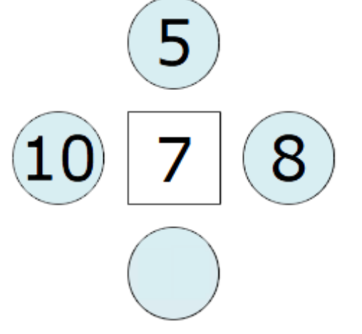
4. The answer for this one is 5 since the mean has to be 7 which means the sum of outer numbers has to be 4*7=28. The sum before 5 was added was 23.

