To solve the problem, we have to use different methods for connecting average problems of different sizes. This is the method for a 1 x 2 puzzle:

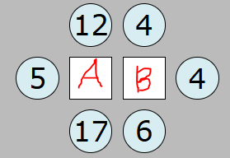
Let’s take this as an example. In this puzzle, 12 + 4 + 5 + 4 + 17 + 6 is equal to 48, so let’s take ⅓ of 48, which is 16. Now we know that
A + B = 16.
To get closer to the values of the individual boxes, we can look around the boxes for clues. For example, 4A = 12 + 5 + 17 + B, so A is the mean average of 34 + B. Now, 34 is not divisible by 4, so let’s take the closest number which is divisible by 4, 36. 36/4 is 9, so
A is at least 9.
Similarly, let’s look at B. 4B = 4 + 4 + 6 + A, so B is the mean average of 14 + A. 14 is also not divisible by 4, so let's take 16. 16/4 = 4, so B is at least 4.

Now, 9+4=13, so we need to adjust A and B until we reach 16. If A=9 then 4B = 23. 23/4 = ~6 so let’s take B=6. Now, If B = 6, 4A = 40, we get a perfect value of A=10.
Now, when A=10, 4B = 24, so B=6.
Now we can solve every 1x2.

Now, let's see the method used for larger puzzles 1x3 onwards.
(next page)
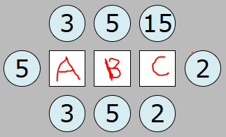
In this puzzle, I labeled the boxes A, B, and C. Now, we can derive formulae to work out the values, such as -
4A = 11 + B
4B = 10 + A + C
4C = 19 + B
The more the number of boxes in the puzzles increases, you can keep adding letters like D, E, F, etc.
Other than using algebra, you can first roughly estimate the numbers in the boxes. From looking at the puzzle, I can say A > 2, B > 3 and
C > 5. From there, I can adjust and change the values until they are all correct. This method will also work for 1x4, 1x5, etc.

