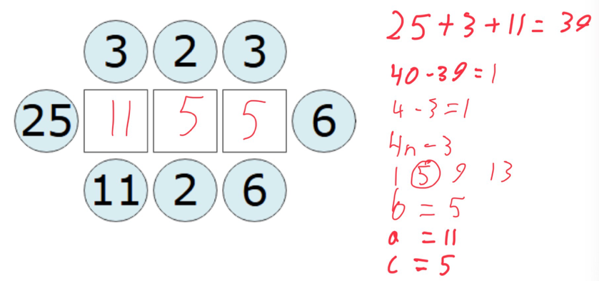
To solve the connecting averages problems, you can assume the the blanks from left to right as A, B, C. With these variables you can use a formula to find B to help solve for A and C. The formula used is A = (the total of the known values + B) divided by 4. We know the total of the three numbers + B is divisible by 4 because A must be an integer. Therefore, we know B will be in the formula 4n – (an amount taken away from 4 to get to the next number in the sequence). Using this knowledge, we can search along 4n using inferred estimating until we have solved for B which in turn lets us find A and C by averaging the 4 surrounding values.

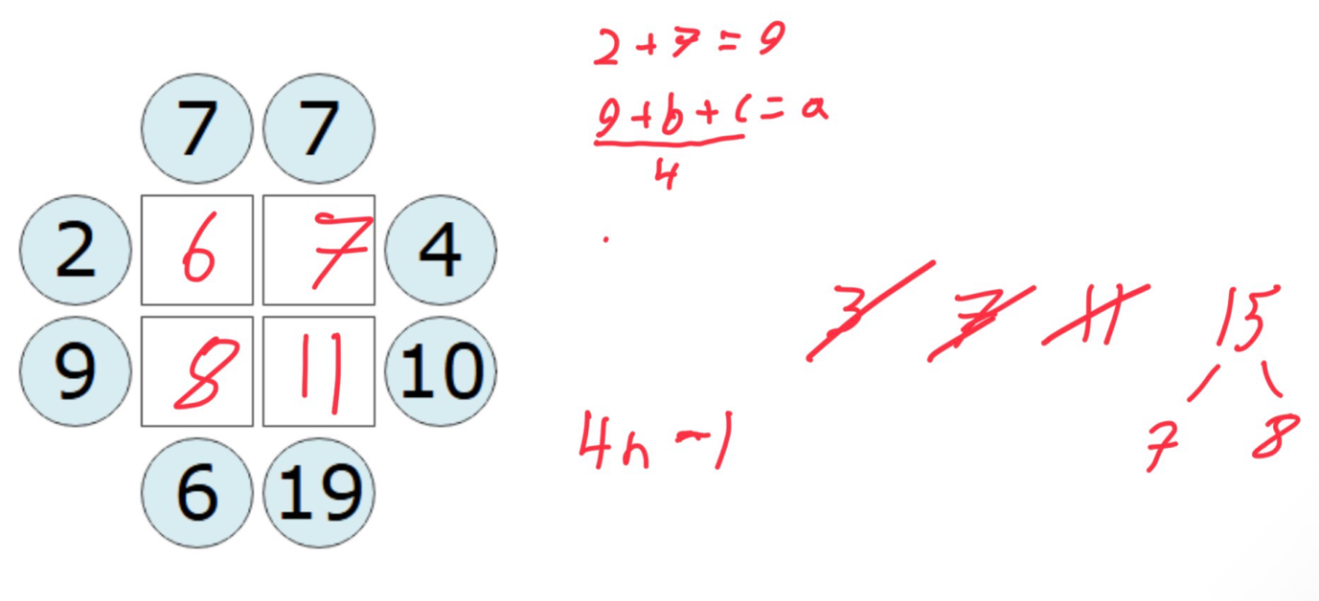
This can also be applied to other problems with more than one missing value. For example, in a question with 2 missing values, you can do the same remembering there is an additional value and then split the numbers in the Nth term sequence into two numbers and see if the solution fits (e.g. 7 can be 1,6/ 2,5/ 3,4) You can then limit the possibilities of splits down by using tricks like the assumption that if the total is already above 12 when you divide by four then the split cannot include 1,2 or 3 as it must be higher (although the number can be 0). You can filter all of the splits by seeing how many numbers in the sequence 4n it is above and based off of the amount it is above you can discount all of the splits including that number or below in that box.

