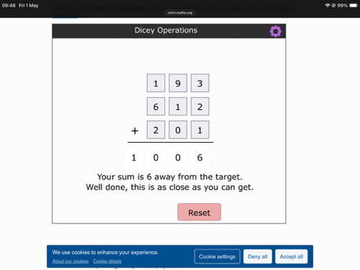
How close can you get to the target?
I could get 6 away from 1000 (1006) which in this question was the closest you could get.
How are you deciding here to put the digits?
I decide where to put the digits by starting with the hundreds and making sure that in total it adds up to 9. Then in the tens column I make sure that it adds up to 10. Sometimes this does not work as the numbers in the tens column do not always add up to 10 so I have to either find another way to make the 100s nine or make the 10s as close to ten as I can.
Will my strategy always work?
My strategy wont always work as sometimes you have too many big numbers and you have to get as close to nine and as close to ten and that could be five away.
When did my strategy work best?
My strategy works best when I have lots of small numbers and zeros to make 9 and 10
When did my strategy not work well?
My strategy didn’t work so well when I had barely any zeros to work with because I had to go over nine and ten

