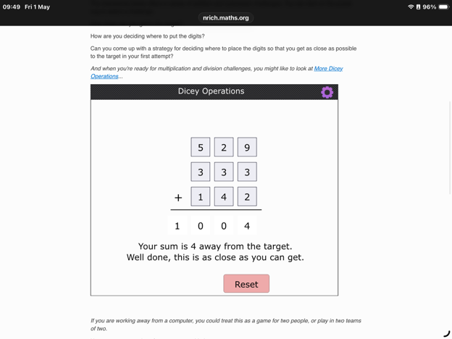
How close did I get to the target?
. I got 4 away from the target (1004).
How am I deciding where to put the digits?
. Firstly, I started with the hundred's column, and I try to aim for making that add up to either 8 or 9 (10?). Then, I move onto the ten's column. Here I also aim for a 9 but a 10 would also be good. After that, I move onto the one's column and here if the tens column is 9 then I aim for a 10, but if it is a 10, I make a 9 or 10.
Will my strategy always work?
. If I always get the numbers needed to get 9s or 10s, then yes, my strategy will almost always work. However, if I get many large numbers such as 7s or 8s, then it may be harder to get close to the target.
When did my strategy work best?
. My strategy worked best when I got small numbers such as 3 or 4 and one or two larger numbers.

