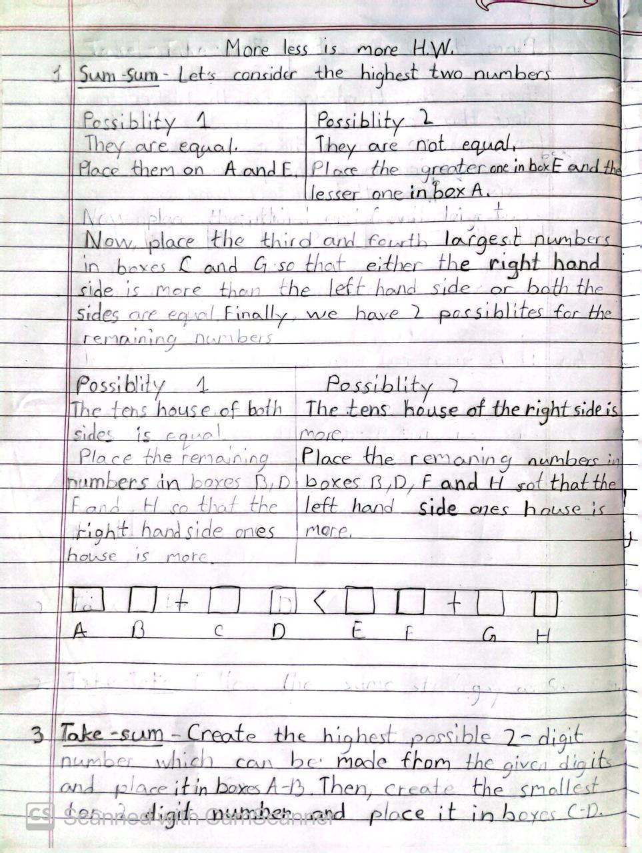
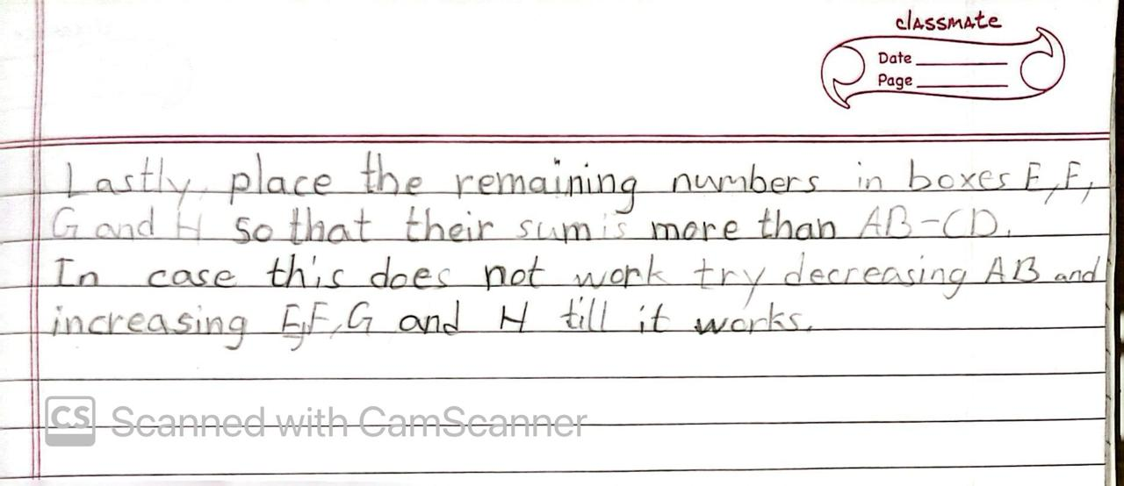
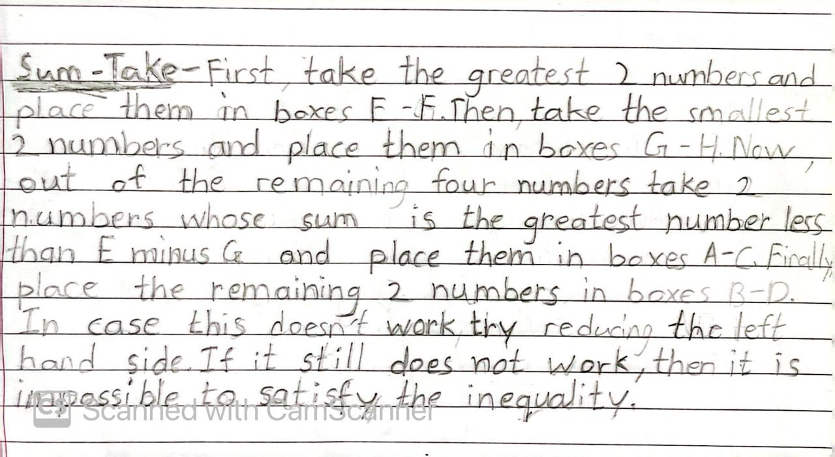
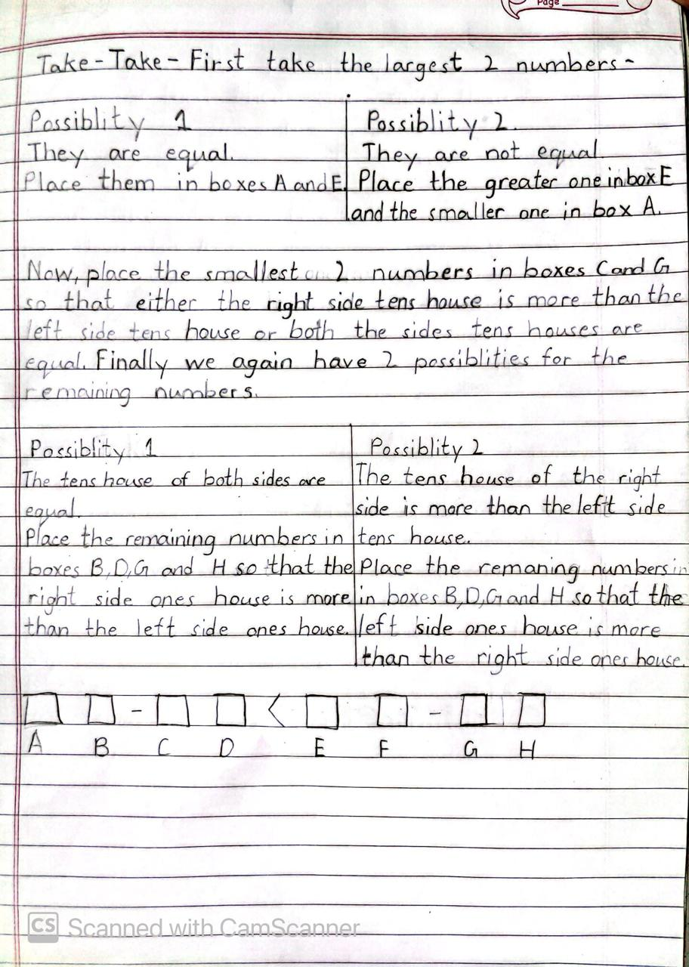

Multiple Surprises
1. If I add the same number to a set of three consecutive numbers, will the new set of numbers be consecutive?
Answer: Yes, If I add the same number to a set of three consecutive numbers, the new set of numbers will be consecutive.
2. If I know that a number is a multiple of 3, what do I need to add to it to get another multiple of 3?
Answer: 3 or a multiple of 3.
3.Which numbers are multiples of 2, 3 and 4?
Answer: Every even number is a multiple of 2. the addition of the digits in a number equals to 3 or a multiple of3 the number is a multiple of 3. every alternate even number is a multiple of 4.
4. Can you use what you have discovered to help you find a few sets of ten consecutive numbers in which:
the first is a multiple of 1
the second is a multiple of 2
the third is a multiple of 3
the fourth is a multiple of 4
the fifth is a multiple of 5
the sixth is a multiple of 6
the seventh is a multiple of 7
the eighth is a multiple of 8
the ninth is a multiple of 9
the tenth is a multiple of 10?

Answer: Yes, I have used what I learned to find sets of ten numbers which satisfy the given condition.
5. Show several sets you found.
Answer:362881,362882,362883,362884,362885,362886,362887,362888,362889,362890 and 725761,725762,725763,725764,725765,725766,725767,725768,725769,725770.

6.Explain your methods.
Answer: First, I multiplied the numbers 1 to 9 and the answer of this multiplication is 362880.
362880 can be divided by all numbers from 1 to 10. A multiple of any number + that number is equal to a multiple of that number. So, one by one, then I added numbers 1 to 10 to get multiples of numbers 1 to 10 respectively. this was my first set. then I doubled 362880 and added numbers 1to10 to get multiples of numbers 1 to 10 respectively. Hence, my conclusion is that you can multiply 362880 by any number and then add numbers 1 to 10 to get different sets.
7.Can you use these ideas to find long sequences of 20 consecutive numbers that do not contain any prime?

Answer: Yes, it is possible to find sets of 20 numbers without any primes.
e.g-51090921717094400002
51090921717094400003
51090921717094400004
51090921717094400005
51090921717094400006
51090921717094400007
51090921717094400008
51090921717094400009
510909217170944000010
510909217170944000011
510909217170944000012
510909217170944000013
510909217170944000014
510909217170944000015
510909217170944000016
510909217170944000017
510909217170944000018
510909217170944000019
510909217170944000020
510909217170944000021

