I have solved all three problems using the same method. Start with any one domino and then find another two dominoes that match each part of the first domino and so on. Going by the same reasoning, there can be 16 solutions for making one large doughnut as we could start using any one of the 16 domino cards.

Solution 1:
4 doughnuts using 4 domino cards each:
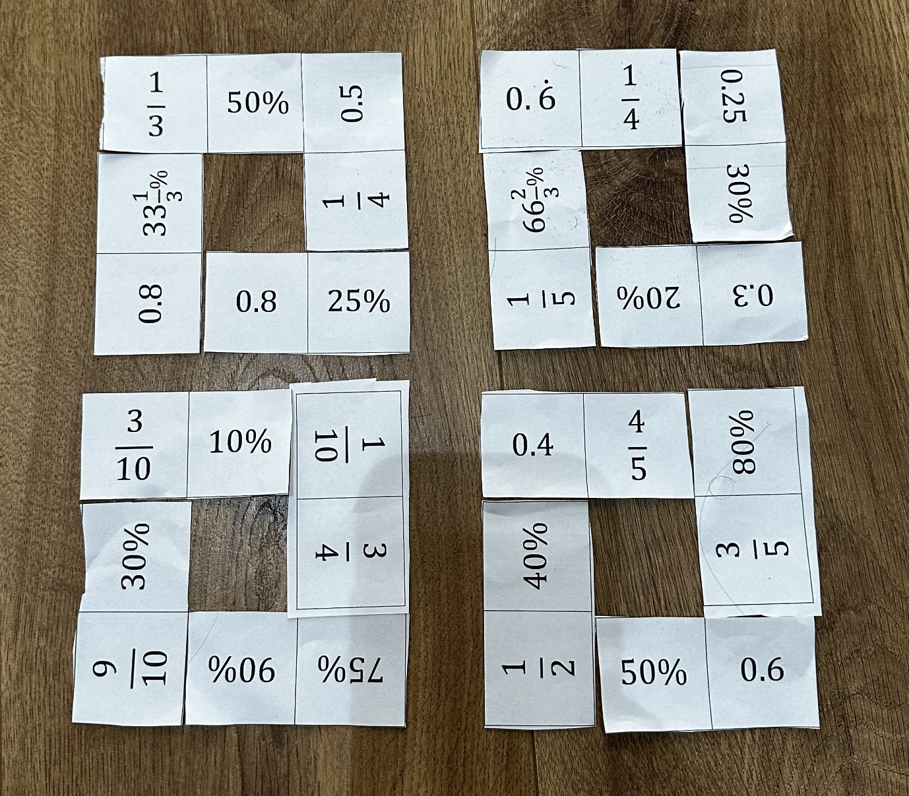

Solution 2:
2 doughnuts using 8 domino cards each:
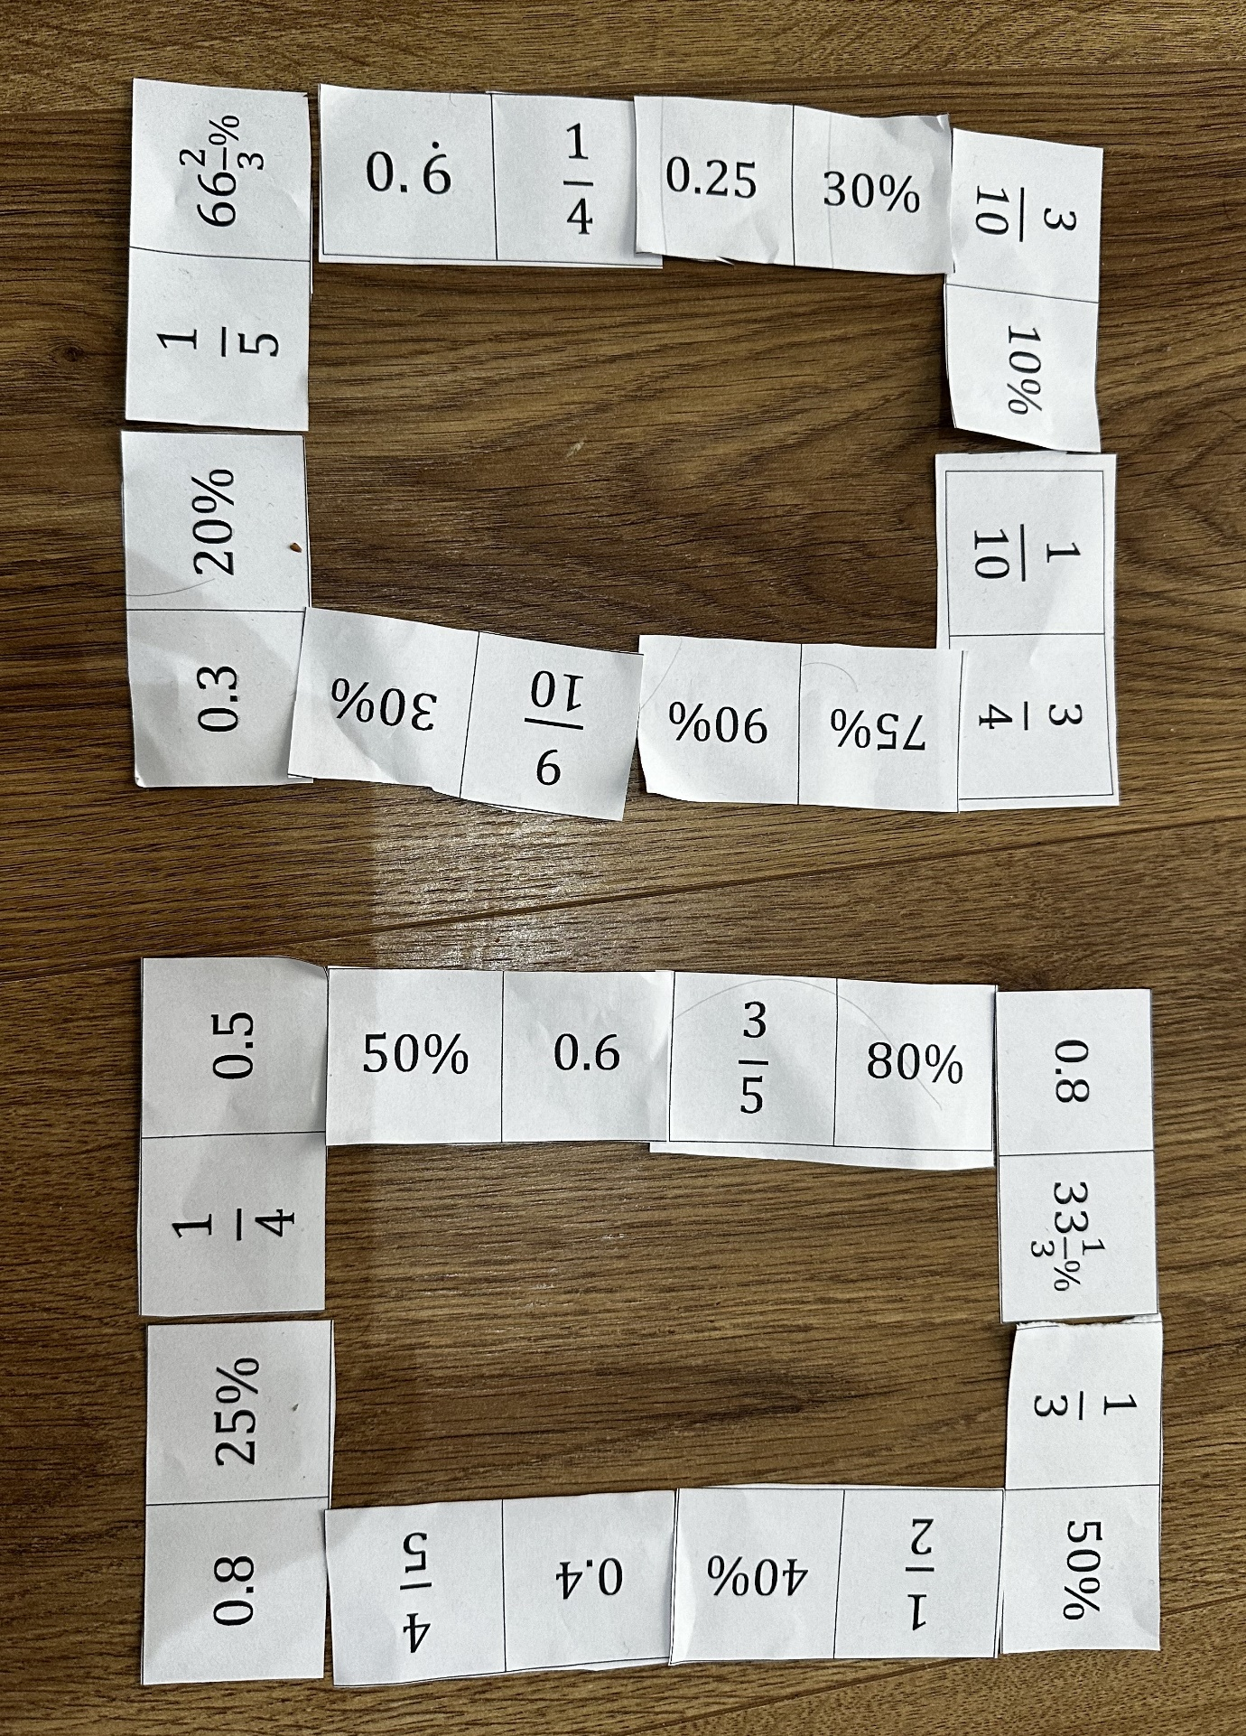
Solution 3:
1 doughnut using all 16 domino cards:
