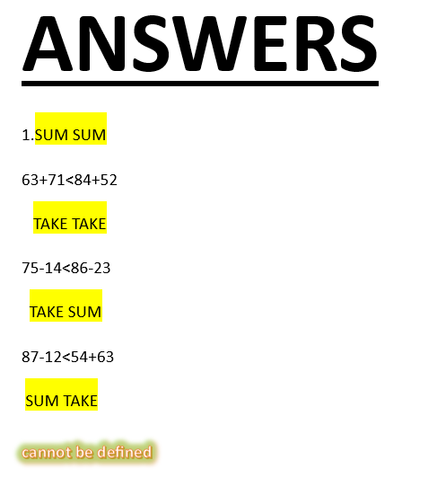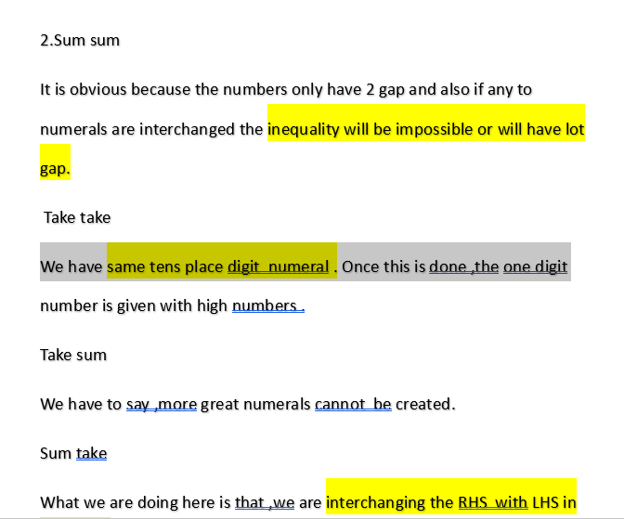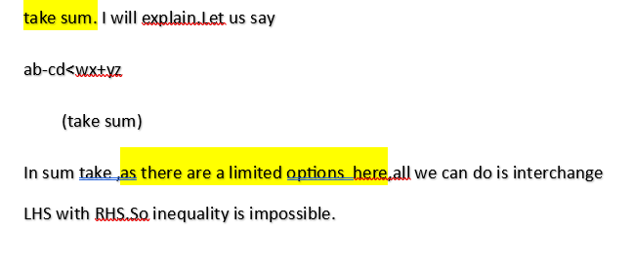
3.Algoritm
SUM SUM
Rule1: Inequality should be right.
Rule2: Ten’s place of LHS and RHS should be close or equal.
Rule3: If tens place equal, greater one’s place sum should be on RHS.
TAKE TAKE
Rule1: If two 0s are there, they should be on C and D.
Rule2:!f two 0s are there, (on C and D), high tens digit and low subtraction should be done.
Eg;.85-00<99-13
Rule3: 0 has few properties in Take take :
If three 0s are there:96-00<98-01
If one 0 is there: 76-03<85-11
TAKE SUM
Rule1: Highest numerals should be subtracted by lowest numerals.
Eg: No .s :1,3,9,8,6,3,7,4.
98-13<a d + x y
Rule2:Once LHS done, do high sum on RHS.
Eg:74+63
SUM TAKE
Cannot be explained.

