Which is Bigger Nrich Solution
This is solved collaboratively in the session.
Some of the syudents submitted their work late. So submitting their work in separate file.
Here are solutions from Aadhya and Arjun.
Aadhya’s work:
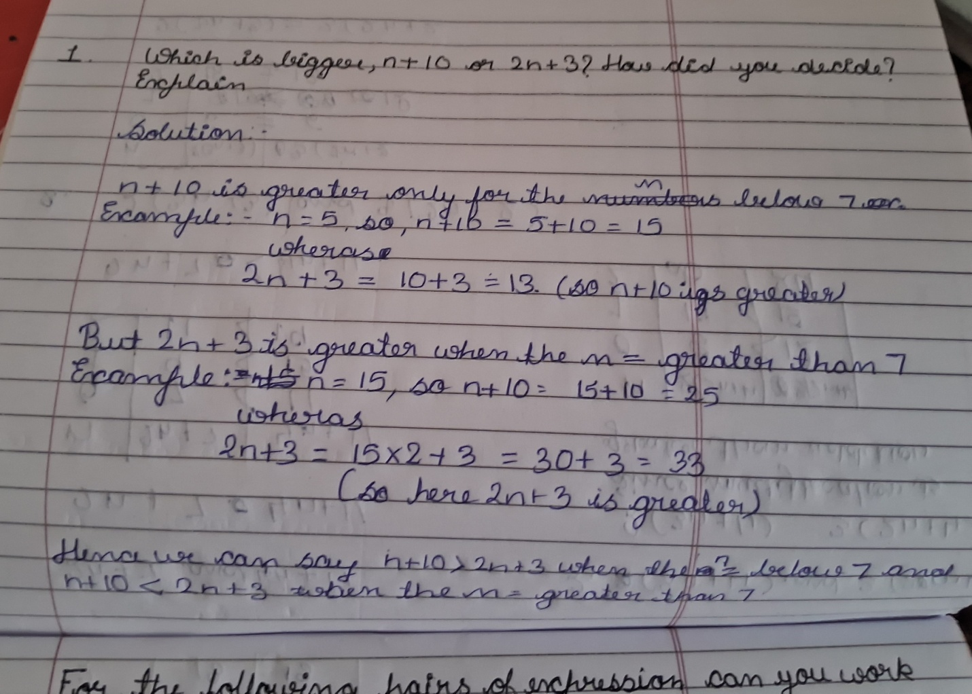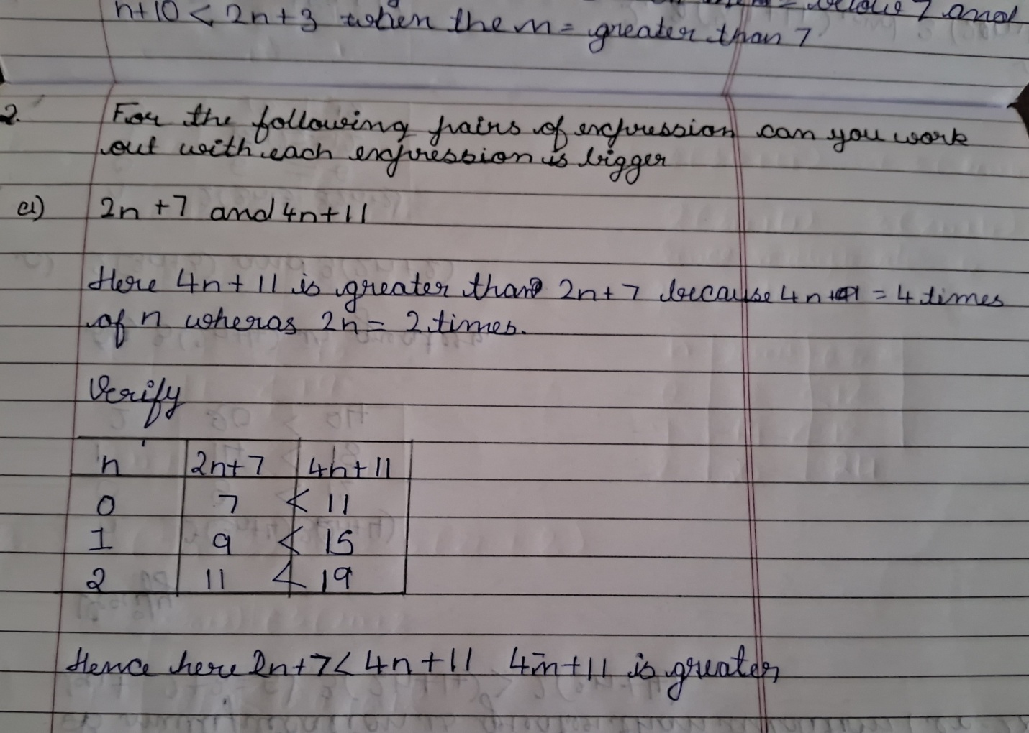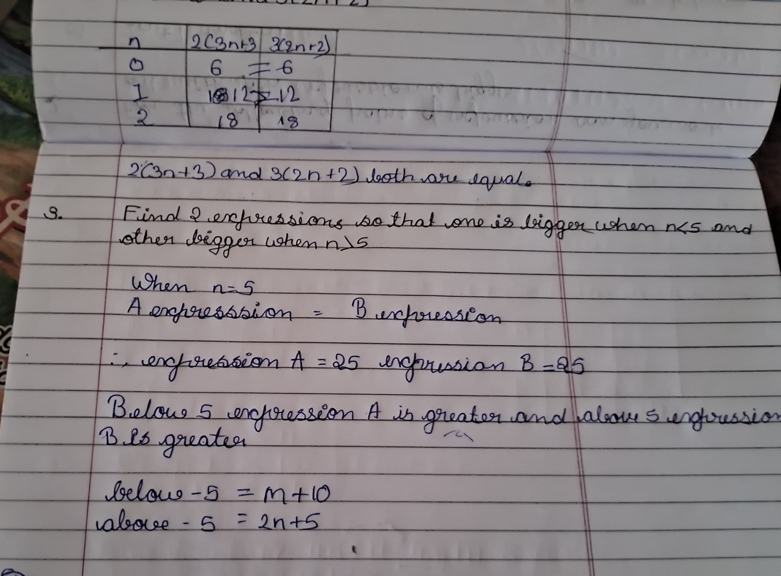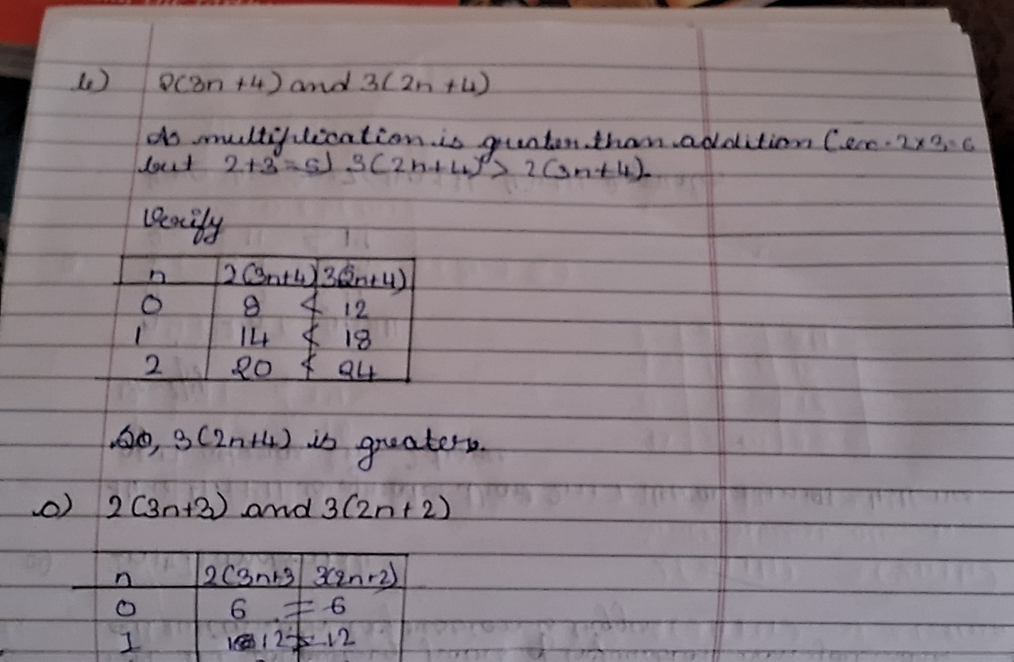
Next 2 images are from Arjun’s solution:
