Which is Bigger Nrich Solution
Myself Shubhangee (Facilitator) had worked collaboratively on ‘Which is Bigger’ with a group of 7 students of 4th and 6th grade, in online mode, in ‘Ganit Kreeda’, Vicharvatika, India. The names of the students are:
Krish, Aadhya, Arjun, Hrishikesh, Dhyan, Isha, Aakarsh.
We started this task in the session and then kids worked on it at home. They have submitted their homework. Here is the list of questions:
- Which is bigger, n+10, or 2n+3? How did you decide? Explain.
- For the following pairs of expressions, can you work out when each expression is bigger?
2n+7 and 4n+11.
2(3n+4) and 3(2n+4).
2(3n+3) and 3(2n+2).
- Find two expressions so that one is bigger whenever n<5 and the other is bigger whenever n>5
4. Find three expressions so that the first is biggest whenever n<0, the second is biggest whenever n is between 0 and 4, and the third is biggest whenever n>4.
5. Find three expressions so that the first is biggest whenever n<3, the second is biggest when n>3, and the third is never the biggest.
6. Find three expressions so that one of them is the biggest regardless of the value of n.

Kids used random values for n initially. Based on their solutions they decided which of the expressions is bigger. Later some of them used algebra to find which one is bigger. Some of them broke the expressions and then compared them by removing same terms like:

Which is bigger, n+10, or 2n+3?
n + 10 = n+ 3+7 and 2n+3 =n+ n+ 3
This clearly shows that n+10 = 2n+3 when n=7.
n+10 > 2n+3 when n<7.
n+10 < 2n+3 when n>7.
Attaching some of their work here:
Here is Hrishikesh work:
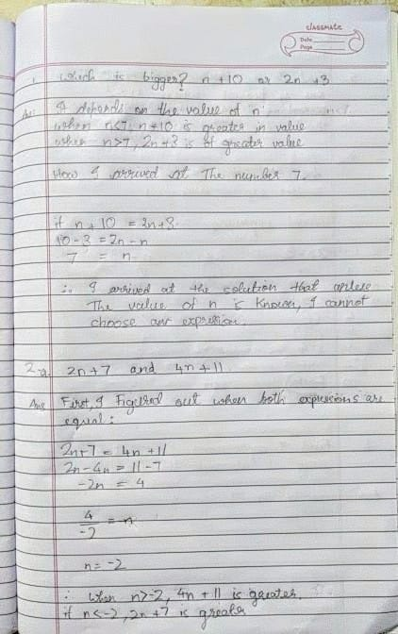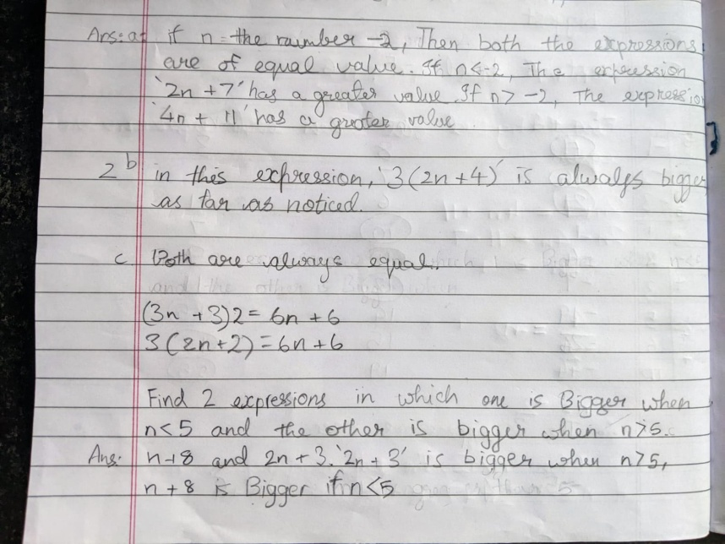
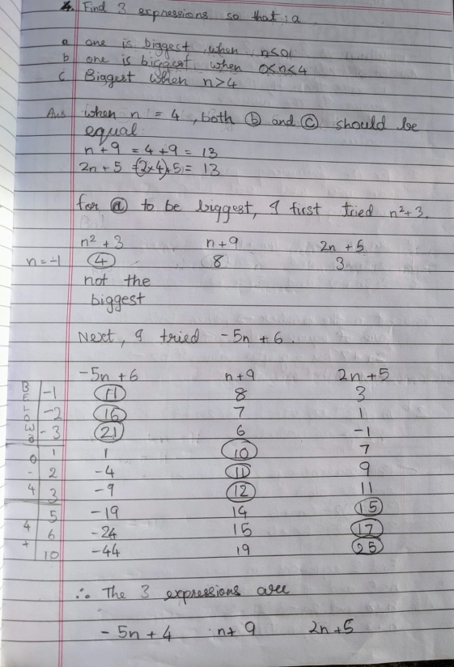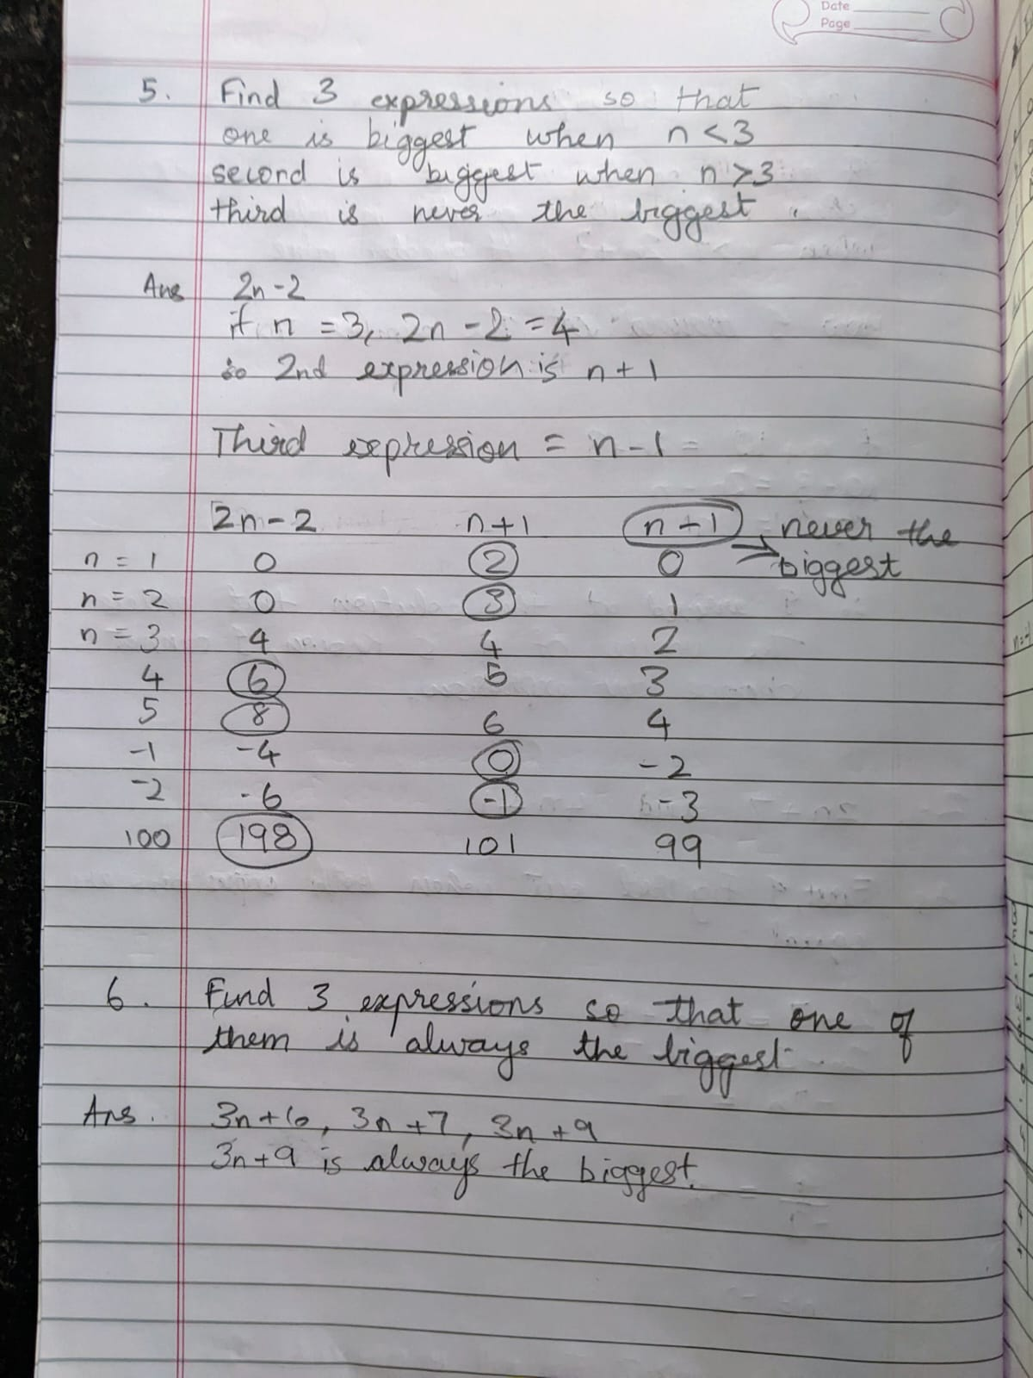
Next 5 images are from Isha:
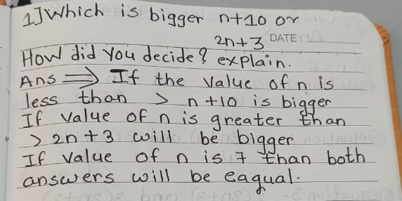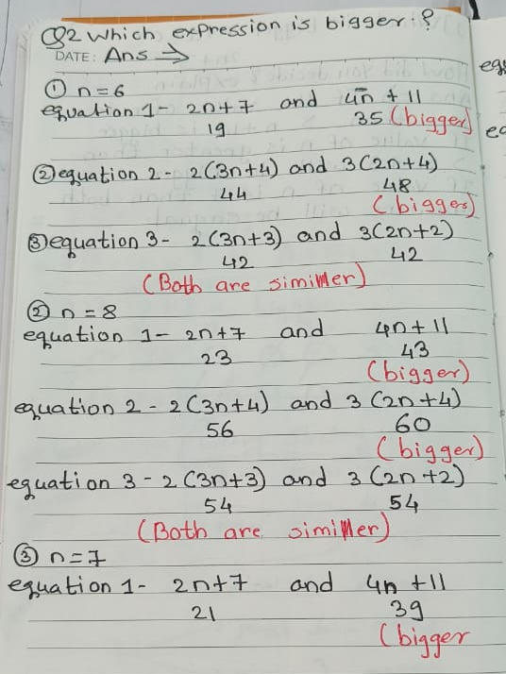
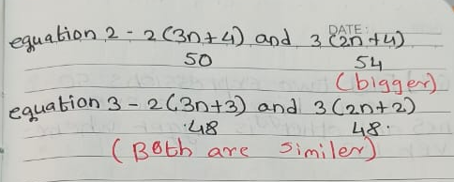
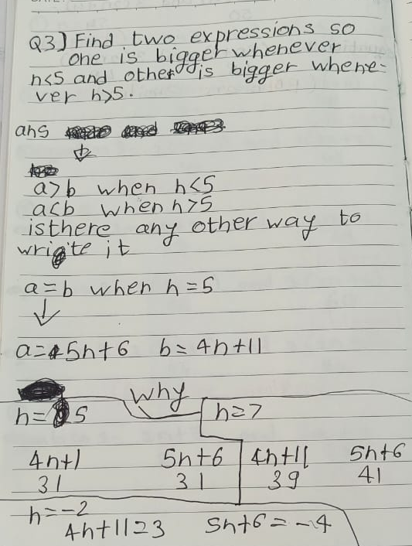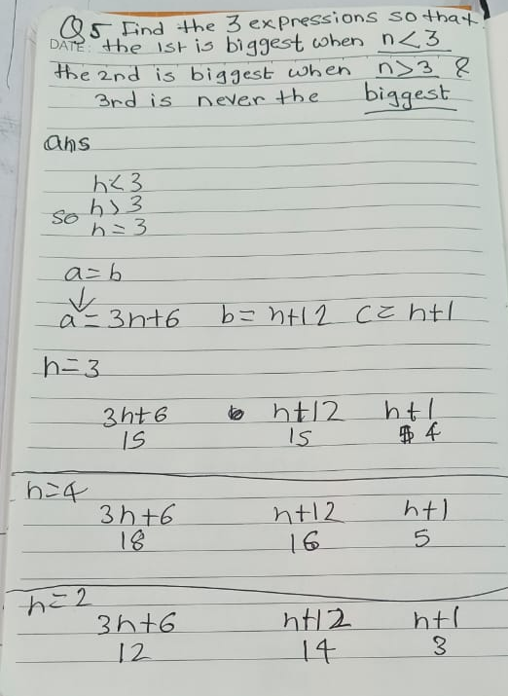
Dhyan’s solution:
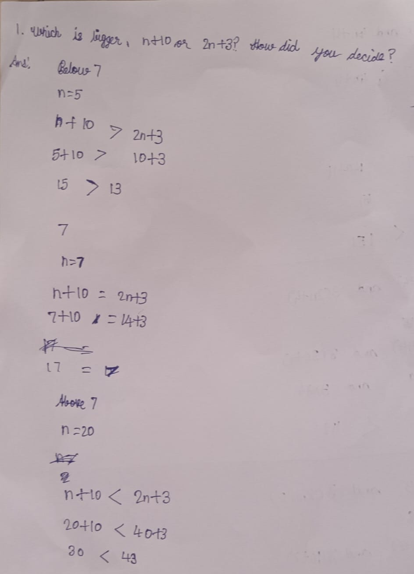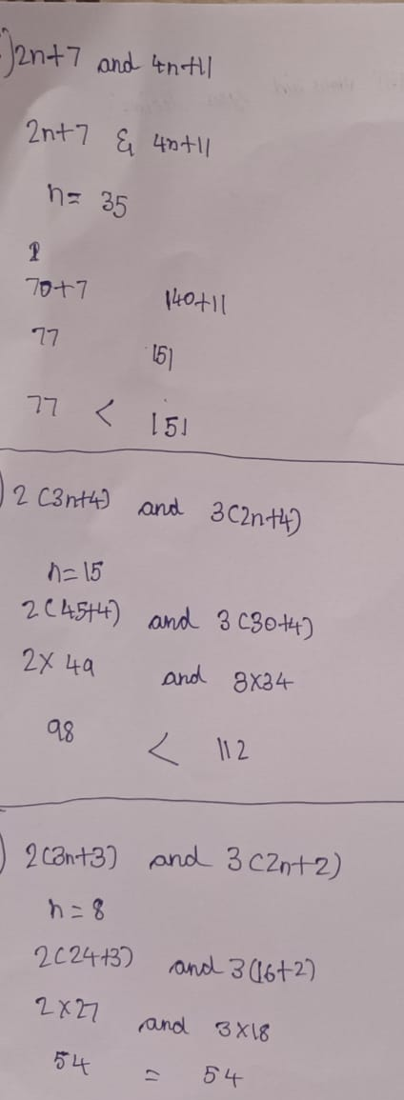
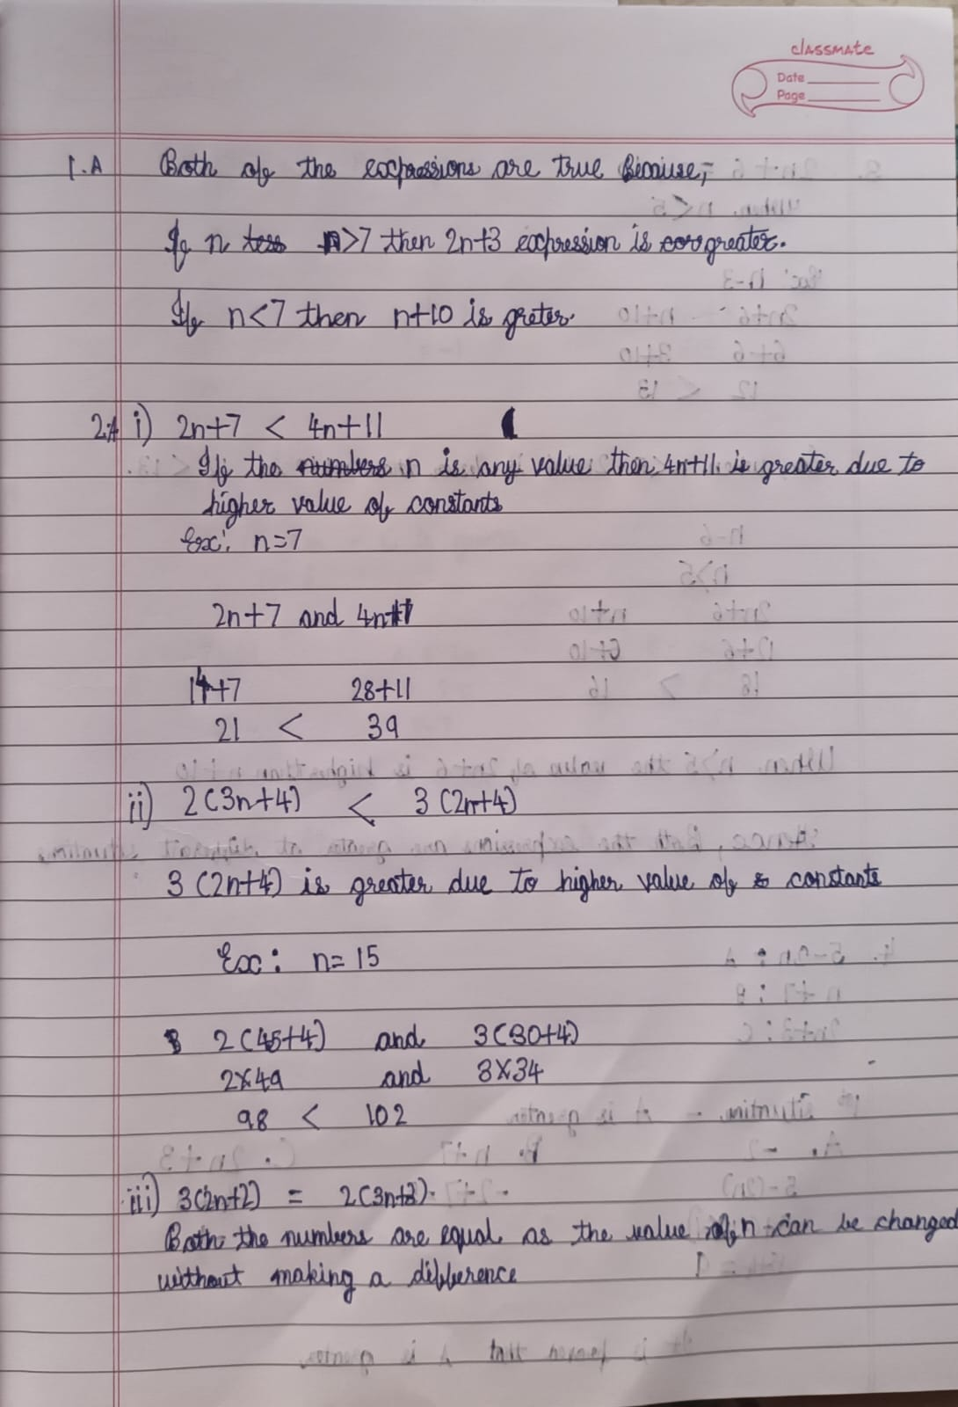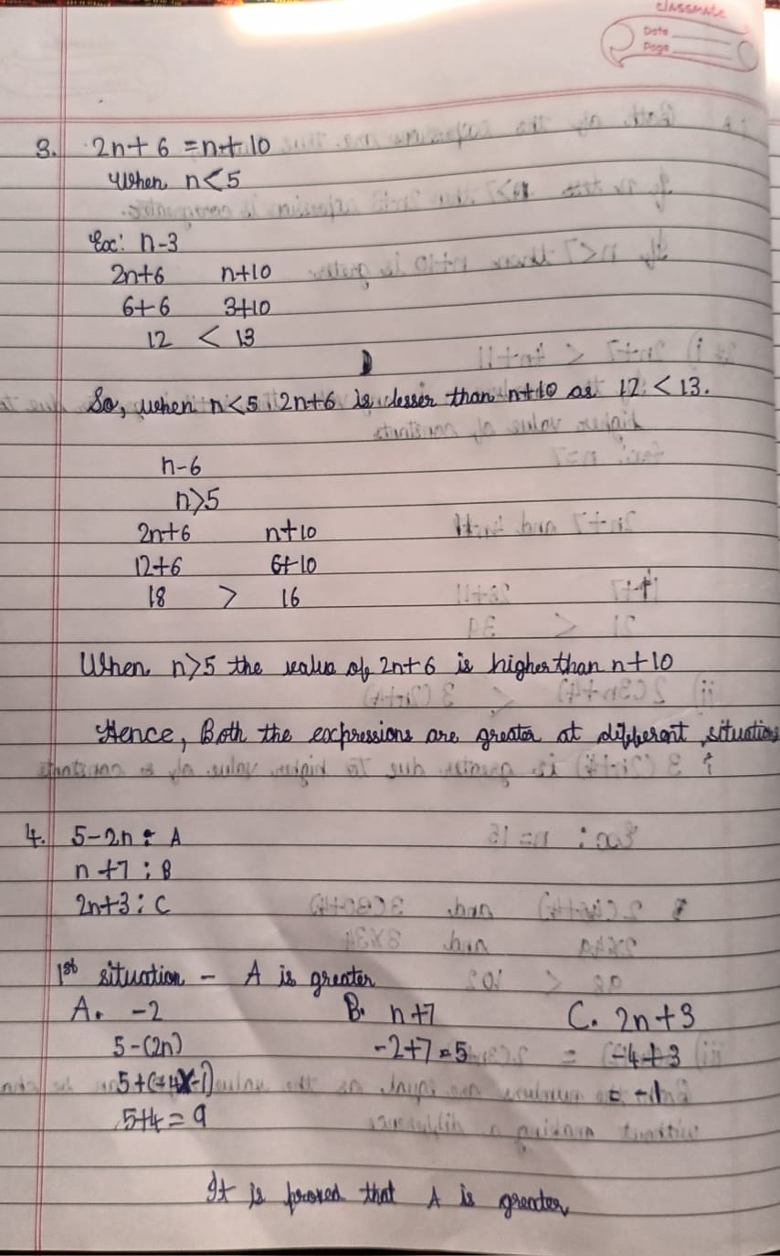
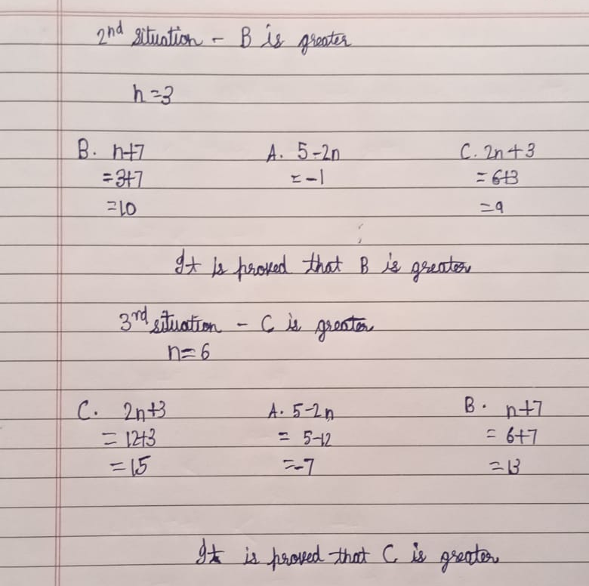
Here is solution from Aakarsh:
