Nrich solution for Digit Discovery
Myself Shubhangee (Facilitator)had worked collaboratively on ‘Digit Discovery’ with a group of 10 students of 4th and 5th grade, in online mode, in ‘Ganit Kreeda’, Vicharvatika, India. The names of the students are:
Tejas, Valerie, Varun, Kaumudi, Dhwani, Ira, Prathamesh, Adhrit, Delissaa, Riyansh.

There are two digit cards in front of Rafe, and two in front of Jasmine. Each card shows a digit from 0 to 9.
Rafe says:
"I've just noticed something interesting. If you add together the two numbers in front of me, the answer is the same as what you get when you multiply the two numbers in front of you."
Q: What might the digit cards be?
Kids shared many different answers. Their responses are summarized here

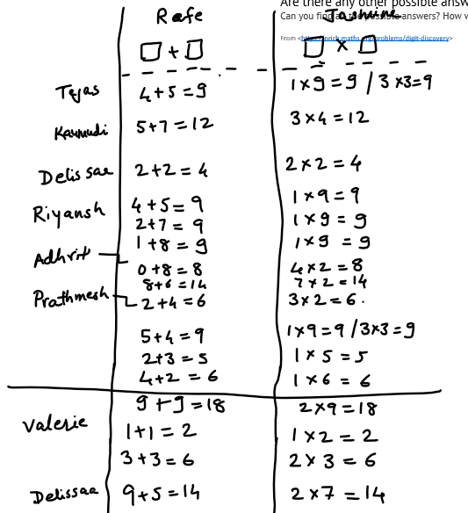

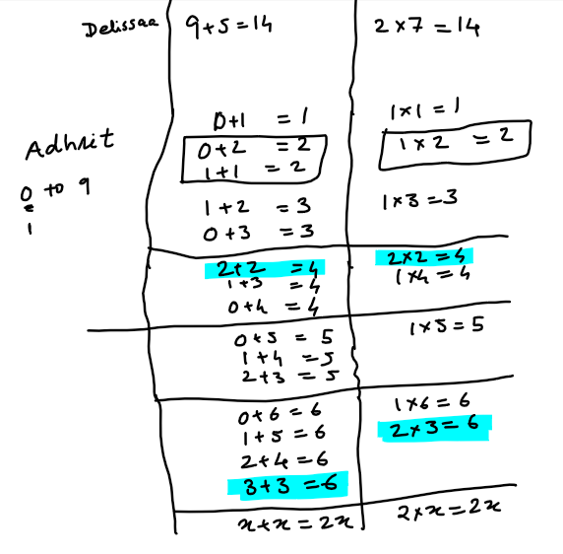

Then, Jasmine says:
"I've noticed something else - it works the other way round as well. The sum of my numbers is the same as the product of your numbers."
Q: What might the digit cards be now?
Dellissa found one solution as 2x2 =4 and 2+2=4
Adhrit found 1,5 and 3,2.
Here is Adhrit’s work:
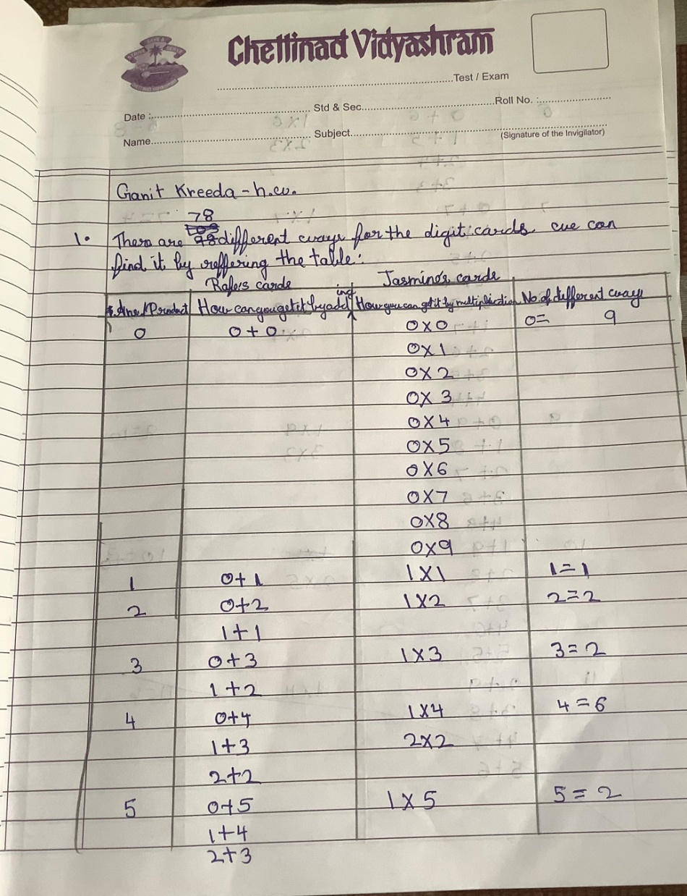
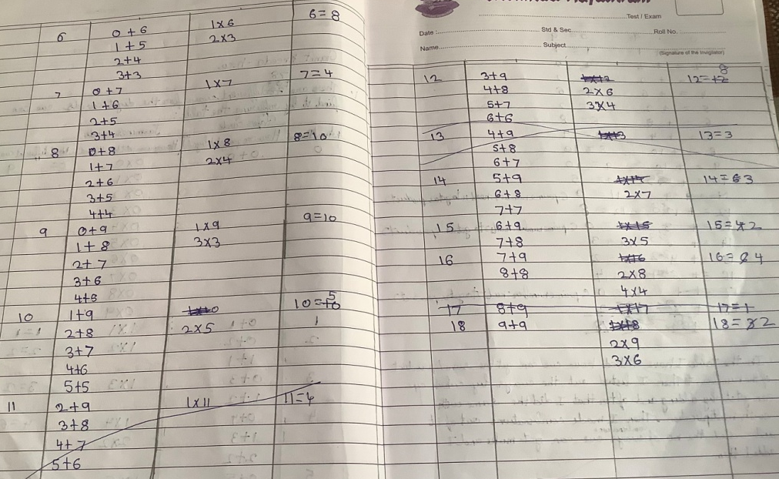

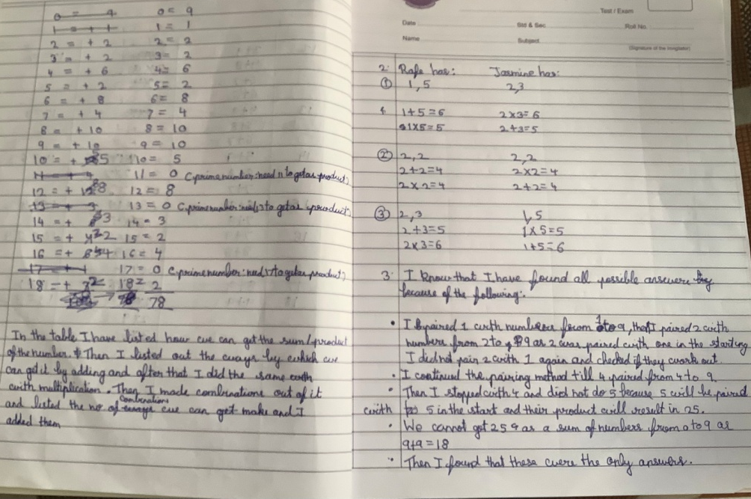
Below is Delissa’s work:

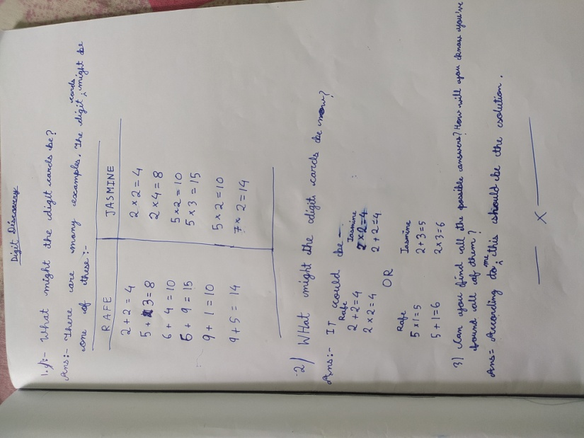
Below is Valerie’s work:
