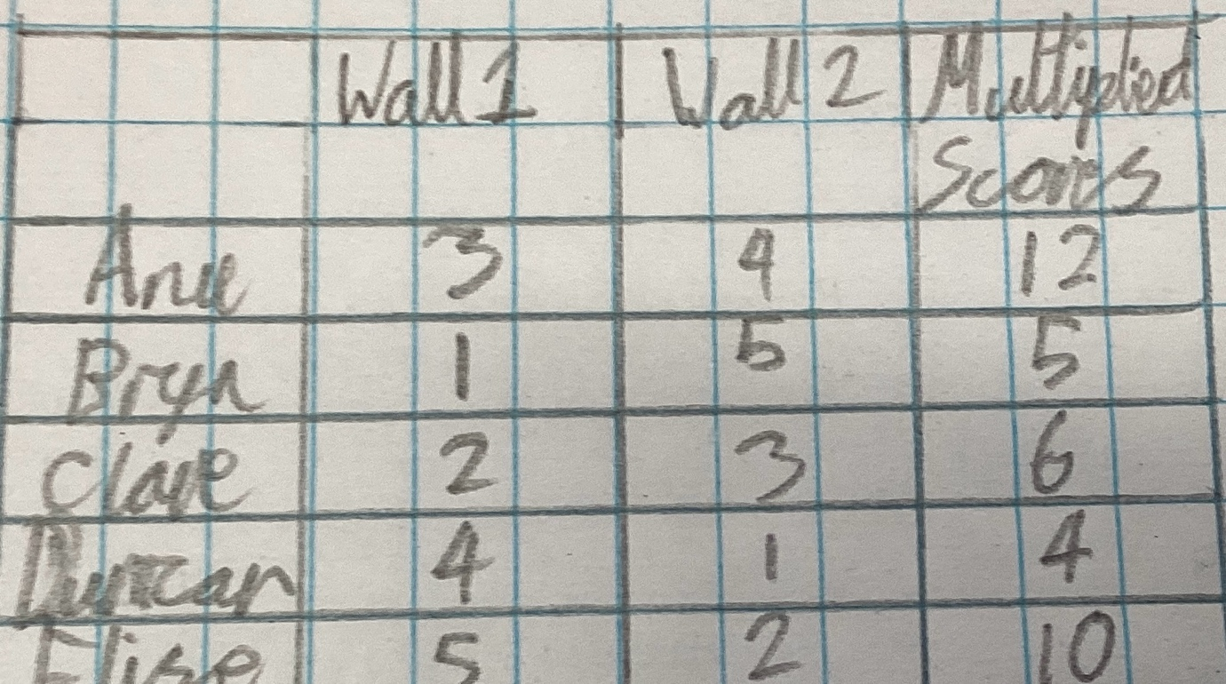
1. Duncan is in the lead.
2.Yes, because if you add it, Clare, and Duncan are both in the lead, Bryn is second and Anu and Elise last.
3.Anu is correct because if Elise passes her, she would be joint second, so she is in the top three.
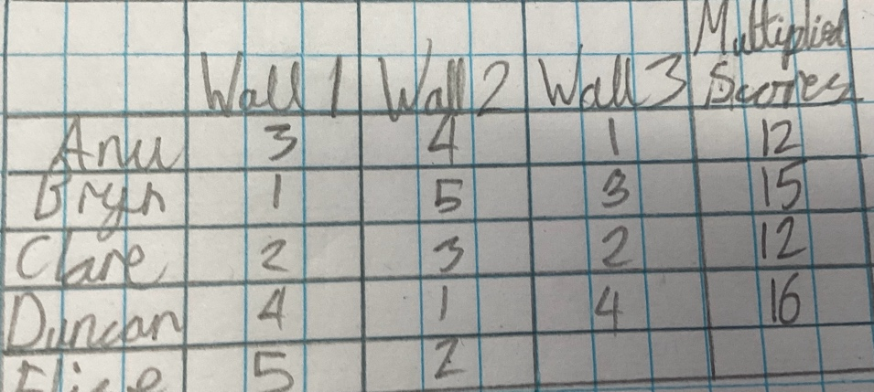
4.Elise would be first, second Anu and Clare, third Bryn and Duncan would be last.
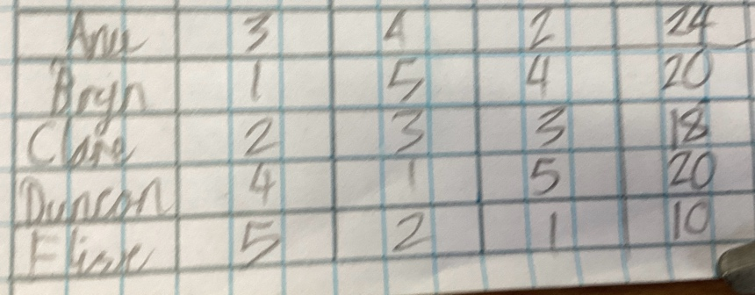
5.The outcome would be different because it would be flipped.

