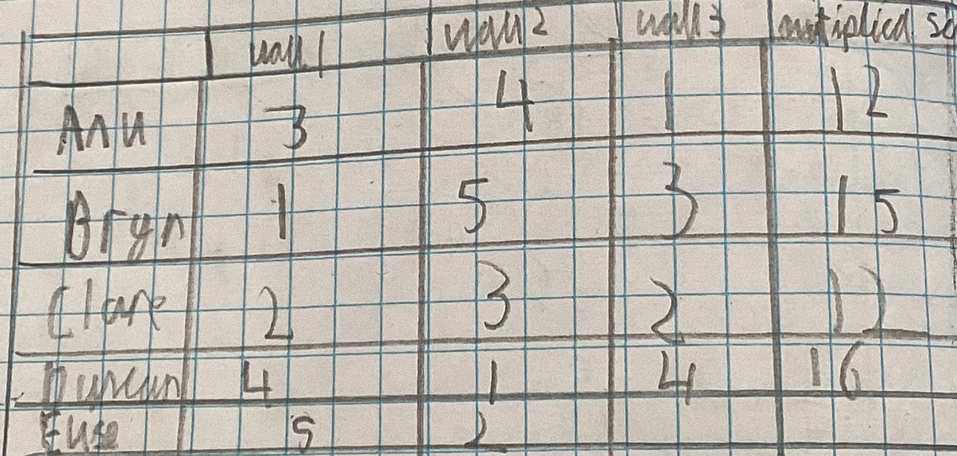
At the moment Duncan is in the lead.
When I added the scores it changed a lot because Clare and Duncan are drawing.
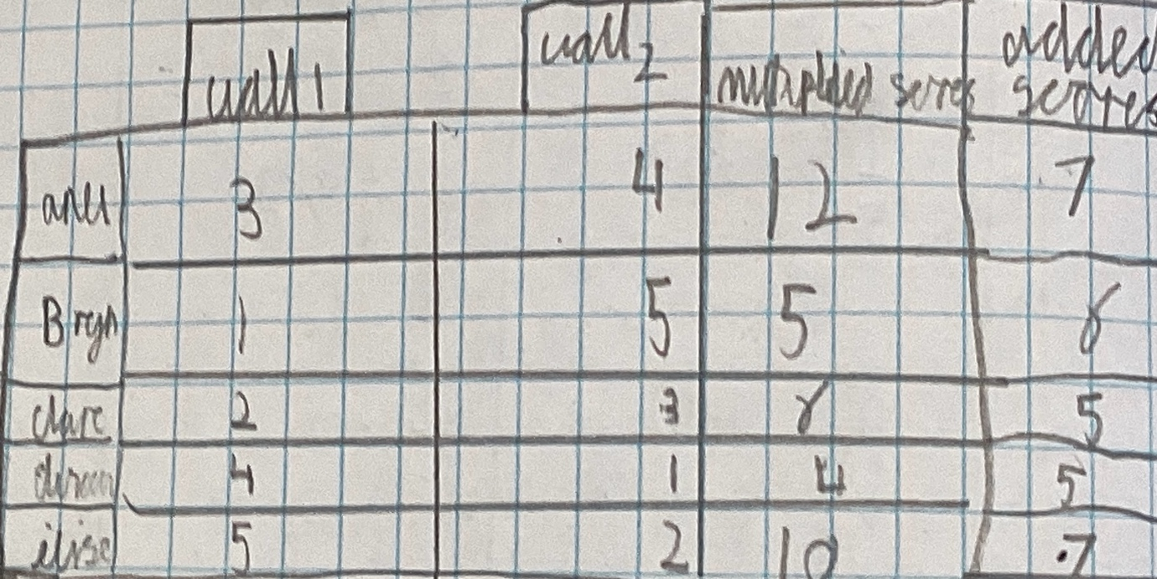

2 Anu is false because she will be in 24 Clare on 18 and Bryn will be on 20.

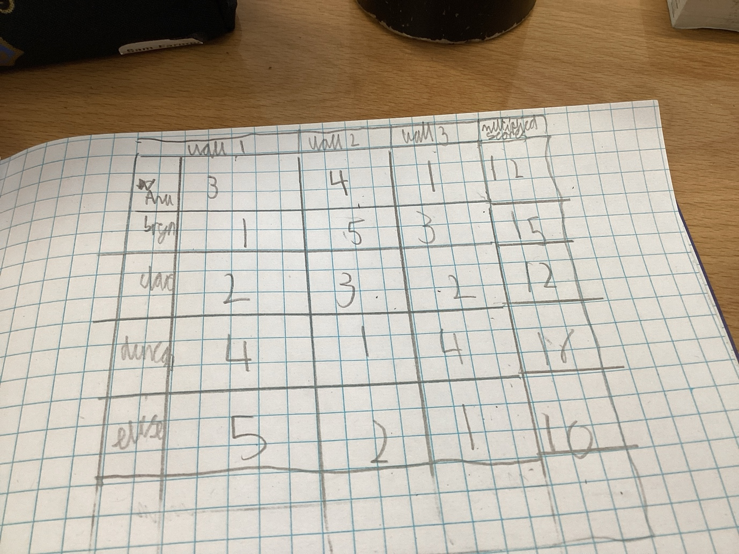

In this Clare is first and goes in the lead with the lowest number.this bodes well for her.

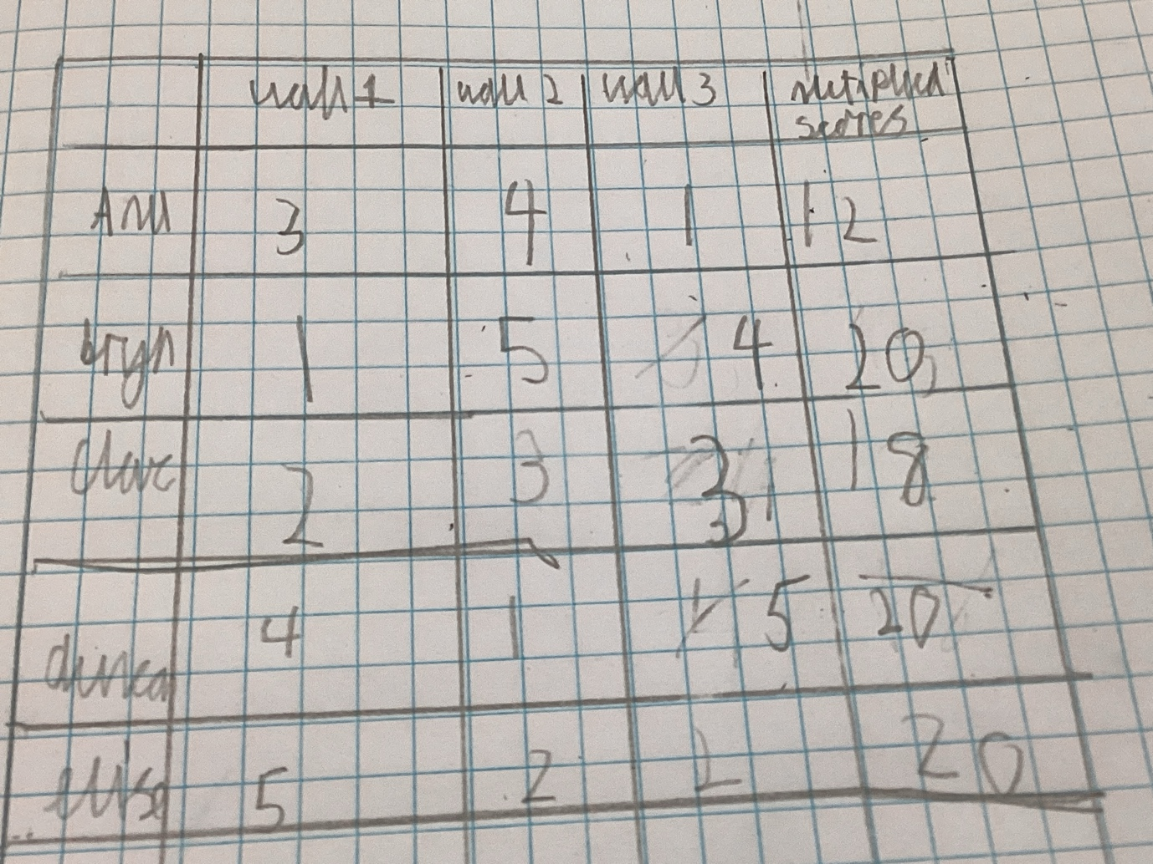
If elise came 2nd that is what this table shows.

This table shows elise coming 3rd .
