Keep it Simple Solution for Nrich
Myself Shubhangee (Facilitator)had worked collaboratively on ‘Keep it Simple’ with a group of 10 students of 4th and 5th grade, in online mode, in ‘Ganit Kreeda’, Vicharvatika, India. The names of the students are:
Tejas, Valerie, Varun, Kaumudi, Dhwani, Ira, Prathamesh, Adhrit, Delissaa, Riyansh.
- Can you describe Charlie’s rule?
Ans: Dhwani explained it as:
Charlie’s rule was to take a unit fraction that was immediately smaller than the fraction given and subtract. Then he added the difference and the first unit fraction together where sum was given unit fraction
- Are all his examples correct?
Ans: No, the first and the third are not correct.
- What do you notice about the sums that are correct?
Ans: The given unit fraction’s denominator and the first unit fraction’s denominator are consecutive numbers.
Dhwani said that…In the sums that are correct, the first unit fraction was immediately lesser than the answer of the sum.
- Find some other correct examples. How would you explain to Charlie how to generate lots of correct examples?
1/5 = 1/6 + 1/30
1/7 = 1/8 + 1/56
1/12 = 1/13 + 1/ 156

Ans: Take two consecutive numbers and multiply them together. Write the consecutive numbers and the product as unit fractions. E.g. 3x 4= 12 & 1/3 = ¼ + 1/12. Or 8x9 = 72 and 1/8 = 1/9 + 1/72.
Adhrit spotted the pattern from Charlie’s examples as 1/n = 1/(n+1) + 1/n(n+1).
Dhwani said that for any given unit fraction like 1/8, take the biggest possible unit fraction smaller than 1/8…which is 1/9. And then subtract 1/9 from 1/8 to get 1/72.
In general,
For given any unit fraction 1/n, Charlie has selected the biggest unit fraction
1/(n+1) smaller than the given fraction. And then subtract 1/{n+1} from 1/n to
get another unit fraction 1/n(n+1).
Adhrit explained why this will always give unit fraction.
As n and n+1 are consecutive numbers and as 2 consecutive numbers are
always co-prime, LCM of n and (n+1) is always 1.
1/n – 1/(n+1) = [(n+1) – n]/n(n+1) = 1/n(n+1)
6. Charlie tried to do the same with ⅛. Can you finish Charlie’s calculations to see which
ones work?
Children used trial and error for getting all possible ways starting from 1/9 till 1/16 which is half of 1/8. They used concept of Equivalent fraction to find all possible solutions.
Adhrit chose an odd number to multiply the denominator(i.e. 8 here) to get even denominator. For ex: 1/8 = 1/8x3 = 1/8x3 + 2/8x3= 1/24 + 1/12. He tried it with all odd multipliers to get even denominator. It is shown here.
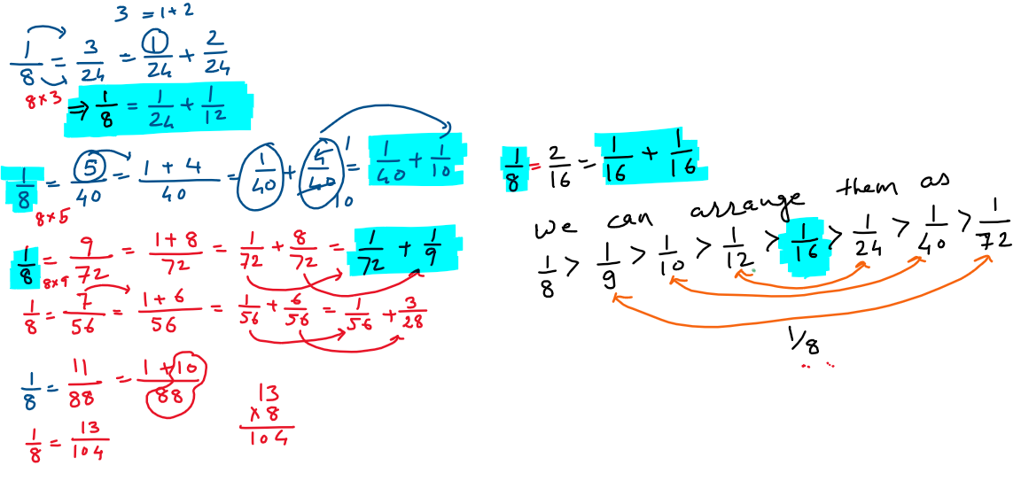
1/8=1/9+1/72
1/8=1/10+1/40
1/8=1/11+… (Does not work)
1/8= 1/12 + 1/24
1/8=1/13+… (Does not work)
1/8=1/14+… (Does not work)
1/8=1/15+… (Does not work)
1/8=1/16+1/16 (Does not work as these are not distinct.)
8. Choose different unit fractions of your own to test out your theories.
1. 1/9 = 1/10 + 1/90
2. 1/9 = 1/11 + 2/99 (Does not work)
3. 1/9 = 1/12 + 1/36
4. 1/9 = 1/13 + 1/107 (Does not work)

1/9 = 1/14 + 1/126 (Does not work)
……………………………………
1/9 = 1/18 + 1/18

