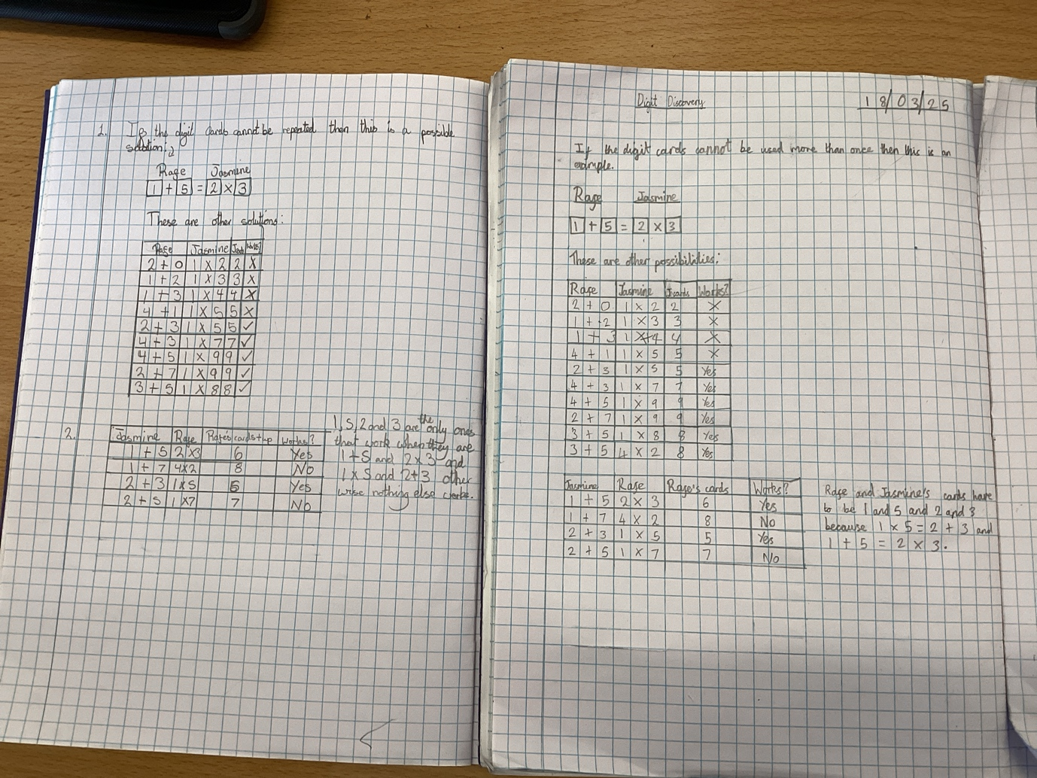
This is our solution to Digit Discovery.

