Digit Discovery
There are two digit cards in front of Rafe, and two in front of Jasmine. Each card shows a digit from 0 to 9.
Rafe says:
"I've just noticed something interesting. If you add together the two numbers in front of me, the answer is the same as what you get when you multiply the two numbers in front of you."
What might the digit cards be?
Are there any other possible answers?
Everything in these tables shows the possible answers
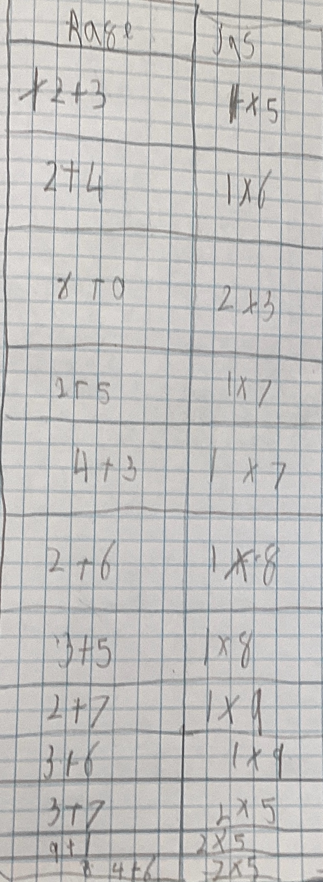
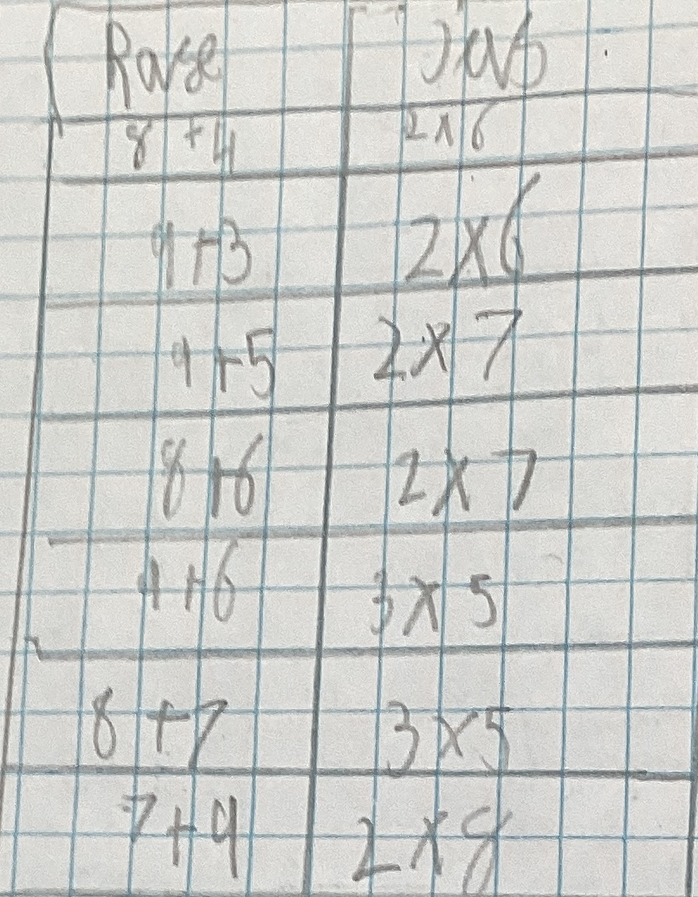
Then, Jasmine says:
"I've noticed something else - it works the other way round as well. The sum of my numbers is the same as the product of your numbers."
What might the digit cards be now?
Can you find all the possible answers? How will you know when you've found all of them?

Extension:
Rafe and Jasmine take two new digit cards each.
Rafe says:
"There's something interesting about these cards as well. If you subtract one of my numbers from the other one, the answer is the same as what you get when you divide one of your numbers by the other one."
Jasmine says:
"And it still works the other way round! Subtracting my numbers gives the same answer as dividing your numbers."
What might the digit cards be?
Are there any other possible answers?
Can you find all the possible answers? How will you know when you've found all of them?

