Nrich Solution for Quadratic Patterns
This task was conducted by Shubhangee in online mode for 2 sessions. The name of 10 students are:
Sehar, Nikhil, Vishnuvardhan, Ahana, Ananthajith, Dhruv, Vihaan, Arya, Aaradhya, Vishnu.
All the students collaboratively solved these. There are some students work which is posted independently.

Q.1: 2×4+1=9 = 3^2
4×6+1=25 = 5^2
5×7+1=36 = 6^2
9×11+1=100 = 10^2
In words:
When you add 1 to the product of any two numbers that differ by 2, the answer is always a square of number between them.
Algebraically:
n(n+2) + 1 = (n+1)^2
Proof:
L.H.S = n(n+2) + 1 = n^2 +2n +1 = (n+1)^2 = R.H.S
Using a diagram:
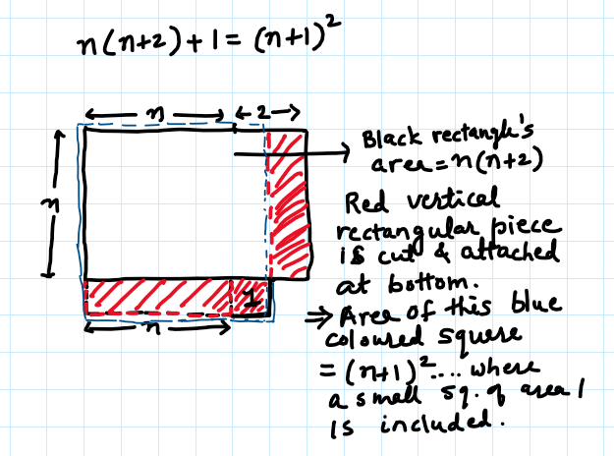
Q.2: 2×3+3= 9 = 3^2
5×6+6= 36= 6^2
4×5+5= 25= 5^2
9×10+10=100= 10^2
In words:
If you multiply two consecutive numbers and then add the bigger of those numbers to it, the answer is always the square of the bigger number.
Algebraically:
n(n+1) + n+1 = (n+1)^2
Proof:
L.H.S = n(n+1) + n+1 = n^2 + n + n+1
=n^2+2n+1= (n+1)^2 = R.H.S
OR
n(n+1) means (n+1) added n times.
n(n+1) + n+1 means (n+1) added (n+1) times.
So, n(n+1) + n+1 = (n+1)(n+1)=(n+1)^2
Using a diagram:
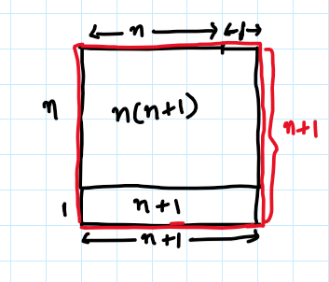
Square outlined in black shows LHS and Square outlined in red shows RHS.
Q.3: Choose three consecutive numbers, square the middle one, and subtract the product of the other two. Repeat with some other sets of numbers. What do you notice? Can you represent this pattern numerically, algebraically and using a diagram ?
Numerically,
1,2,3 2x2 – 1x3 = 4-3 = 1
4,5,6 5x5– 4x6 = 25-24 = 1
Dhruv’s solution:
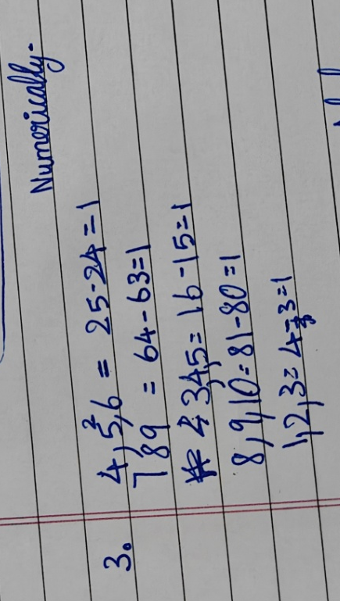
Algebraically:
Let 3 consecutive numbers be (n-1), n, (n+1)
(n)^2 – (n-1) x (n+1) = 1
As (n-1) x (n+1) = n^2 – 1, (n)^2 – (n-1) x (n+1) = 1
Diagramatically:
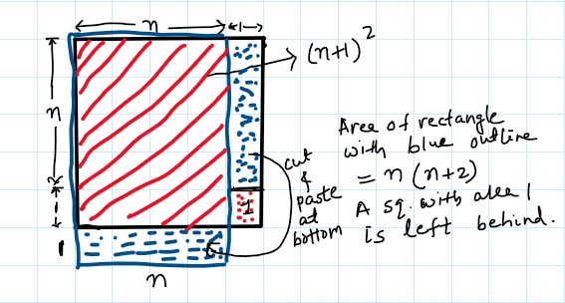
Q.4: 3×3−1×1= 9 - 1 = 8 = 4x2
8×8−6×6= 64-36 = 28 = 4x7
7×7−5×5= 49-25 = 24 = 4x6
10×10−8×8=100-64= 36 = 4x9

In Words:
Difference of squares of 2 consecutive even or 2 consecutive odd numbers is always equal to the 4th multiple of the number between them.
Algebraically:
(n+2)^2- (n)^2 = (n+1)^2
Proof:
L.H.S = (n+2)^2 – n^2= n^2 + 4n + 4 – n^2
=4n+4= 4(n+1) = R.H.S
OR
Using identity,
LHS=(n+2)^2- (n)^2 = (n+2+n)(n+2-n)
= (2n+2)(2) = 4n+4 = 4(n+1) =RHS
Using Diagram:
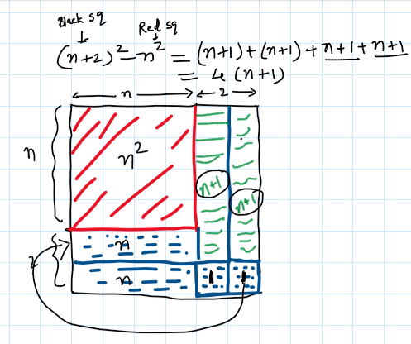

- n(n+1)−(n−1)(n+2)=?
(n+1)(n+2)−n(n+3)=?
(n−3)(n−2)−(n−4)(n−1)=?
What do you notice?
Numerically:
1,2,3,4
2x3-1x4=6-4=2
4,5,6,7
5x6-4x7=30-28=2
In Words:
- Choose any 4 consecutive numbers.
- Subtract product of 2 extreme numbers from the product of 2 middle numbers.
- The answer is always equal to 2.
Algebraically:
(n+1)(n+2)−n(n+3)=2

Using Diagram:
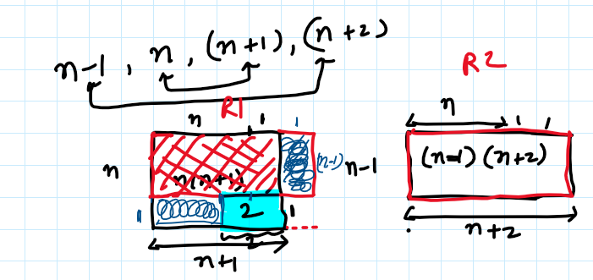

Q.6: 3×5+1=?
5×7+1=?
7×9+1=?
9×11+1=?
What do you notice?
This is same as Q.1.
Q.7: Choose three consecutive numbers and add the product of the smallest two to the product of the greatest two.
Repeat with some other sets of numbers.
Numerically,
1,2,3
1x2 + 2x3 = 2+6 = 8 =2x 2^2
3,4,5
3x4 + 4x5 = 12 + 20 = 32 = 2 x 4^2
Algebraically:
n-1 , n , n+1
(n-1)n + n(n+1) = n^2 – n + n^2 + n = 2n^2

Algebraically and with Diagram:
