Picturing squares part 2

Solutions ;

- How was it built from the original square array?
Solution :
So basically to find this out let us first divide the square into 2 .
The original square ;
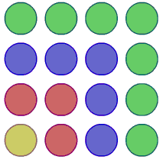

The image when it is divided in 2 ;
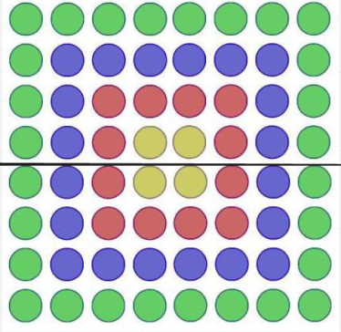
We can so far see no relation with the original square . now let us try cutting this in half again :
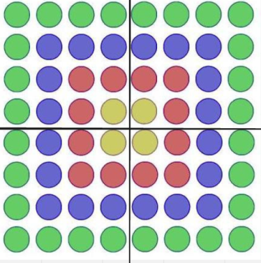
Observation :
- If you observe closely we can see that the quarters are the same size and the same number of colors and dots as the original square except one original picture and 3 other flipped versions of it .
- How many dots there would be in the hundredth diagram (i.e the one with 100 colors )
Solution :
We can see as in the first question that picture one is divided into 4 of the original squares . We can also say this by the number of dots in each layer .
E.g :

Yellow dots= 1, red dot = 3, purple/blue dots=5, green dots =7
Picture 1 :
Yellow dots=4 , red dots = 12 , purple/blue dots =20 , green dots = 28

As we can see the number of dots in every row increases by x4.
So now we can generalize as the following :

Number of terms(n) x number of terms (n) x4 = number of dots or
Number of terms (square) x4 = number of dots

E.g : 5 layers/colors
5x5x4=25x4=100 . or : 4(5 square )=100

100 layer/colors =
100x100x4= 40,000 . or : 4(100 square)The number of dots in 100 layers/colors is 40,000.

- What summation it represents ?
Solution :
It represents summation of :
2
N x 4 = summation/number of layer or colors

- Whether there are alternative ways of expressing the summation , relating to different ways of looking at the diagram .
Solution ;
Another way of looking at is the sum of the layers :
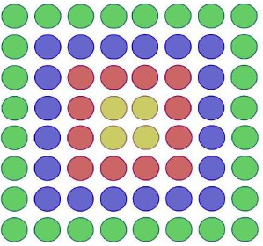
So the yellow dots =4 which is 2 square
Then the red dots + yellow dots = 16 = 4 square
Then the red yellow+blue/purple dots = 36 = 6 square …….
The pattern here you can see is that the square is increasing . (e.g: 2 square 4 square , 6 square … etc ).
But the way to find it out is ; number of terms x2 then square it .
E.g ; (6 layers)
6x2=12 , 12 square =144 . the number of dots in 6 layers/colors = 144 .

So alternative summation = n (no. of terms ) x2 then square it .

2)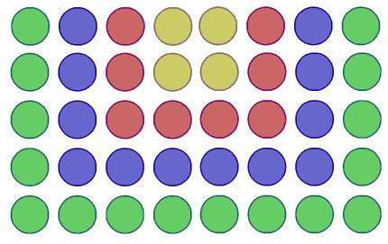

- How was it built from the original square array ?
Solution :
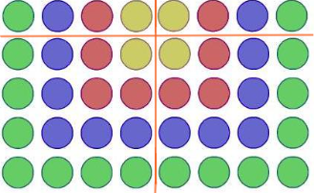
Solution :
We can basically see from the above image that there are 2 of the original square arrays and 8 other dots . so we can also see that the above dots are just twice the number of layers/colors . so we can generalize as the following ;
2
2x no. of terms + no. of terms x2 .

Example :( 2 terms )
2
2 x2 + 2x2=
8+4=12 and this is right as the number of yellow dots = 4. Number of
red dots=8. .

- How many dots there would be in the hundredth diagram (i.e the one with 100 colors )
Solution :
2
2x no. of terms + no. of terms x2 .
As above this is our formula also explained in the question above . so plug in the numbers and :
2
2x 100 + 100 x 2 =
2x10,000+200=
20,000 + 200 = 20,200

The number of dots in the hundredth diagram would be 20,200.
- What summation it represents ?
Solution :
2
2x no. of terms + no. of terms x2 .
The above is the summation it represents .

- Whether there are alternative ways of expressing the summation , relating to different ways of looking at the diagram .
Solution :
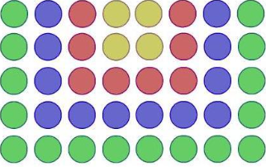

So let us count its colors .
Yellow = 4
Red = 8
blue/purple=12
green=16
Now we can see that these are just the multiples of 4 .
Let us divide this figure in half and look at it more closely .
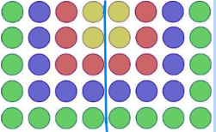
We can now see that on each side the colours are now :
yellow=2
red=4
blue/purple=6
green=8
Now if you can observe these numbers connect to the previous homework where we had a similar question . This is also used in the further questions in this document . (fig.3 , fig.4 )
So we can use the formula:
No. of terms x number of terms - 1 .
But it doesn't stop here as there is 2 copies of each :
Formula (general):
No. of terms x no. of terms -1 x2 =
(e.g: 5 layers )
5 x 5-1(4) x2 =
5x4x2= 40 .

3) 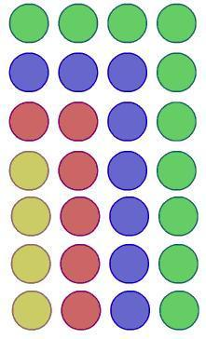

- How was it built from the original square array ?
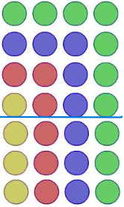

We can observe we have one copy of the original square + 3x4 = 12.
So 16+12=28. Now another thing we can observe here is that the bottom 3x4 , is just multiplying 3 x the number of terms/colors/layers .
So we can generalize as the following :
2
No. of terms + 3x no. of terms .

E.g :(5 colors/layers )
2
5 + 3x5
25+15=40.

- How many dots there would be in the hundredth diagram (i.e the one with 100 colors )
Solution:
Lets plug in formula :
2
No. of terms + 3x no. of terms .
Now let us apply this to hundred :
2
100 + 3x100 =
10,000+300= 10,300
The number of dots that will be there in the hundredth diagram would be 10,300

- What summation it represents ?
Solution :
2
No. of terms + 3x no. of terms .
The above is the summation . This is explained in the q.1 for this diagram .

- Whether there are alternative ways of expressing the summation , relating to different ways of looking at the diagram .
Solution :
First let us count its colors :
yellow=4
red=6
blu/purple=8
green=10

Now we can see this is similar to the question(2+4+6…) as it has gap of two and is missing a 2 so we generalize this as :(in other questions as well fig.2,fig.4)
Formula :
No. of terms x no . of terms - 1 .

4)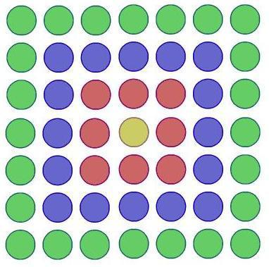

- How was it built from the original square array ?
Solution :
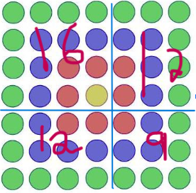

As we can see there is one copy of the original square diagram and 2 (2+4+6 …) diagrams which connects to the previous homework as we had the question (2+4+6 …) , then we have a figure of 3 square (9) .

And we can see the number of terms is 4 , so we square that to get 16,
2
then we use the formula : no of terms

Now we can see there are 2 copies of (2+4+6) .
looking at the picture each of these diagrams are the :
number of terms x number of terms -1
Since there is 2 of this we just multiply it by 2 which is now :
Number of term x number of terms - 1 x2

Let us go further . now we can see that the 3 square (9) now we can
See that is like 4 square but with the base no. 1 less . then we just square it .

So we can conclude this :
2
Number of terms -1 .
Put this all together to form the general formula :
2 2
Number of terms +number of terms - 1 + number of terms x numbers of terms -1 x 2 .

For example : 5 layers
2 2
5 + 5 x 5-1 (4)x2 + 5-1(4) =
25+ 40+ 16 =
81
( i have another a less complicated method in the last question of this problem )

- How many dots there would be in the hundredth diagram (i.e the one with 100 colors )
Lets plug in formula :
2 2
Number of terms +number of terms - 1 + number of terms x numbers of terms -1 x 2 .
2 2
100 + 100 -1 + 100 x 99 x2 =
10,000 + 9801 + 9900 x2 = 10,000+ 9801 +19800 = 39,601
The final solution is that in the hundredth figure there will be 39,601 dots

- What summation it represents ?
Solution :
2 2
Number of terms +number of terms - 1 + number of terms x numbers of terms -1 x 2 .
This is what we used in the previous questions. More is mentioned in the following question .

- Whether there are alternative ways of expressing the summation , relating to different ways of looking at the diagram .
Solution :

Let us observe the number of dots in each color .
yellow=1, red=8,blue/purple=16, green=24
So let us add 1+8=9 . So we can see that 9 is 3 squares , and the number of terms is 2 so we add 1 to the base and square it (for this example ),but this doesn't work for every example (e,g 1+8+16 =25 ( 5square) this will not work if you add one to 3 (the number of terms ) 3+1= 4 then square it 4 square but the sum of 5 square so this doesn't work .) so another way : 2-1=1 and we are adding one to base then squaring it , this can apply to other numbers of layers as well . let us generalize this as :
2
No. of terms + number terms -1 .

e.g :( 5 layers or terms)

2 2
5+5-1 = 9 = 8 1 .

—-------------------------------------x—------------------------------------------- Dia.r
- for nrich website
-continuation on picturing squares
- submitted on 18/1 1/2024

