Nrich Solution for Picturing Square Numbers 2

This task was taken by Shubhangee in online mode with 8 students namely:
Tejas, Prapthi, Sanat, Valerie, Dia, Mantavya, Varun, Thejasvi.
This task was done completely in a collaborative mode and we got all the solutions in one session.
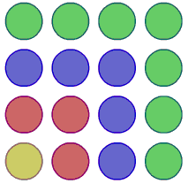

We have just seen that the sum of odd numbers can be represented as a square array of dots.
The square diagram can be adapted to represent related summations.
Make notes on:
- How it was built from the original square array.
- How many dots there would be in the 100th diagram (ie the one with 100 colours).
- What summation it represents.
- Whether there are alternative ways of expressing the summation, relating to different ways of looking at the diagram.
Dia 1

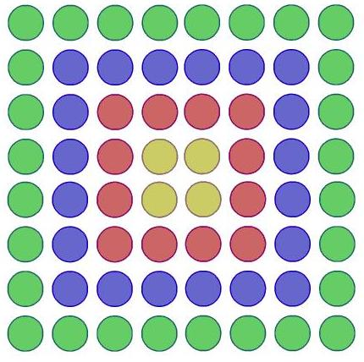

Observations made by students:

Dia & Prapthi : This picture can be divided into 4 equal parts and use earlier picture for reference. Total dots in each quarter = n^2.
So total dots for given pic is 4n^2.

Valerie, Varun & Thejasvi : They counted it colourwise as:
1st colour: Y 4 = 4x2- 4 = 4x1
2nd colour: P 12 = 4x4- 4 = 4x3
3rd colour: B 20 = 4x6- 4 = 4x5
4th colour: G 28 = 4x8- 4 = 4x7
....................................
....................................
nth colour 4x(2n-1)
They added all the terms as 4 + 12 + 20 + 28 = 64 = 8^2

After making a table of their observations
Number of Colours | Total dots
1 | 4 = 2^2 = (2x1)^2
2 | 16 = 4^2= (2x2)^2
3 | 36 = 6^2= (2x3)^2
4 | 64 = 8^2= (2x4)^2
... | ...
... | ...
n | (2n)^2

- How it was built from the original square array.
4 times original square array

- How many dots there would be in the 100th diagram (ie the one with 100 colours).
4(100)^2 = 40000

- What summation it represents.
4 + 12 + 20 + 28 + ... = 4 (1 + 3 + 5+ 7+...)

- Whether there are alternative ways of expressing the summation, relating to different ways of looking at the diagram.
As explained above. 4n^2 or (2n)^2.
Henceforth n represents number of colours used.

Dia 2
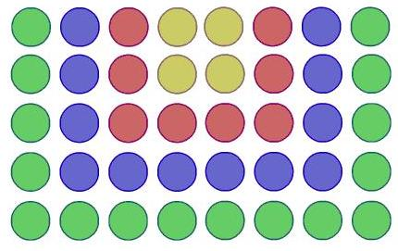

- How it was built from the original square array.
2 times original square array + 2 times number of colours
If n represents number of colours used, then
total number of dots = 2n^2 + 2n.

- How many dots there would be in the 100th diagram (ie the one with 100 colours).
2(100)^2 + 2(100)= 20000 + 200 = 20200

- What summation it represents.
4 + 8 + 12 + 16 + ... = 4 (1 + 2 + 3+ 4+...) OR
2( 2 + 4 + 6 + 8 + ....)

- Whether there are alternative ways of expressing the summation, relating to different ways of looking at the diagram.
Dia, Tejas & Sanat’s way:
They divided the diagram vertically in 2 equal parts and they counted the total number of dots colourwise as 2 + 4+6+8+...
Then as they had already found solution for this earlier as
2+4+6+8+...+2n = n(n+1)
So, here total no. of dots = 2n(n+1)

Varun, Thejasvi and Prapthi’s approach:
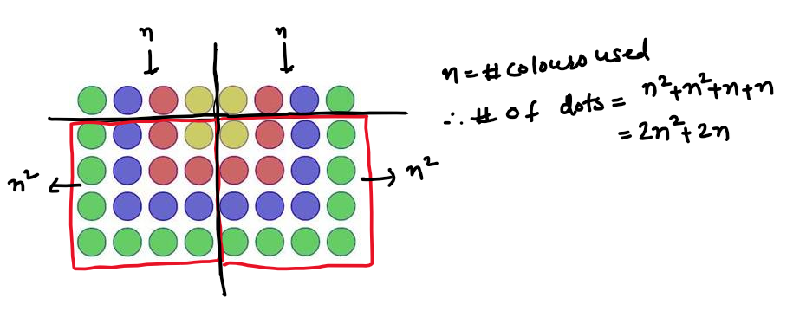

So, here total no. of dots = n^2 + n^2 + n + n = 2n^2 + 2n.

Dia 3
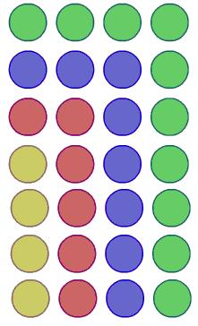
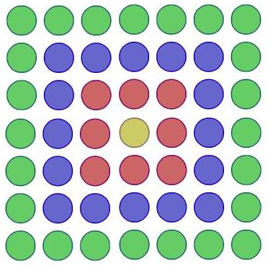

- How it was built from the original square array.

Varun separated original square array from this as shown
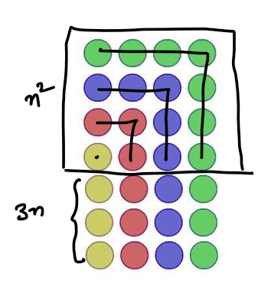
So total number of dots = n^2 + 3n, n= # of colours.
- How many dots there would be in the 100th diagram (ie the one with 100 colours).
- total number of dots = n^2 + 3n
total number of dots (100th dia) = (100)^2 +300= 20000+300 = 20300

- What summation it represents.
This was explained by Dia.
4 +6+8+10+... = 2(2+3+4+5+....)

- Whether there are alternative ways of expressing the summation, relating to different ways of looking at the diagram.
Thejasvi, Mantavya & Prapthi’s way:
They counted number of rows and number of columns separately for n colours, as....
# rows= 3+n
# columns = n
So, total number of dots = (3+n) n = 3n + n^2 .
Dia 4

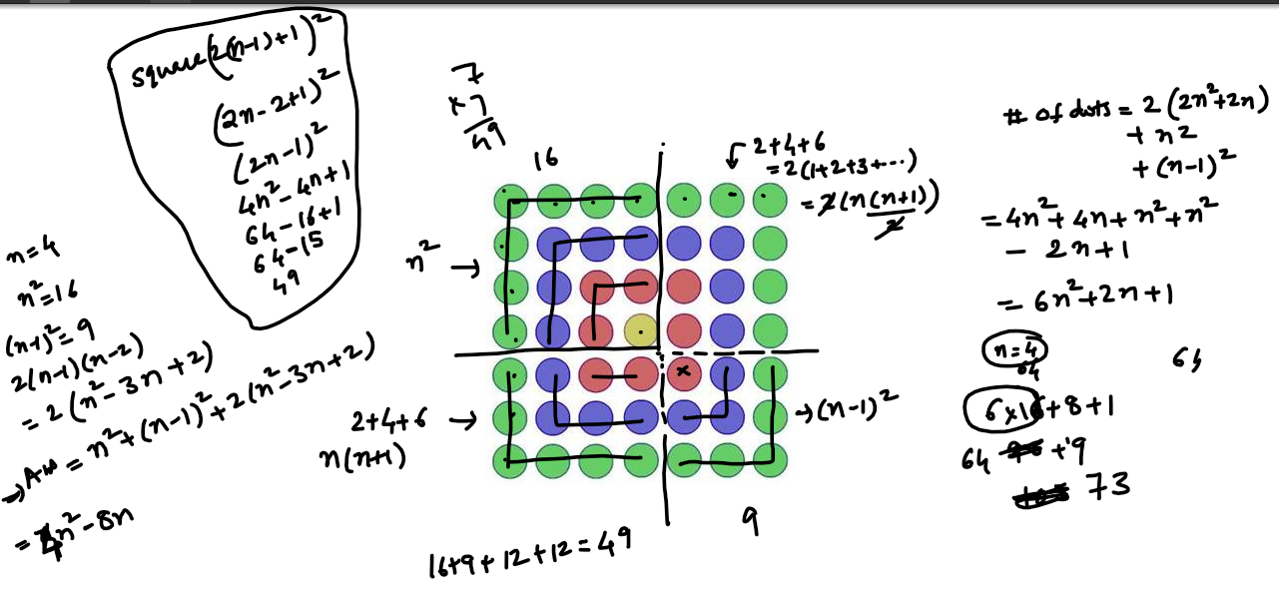

- How it was built from the original square array.
Varun’s method:
He took out original square array from left topmost corner of diagram 4.
As explained earlier, dots of this part=n^2.
Similarly, dots of right bottommost part = (n-1)^2.
Other two parts are identical and
dots in each part = 2+4+6+...2(n-1) =2(1+2+3+...n-1)= 2x(n-1)(n)/2 = (n-1)(n) = n^2 - n
So, total dots = n^2 +(n-1)^2 + 2(n^2 - n)
= n^2 + n^2-2n + 1+2n^2-2n
= 4n^2 -4n + 1
- How many dots there would be in the 100th diagram (ie the one with 100 colours).
4(100)^2 -4(100) + 1= 40000 -400 +1 = 39601

- What summation it represents.
1+8+16+24+....8(n-1)
=1+8(1+2+3+...n-1)
=1+8(n(n-1))/2
=1+4(n^2 - n)
=1+4n^2 -4n.

- Whether there are alternative ways of expressing the summation, relating to different ways of looking at the diagram.
- Thejasvi, Mantavya & Prapthi’s way:
They counted the number of rows and columns irrespective of colours and calculated the total number of dots . They observed the pattern as square of 1x1, 3x3, 5x5....
.and total number of dots as...
1, 9,25, 49...
1^2, 3^2, 5^2, 7^2.....(2n-1)^2

Below is Mantavya’s Solution:

