Quadratic Patterns

Q. Charlie has been playing with calculations again...
2 × 4 + 1 = 9
4 × 6 + 1 = 25
5 × 7 + 1 = 36
9 × 11 + 1 = 100
What do you notice?

Ans: I notice that the final answer is equal to the square of the middle number.

Charlie's explanation:
n(n + 2) + 1 = n² + 2n + 1 = (n + 1)²
or alternatively,
(n − 1)(n + 1) + 1 = n² – n + n – 1 + 1 = n²

Alison’s diagram:


Q. Can you make sense of Charlie's method and Alison's diagrams?
Ans: Yes, Charlie’s algebra and Alison’s diagram make sense.

Q. Here are some more number patterns to explore. Some have been expressed numerically, some in words, and some algebraically.
Can you represent each pattern in all four ways,
numerically (so you can spot the pattern),
in words (so you can describe the pattern),
algebraically (so you can prove the pattern continues),
and using a diagram (to explain the pattern)?

Explain how you worked it out.

- 2 × 3 + 3 = ?
5 × 6 + 6 = ?
4 × 5 + 5 = ?
9 × 10 + 10 = ?
What do you notice?
Ans: In numbers: 2 × 3 + 3 = 9
5 × 6 + 6 = 36
4 × 5 + 5 = 25
9 × 10 + 10 = 100
In words: Take two consecutive numbers and add the second number to the product of the two numbers. You get the square of the larger number.
With algebra: n(n + 1) + n + 1 = n² + n + n + 1 = n² + 2n + 1 = (n + 1)²
In a diagram: 

- Choose three consecutive numbers, square the middle one, and subtract the product of the other two.
Repeat with some other sets of numbers.
What do you notice?
Ans: In numbers: 3² – 2 x 4 = 1
4² – 5 x 3 = 1
10² – 9 x 11 = 1
11² – 10 x 12 = 1
In words: Choose three consecutive numbers, square the middle one, and subtract the product of the other two. You always get 1.
With Algebra: (n + 1)² – n(n + 2) = n² + 2n + 1 – (n² + 2n) = 1

In a diagram:

- 3 × 3 – 1 × 1 = ?
8 × 8 – 6 × 6 = ?
7 × 7 – 5 × 5 = ?
10 × 10 – 8 × 8 = ?
What do you notice?
Ans: In numbers: 3 × 3 – 1 × 1 = 8
8 × 8 – 6 × 6 = 28
7 × 7 – 5 × 5 = 24
10 × 10 – 8 × 8 = 36
In words: Take three consecutive numbers. The difference of the squares of the first and last numbers is equal to 4 times the middle number.
With algebra: (n + 2)² – n² = n² + 4n + 4 – n² = 4n + 4 = 4(n + 1)
In a diagram:
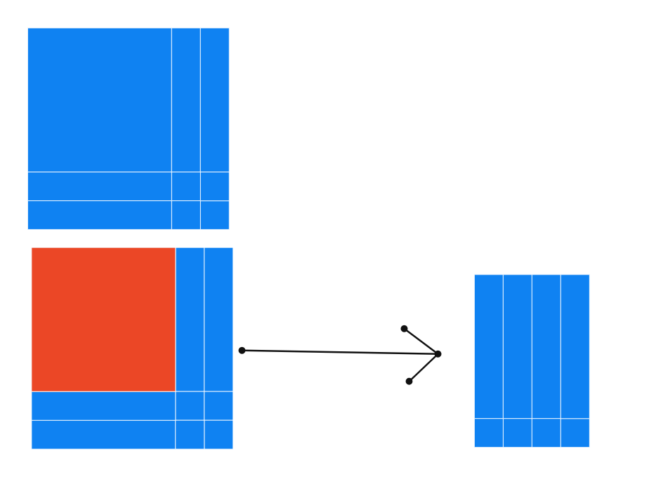
- n(n + 1) − (n − 1)(n + 2) = ?
(n + 1)(n + 2) − n(n + 3) = ?
(n − 3)(n − 2) − (n − 4)(n − 1) = ?
What do you notice?
Ans: In numbers: 2 x 3 – 1 x 4 = 2
5 x 6 – 4 x 7 = 2
8 x 9 – 7 x 10 = 2

In words: Take 4 consecutive numbers. Find the difference between the product of the middle two numbers and the product of the first and last numbers. This is always 2.
With algebra: (n + 1)(n + 2) – n(n + 3) = n² + 3n + 2 – n² – 3n = 2

In a diagram:
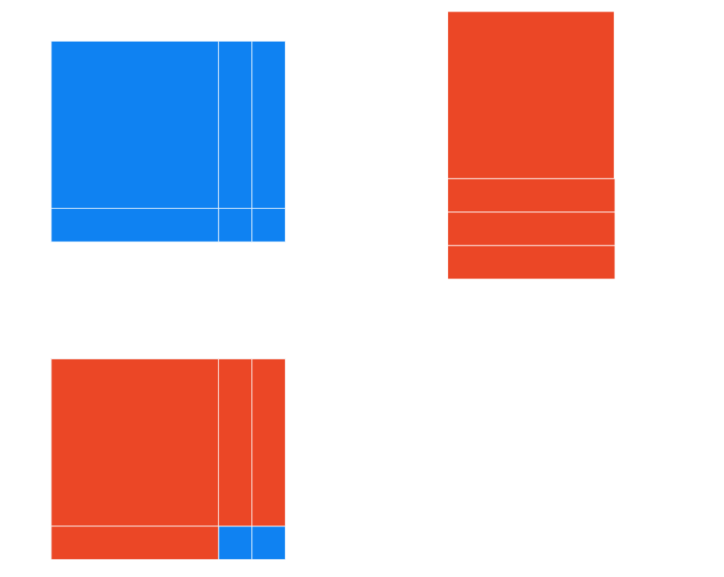

- 3 × 5 + 1 = ?
5 × 7 + 1 = ?
7 × 9 + 1 = ?
9 × 11 + 1 = ?
What do you notice?
Ans: In numbers: 3 × 5 + 1 = 16
5 × 7 + 1 = 36
7 × 9 + 1 = 64
9 × 11 + 1 = 100

In words: Take 3 consecutive numbers. Add 1 to the product of the first and the last numbers. You get the square of the middle number.
With algebra: n(n + 2) + 1 = n² + 2n + 1 = (n + 1)²
In a diagram:


- Choose three consecutive numbers and add the product of the smallest two to the product of the greatest two.
Repeat with some other sets of numbers.
What do you notice?
Ans: In numbers: 2 x 3 + 3 x 4 = 18
3 x 4 + 4 x 5 = 32
8 x 9 + 9 x 10 = 162
10 x 11 + 11 x 12 = 242
In words: Choose three consecutive numbers and add the product of the smallest two to the product of the greatest two. You get two times the square of the middle number.
With algebra: n(n + 1) + (n + 1)(n + 2) = n² + n + n² + 3n + 2 = 2n² + 4n + 2 = 2(n + 1)²
In a diagram:
