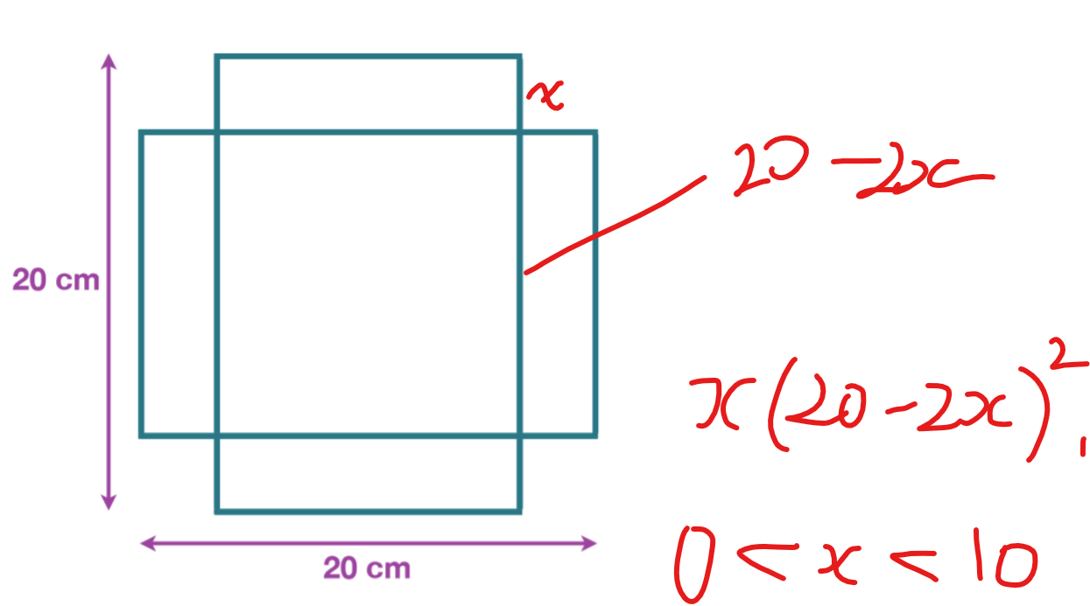
For a box generated this way, the height is x, and the side lengths of the square are $20-2x$. The volume is $x{(20-2x)}^{2}$.
$$=x(400-80x+4x^{2})$$
$$=4x^{3}-80x^{2}+400x$$
$$=4x(x^{2}-20x+100)$$
Also, the domain of the function is $0<x<10$.
- Using AM-GM
The AM-GM equality states that $\frac{a+b+c}{3}≥\sqrt[3]{abc}$ for real numbers a, b, and c. We can set them to cancel out like this:
$$a=x$$
$$b=\frac{10-x}{2}$$
$$c=\frac{10-x}{2}$$
$$\frac{a+b+c}{3} ≥\sqrt[3]{abc}$$
$$abc=\frac{4x(10-x)^2}{3}$$
$$a+b+c=10$$
$$\sqrt[3]{\frac{x{\left(10-x\right)}^{2}}{4}}≤\frac{10}{3}$$
$$\frac{x{\left(10-x\right)}^{2}}{4}≤\frac{{10}^{3}}{3^{3}}$$
$$\frac{100x-20x^{2}+x^{3}}{4}≤\frac{1000}{27}$$
$$4\left(100x-20x^{2}+x^{3}\right)≤\frac{16000}{27}$$

- Using Graphical

We can simply plot the graph of $y={x(20-x)}^{2}$ between 0 and 10 to find the maximum of the value, using a GDC or any graphing calculator. We find this value is $x=3\frac{1}{3}$or $\frac{10}{3}$, plugging it back in we get $\frac{16000}{27}$ for the volume.

