Take a square sheet of paper 20cm by 20cm, cut identical squares from each corner, and fold up the flaps to make a box (without a lid).
Image
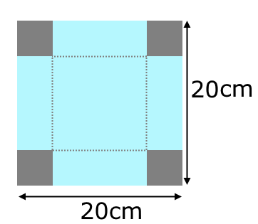
What is the volume of your box?
15x15x2.5 = 562.5cm³
What different volumes can you make by varying the size of the squares you cut out?
16x16x2 = 512cm³
12x12x4 = 576cm³
14x14x3 = 588cm³
13x13x3.5 = 591.5cm³
13.5x13.5x3.25 = 592.3125cm³

What is the maximum possible volume of this type of box that can be made from a 20cm-by-20cm square of paper?
About 13.3x13.3x3.35 = 592.58cm³ but it’s not the max because we could add decimals to the back of the number and there will be no end for this, so there is no end for a maximum.
Now try starting with different sized square sheets of paper.
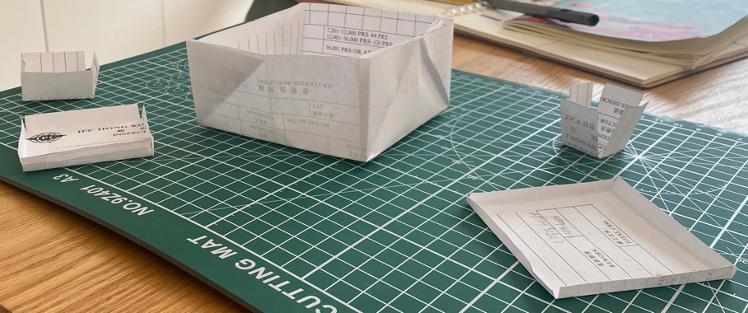
I used an 8x8 square.
4x4x2 = 32cm³
7x7x0.5 = 24.5 cm³
2x2x3 (remove 3x3) = 12cm³
6x6x1 (remove 1x1) = 36cm³

Can you find a relationship between the size of paper and the size of the square cut-out that produces the maximum volume?
The smaller the square you cut off the larger the volume, but it should be at a correct ratio because if you cut too less, the height will be very short. Therefore, there should be a correct ratio of the area cut off and the surface area with the volume. The ratio is the original square’s length times 0.1625 to get the length of the square you need to cut at the corners.

