Dominoes Sets
As part of the Year 3 and Year 4 Mathematics Extension Program (MEP) at Lumen Christi Primary School, students had the opportunity to work on the Dominoes Sets problem.
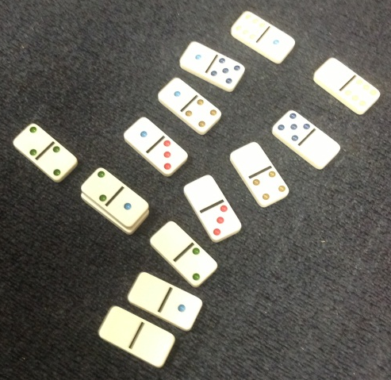
To make the problem extra challenging we discovered that one of the other classes had mixed up all of the dominoes in the Mathematics Resource room.
We had 6 containers. Some were nearly empty and some were totally full.
Our first challenge was to try and work out how many dominoes were in a standard set.
We did this by sorting the dominoes.
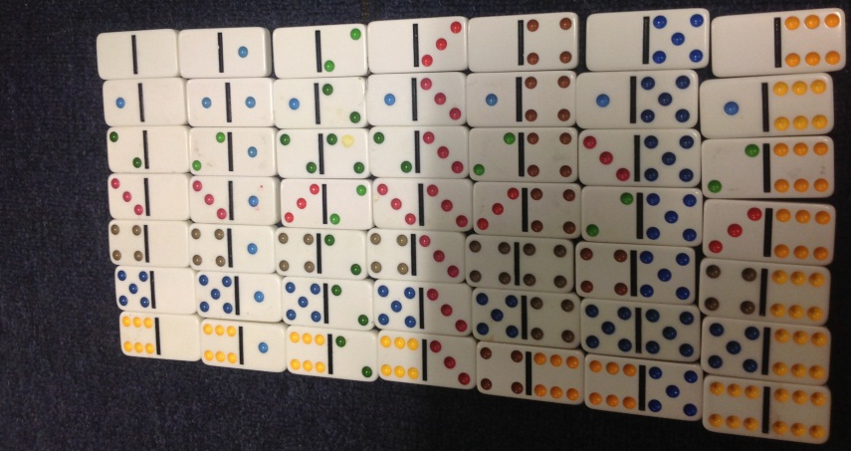
This helped us work out how many dominoes we needed and how many dominoes were missing from each set.
Aidan and Jade made a set of 49 dominoes.
We soon realised that this amount would not fit back into the container. From this we worked out that maybe a standard set only needed one of each domino – no repeats allowed.
Lachlan, Alex and Anthony were the first group to find the solution. They noticed that you only needed 7 of the zero dominoes. After that each set would need to have one domino less.
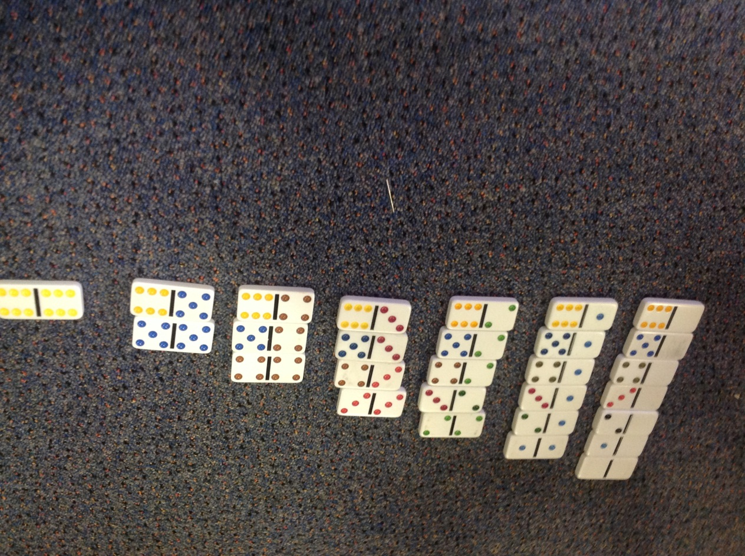
A standard set of dominoes has 28 dominoes.
7 + 6 + 5 + 4 + 3 + 2 + 1 = 28
Using this information we think that a set of 0 – 9 dominoes would have 55 dominoes.
10 + 9 + 8 + 7 + 6 + 5 + 4 + 3 + 2 + 1 = 55

