Stage 4 ★★
Mixed Selection 1 - Solutions

- Pieces of eight
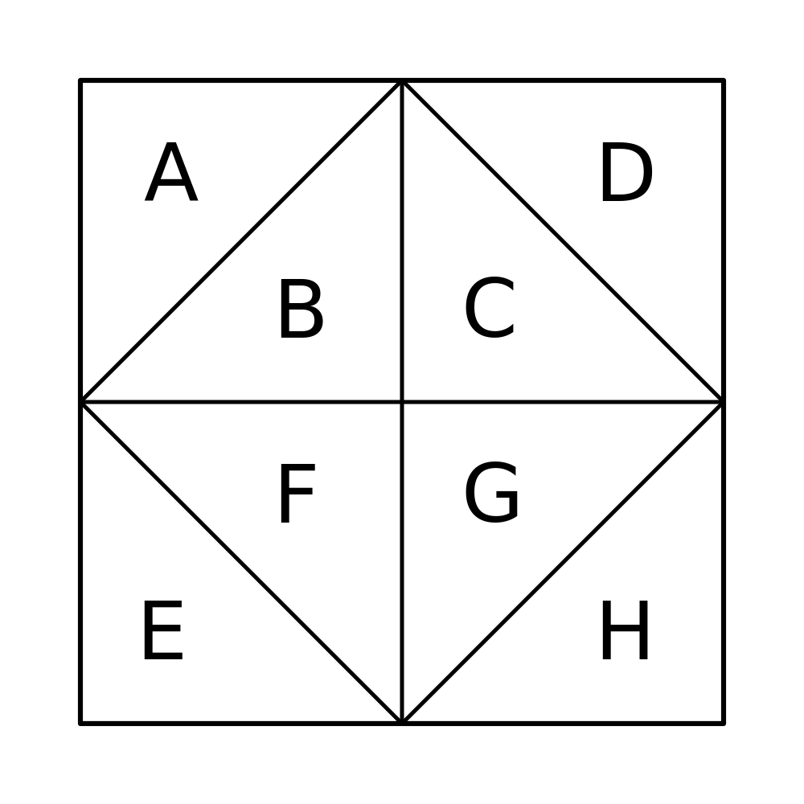
If the first triangle selected to be shaded is a corner triangle, then the final figure will have at least on axis of symmetry provided that the second triangle selected is one of five triangles. For example, if A is chosen first then there will be at least one axis of symmetry in the final figure if the second triangle selected is B, D, E, G or H. The same applies if an inner triangle is selected first: for example, if B is chosen first then there will be at least one axis of symmetry in the final figure if the second triangle selected is A, C, F, G or H.
So, the probability that the final figure has at least one axis of symmetry is $\frac{5}{7}$.

- Two girls
Let the number of boys in the class be $x$.
Then $\frac{10}{10+x}×\frac{9}{9+x}=0.15=\frac{3}{20}$.
Rearranging and simplifying gives $1800=3(10+x)(9+x)$, then $x^{2}+19x-510=0$.
Factorising gives $(x+34)(x-15)=0$ and, since $x≠-34, x=15$.
- Swapping sweets
There are two stages here – the sweet that Kate removes, and the sweet that Anna removes – and so a two-stage tree diagram will be helpful.
When Kate takes a sweet out of her bag, there are 4 to choose from, and they are all different colours – so the probability of choosing each colour is $\frac{1}{4}$.
When Anna takes a sweet out of her bag, there are 5 to choose from. If Kate put a red sweet into Anna's bag, then there are two red sweets, so the probability that Anna chooses a red sweet is $\frac{2}{5}$. There is still only one blue sweet, one green sweet and one yellow sweet, so the probability that she chooses each of the other colours is $\frac{1}{5}$. Similarly, if Kate put a blue sweet into Anna's bag, then the probability that Anna chooses a blue sweet is $\frac{2}{5}$, and the probability that she chooses each of the other colours is $\frac{1}{5}$ - and so on.
The two bags will each end up with one sweet of each colour if the sweet that Anna puts into Kate’s bag is the same colour as the sweet that Kate has put into Anna’s bag. Those possibilities are highlighted on the tree diagram below.
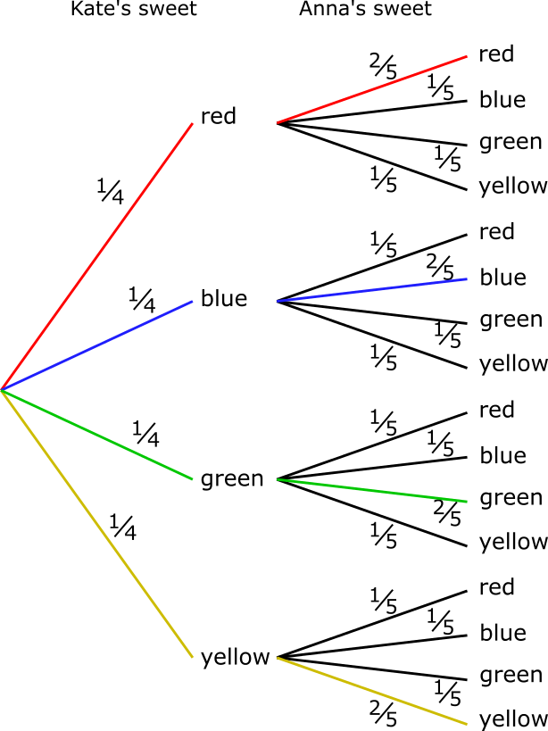
The probability of going along the red path is $\frac{1}{4}×\frac{2}{5}=\frac{1}{10}$. The probability of going along each of the other paths is also $\frac{1}{10}$, so the probability that both bags end up containing one sweet of each colour will be $\frac{1}{10}+\frac{1}{10}+\frac{1}{10}+\frac{1}{10}=\frac{4}{10}=\frac{2}{5}$ .
A fuller solution is available at: https://nrich.maths.org/12532/solution
- XOXOXO
The first four stages are shown in this tree diagram below, without probabilities shown. Once three of the same letter have been used, that letter can't happen again.
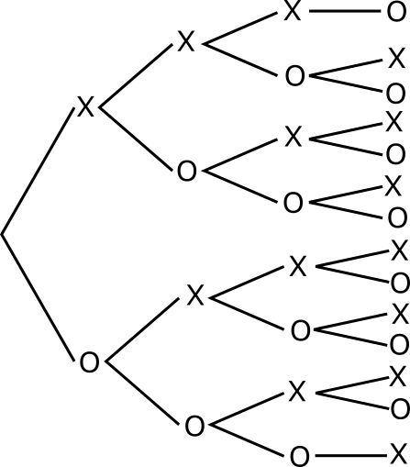
Because the tree diagram is very large, it makes sense to consider only the branches that lead to acceptable 'words'. Those probabilities are shown below, and so are the remaining banches.
At first, there are 6 tiles to choose from, 3 of each letter. Then there are 5 tiles to choose from, and the number that there are of each letter depends on what has already been removed.
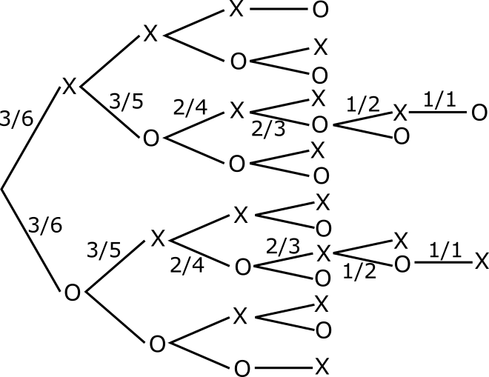
So the probability of getting an acceptable 'word' is
$$\left(\frac{3}{6}×\frac{3}{5}×\frac{2}{4}×\frac{2}{3}×\frac{1}{2}×\frac{1}{1}\right)+\left(\frac{3}{6}×\frac{3}{5}×\frac{2}{4}×\frac{2}{3}×\frac{1}{2}×\frac{1}{1}\right) \\ =\frac{1}{2}×\frac{3}{5}×\frac{1}{2}×\frac{2}{3}×\frac{1}{2}×2 \\ =\frac{3×2×2}{2×5×2×3×2}=\frac{1}{2×5}=\frac{1}{10}$$A fuller solution is available at: https://nrich.maths.org/12790/solution

