Stage 3 ★
Mixed Selection 2

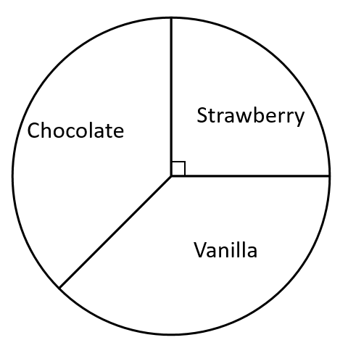
- Ice cream pie
An ice cream stall sells vanilla, strawberry and chocolate ice creams.
The pie chart illustrates the sales of ice cream for the last Saturday.
The number of vanilla and the number of chocolate ice creams sold were the same.
The stall sold 60 strawberry ice creams.
How many chocolate ice creams were sold?

- Balancing the books
A tourist attraction, which opens every day, needs 30 000 visitors per day on average to break even.
Last week there were 120 000 visitors.
What is the number of visitors needed this week to break even over the two-week period?
- Sevens
Sophie has to choose 7 different positive whole numbers whose mean is 7.
What is the largest possible number that she could choose as one of the 7?
- Average discovery
The mean, median and mode of five numbers are all the same.
If four of the numbers are 7, 7, 5 and 7, what must the fifth number be?

