Stage 4 ★★★
Mixed Selection 1

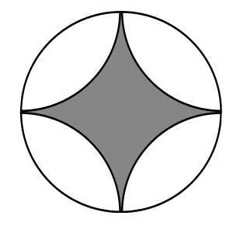
- In or out
The shaded region shown in the diagram is bounded by four arcs, each of the same radius as that of the surrounding circle.
What fraction of the surrounding circle is shaded?

- Snake eyes
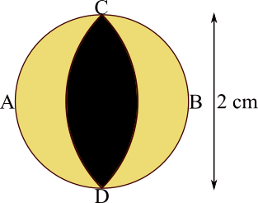
The diameter CD of this snake's eye is 2 cm.
It is yellow with a black slit, made from two arcs of circles with centres at A and B.
Find the area of the yellow part.

- Clown hats
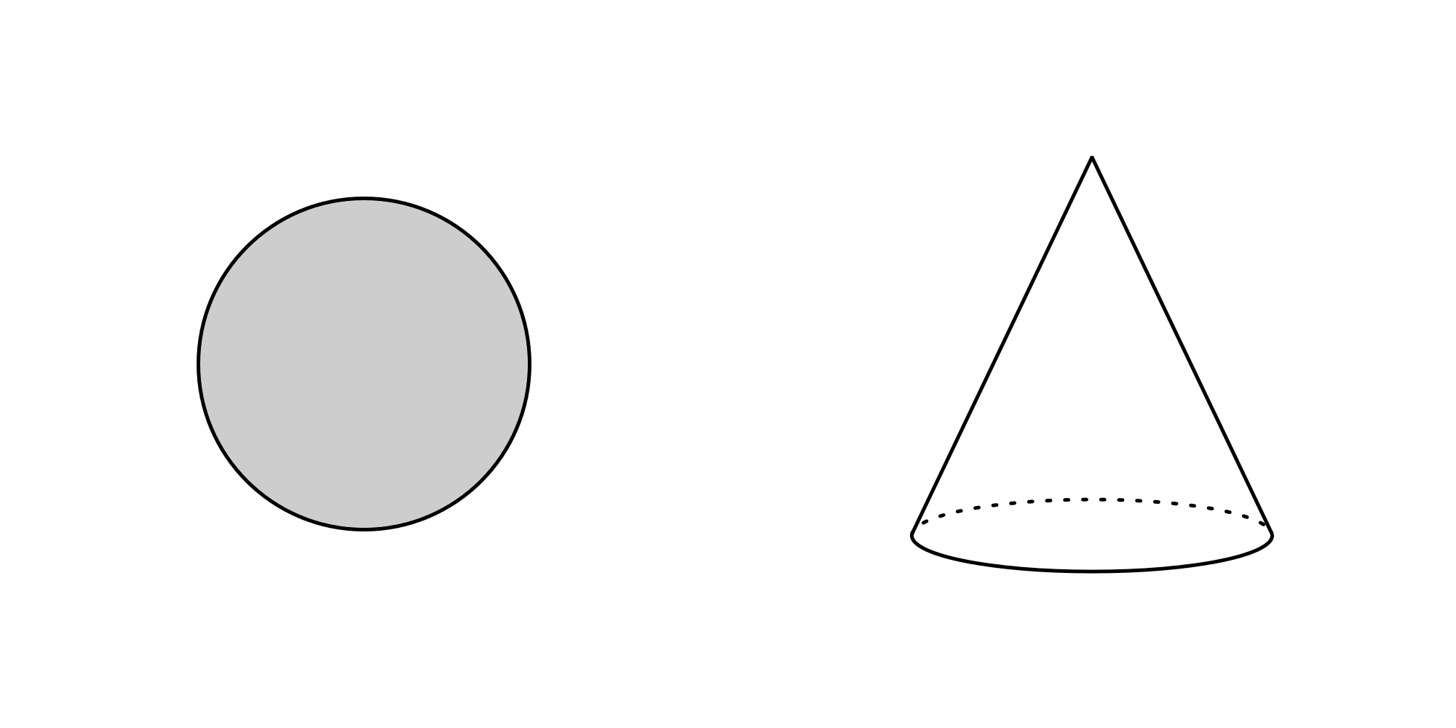
Charlie is making clown hats from a circular piece of cardboard.
The circumference of the base of each hat equals its slant height, which in turn is equal to the radius of the piece of cardboard. What is the maximum number of hats that Charlie can make from the piece of cardboard?

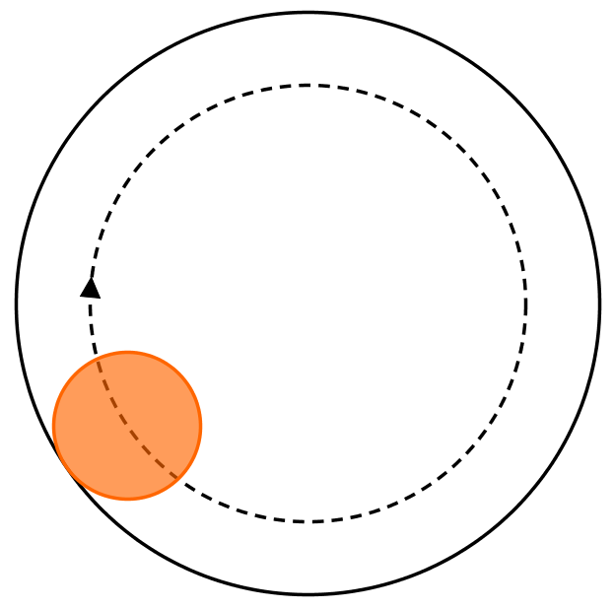
- Roll on
A circular disc of diameter $d$rolls without slipping around the inside of a ring of internal diameter $3d$, as shown in the diagram. By the time that the centre of the inner disc returns to its original position for the first time, how many times will the inner disc have turned about its centre? What if the disc rolls around the outside of the ring?

