Stage 4 ★★★
Mixed Selection 1 - Solutions

- In or out
Let the radii be $r$. Enclose the circle in a square with sides $2r$.
The unshaded area of the square consists of $4$ quadrants (quarters of circles) of radius $r$.
The total area of the square is $4r^{2}$ and the area of each quadrant is $\frac{πr^{2}}{4}$.
So the shaded area is $4r^{2}-πr^{2}={\left(4-π\right)r}^{2}$. Therefore, the fraction of the circle that is shaded is $\frac{{\left(4-π\right)r}^{2}}{πr^{2}}=\frac{4}{π}-1$.

- Snake eyes
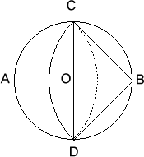
Let $O$ be the centre of the circle and let the points where the arcs meet be $C$ and $D$ respectively. $ABCD$ is a square since its sides are all equal to the radius of the arc $CD$ and $∠ACB=90°$ (angle in a semicircle).
In triangle $OCB$, $CB^{2}=OC^{2}+OB^{2}$; hence $CB=√2$cm. The area of the segment bounded by arc $CD$ and diameter $CD$ is equal to the area of the triangle $BCD$, i.e.
$\left(\frac{1}{4}π{\left(\sqrt{2}\right)}^{2}-\frac{1}{2}×\sqrt{2}×\sqrt{2 }\right)=\left(\frac{π}{2}-1\right)cm^{2}$.

The unshaded area in the original figure is therefore $\left(π-2\right) cm^{2}$. Now the area of the circle is $π cm^{2}$, and hence the shaded area is $2 cm^{2}$.

A fuller solution is available at: https://nrich.maths.org/12997/solution

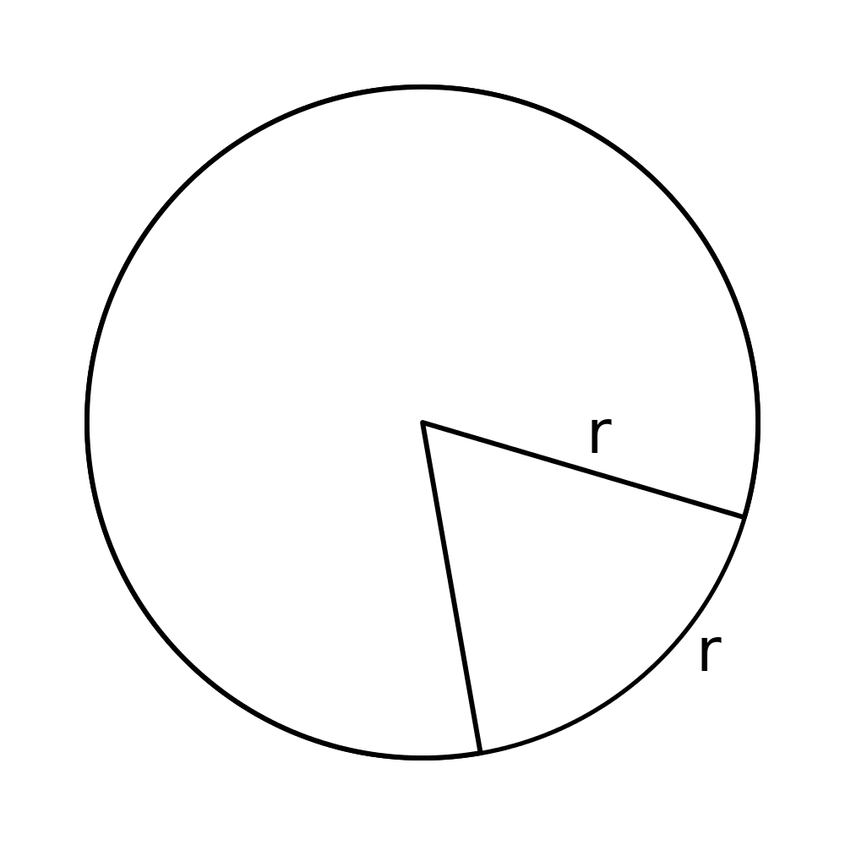
- Clown hats
Let the radius of the circular piece of cardboard be $r$. The diagram shows a sector of the circle which would make one hat, with the minor arc shown becoming the circumference of the base of the hat.
The circumference of the circle is $2πr$. Since $6r<2πr<7r.$we can cut out $6$ hats in this fashion.
Moreover, the area of cardboard unused in cutting out any $6$ hats is less than the area of a single hat. Hence there is no possibility that more than $6$ hats could be cut out.

- Roll on
In returning to its original position, the centre of the disc moves around the circumference of a circle of diameter $3d$, i.e. a distance $3πd$. As the disc does not slip, its centre moves a distance $πd$ when the disc makes one complete turn about its centre, so $3$ complete turns are made.

