Stage 4 ★★
Mixed Selection 1

- Circled corners
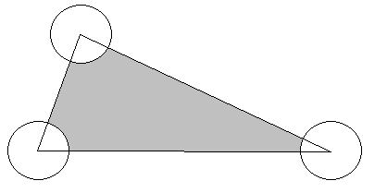
The diagram shows a triangle and three circles whose centres are at the vertices of the triangle. The area of the triangle is $80cm^{2}$ and each of the circles has radius $2cm$. What is the area in $cm^{2}$ of the shaded area?

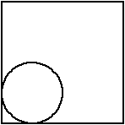
- Rolling inside
A circle of radius 1 rolls without slipping round the inside of a square of side length 4. Find an expression involving $π$ for the exact number of revolutions the circle makes by the time it returns to its original position.

- Sticky tape
A roll of adhesive tape is wound round a central cylindrical core of radius $3cm$. The outer radius of a roll containing $20m$ of tape is $4cm$. What is the approximate outer radius of a roll containing $80m$ of tape?

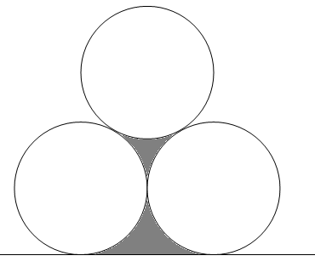
- Wood pile perimeter
The diagram shows three touching circles each of radius $5$cm and a line which touches two of them.
Find the total length of the perimeter of the two shaded shapes.

