Stage 4 ★
Mixed Selection 3

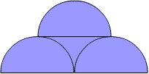
- Semicircle stack
The diagram shows three semicircles, each of radius one. What is the size of the total area shaded?

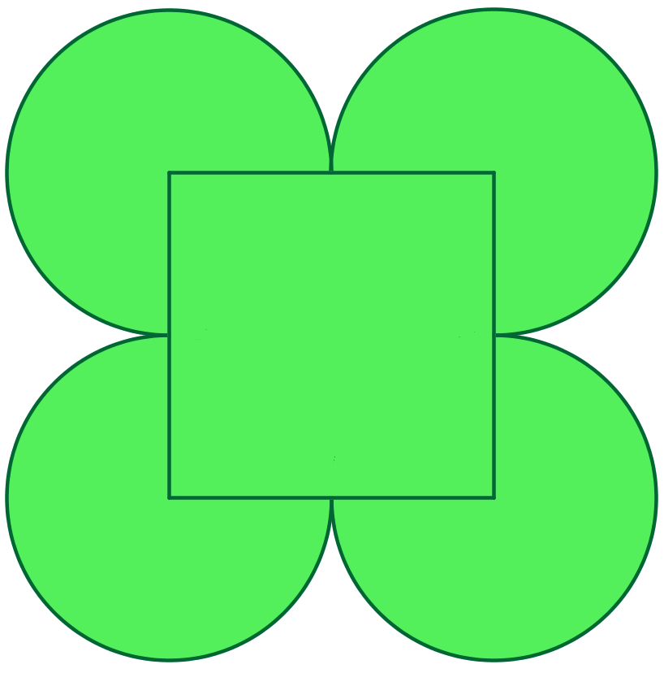
- Four leaf clover
The diagram shows four equal discs and a square. Each disc touches its two neighbouring discs. Each corner of the square is positioned at the centre of a disc. The side length of the square is $2/π$. What is the length of the perimeter of the figure?

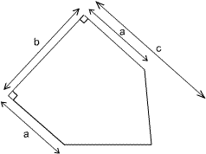

- Pentagonal area
What is the area of the pentagon shown?

- Semicircular design
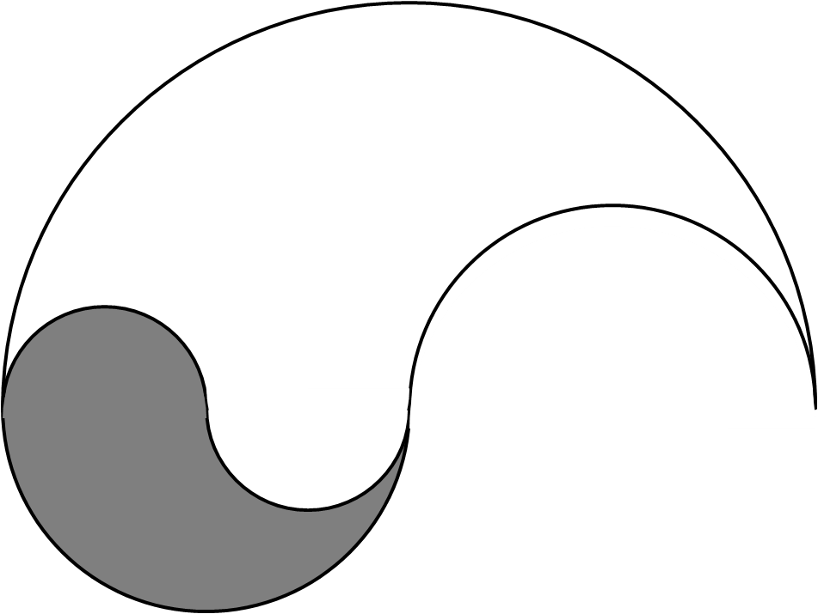
The diagram to the right shows a logo made from semi-circular arcs, each with a radius of $2$cm, $4$cm or $8$cm.
What fraction of the logo is shaded?

