Stage 4 ★
Mixed Selection 1

- Circle in a semicircle

The diagram shows a semicircle containing a circle which touches the circumference of the semicircle and goes through its centre.

What fraction of the semicircle is shaded?

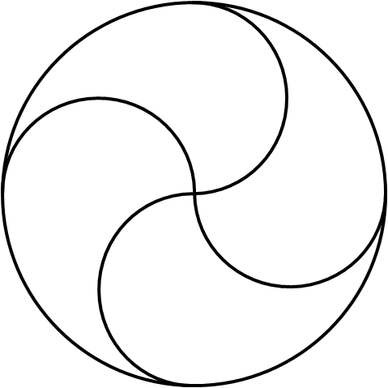
- Four parts
The circle of radius $4cm$ is divided into four congruent parts by arcs of radius $2cm$ as shown.
What is the length of the perimeter of one of the parts, in cm?

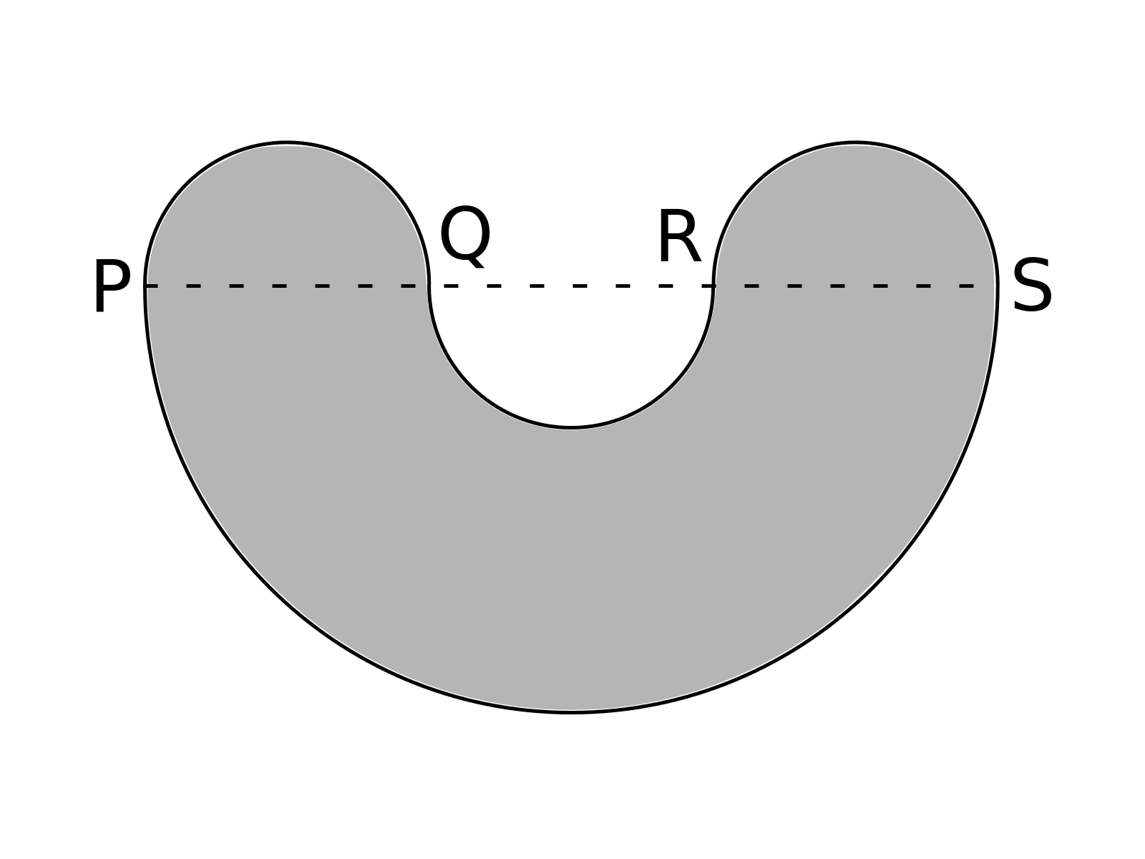
- Smile
The points $P, Q, R, S$ lie in order along a straight line, with $PQ=QR=RS=2cm$. Semicircles with diameters $PQ, QR, RS$ and $SP$ join to make the shape shown below.
What is the area of the shape?

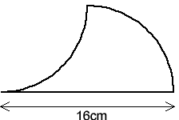
- Arc area
This figure is made from a straight line 16 cm long and two quarter circles, one with its centre at the midpoint of the straight line.

What is the area of the figure (in $cm^{2}$)?

