Stage 3 ★★★
Mixed Selection 1
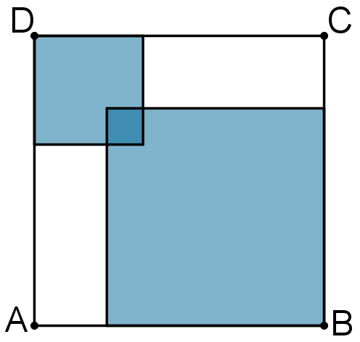
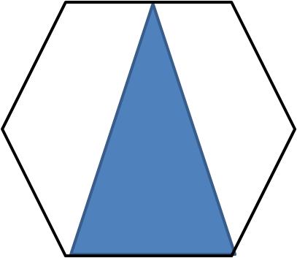
- Four square
The square $ABCD$ has an area of $196$. It contains two overlapping squares; the larger of these squares has an area $4$ times that of the smaller and the area of their overlap is $1$.
What is the total area of the shaded regions?
- Triangle in a hexagon
What fraction of the area of the regular hexagon is the shaded triangle?
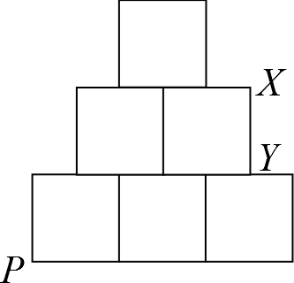
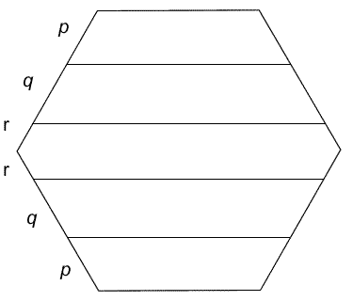
- Pile driver
The diagram shows a figure made from six equal, touching squares arranged with a vertical line of symmetry. A straight line is drawn through the bottom corner $P$ in such a way that that the area of the figure is halved.
Where will the cut cross the edge $XY$?
- Hexagon slices
This regular hexagon has been divided into four trapezia and one hexagon.
If each of the five sections has the same perimeter, what is the ratio of the lengths $p$, $q$ and $r$?

