Stage 3 ★★★
Mixed Selection 1 – Solutions
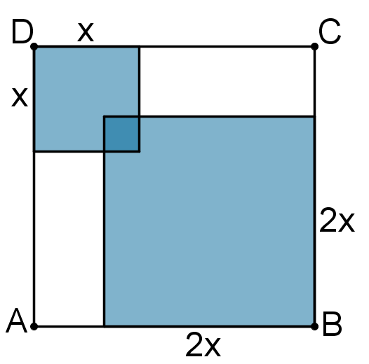
- Four square
The large square has area $196={14}^{2}$, so it has side-length $14$. The ratio of the areas of the inner squares is $4:1$, so the ratio of their side-lengths is $2:1$.
Let the side-length of the larger inner square be $2x$, so that of the smaller is $x$. The figure is symmetric about the diagonal $AC$ and so the overlap of the two inner squares is also a square which therefore has side-length $1$.
Thus the vertical height can be written as $x+2x-1$.
Hence, $3x-1=14$ and so $x=5$
Therefore the small shaded square has an area of $5×5=25$ and the larger shaded square has an area of $10×10=100$
Therefore the total shaded area is $25+100-1=124$
Note also that the two unshaded rectangles have side-lengths
$14-2x=4$ and $14-x=9$
So the total unshaded area is $36×2=72$ and therefore the total shaded area is $196-72=124$

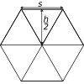
- Triangle in a hexagon
Call the length of one side of the hexagon $s$ and the height of the hexagon $h$. So the area of the shaded triangle is $\frac{1}{2}×s×h$.
Now divide the hexagon into $6$ equilateral triangles:
so the area of the hexagon is $6×12×s×\frac{h}{2}=3×\frac{1}{2}×s×h$, or $3×\text{Shaded area}$. So the shaded area is $13$ of the area of the whole hexagon.
- Pile driver
The small square on top will be in the upper half of the divided figure. Now consider the figure formed by moving this square to become an extra square on the left of the second row, as shown.
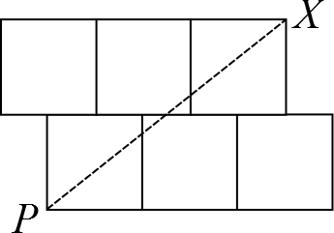
It may now be seen from the rotational symmetry of the figure that the line $PX$ splits the new figure in half- with that small square in the upper half.
Therefore the line which halves the area of the original figure cuts the edge $XY$ at $X$.
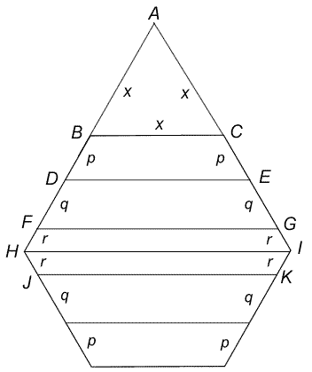
- Hexagon slices
Each exterior angle of a regular hexagon is $\frac{360°}{6}= 60°$, so when sides $HB$ and $IC$ are extended to meet at $A$ , an equilateral triangle, $ABC$ is created.
Let the sides of this triangle be of length $x$. As $BC, DE$ and $FG$ are all parallel, triangles $ABC, ADE$ and $AFG$ are all equilateral.
So, $DE = DA = p + x$; and $FG = FA = q + p + x$.
The perimeter of trapezium
$BCED = x+p+x+2p=2x+3p$;
The perimeter of trapezium
$$DEGF = \left(p+x\right)+\left(q+p+x\right)+2q \\ =2x+2p+3q$$The perimeter of hexagon
$FGIKJH = 2((q+p+x)+2r)=2x+2p+2q+4r$.
So, $2x + 3p = 2x + 2p + 3q$ ; hence $p = 3q$.
Also $2x + 2p + 3q = 2x + 2p + 2q + 4r$ ; hence $q = 4r$ .
So, $p : q : r = 12r : 4r : r = 12 : 4 :1$.

