Stage 3 ★★
Mixed Selection 4

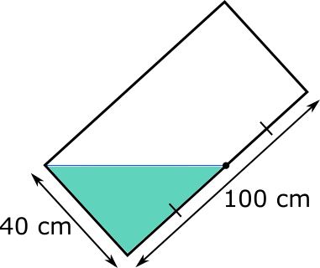
- Tilted tank
A fish tank is a cuboid, 100 cm by 60 cm by 40 cm.
It is partly filled with water, so that when it is resting on a 60 cm edge, the water level reaches the top edge and the midpoint of the base, as shown.
What will the height of the water be when the tank is resting on its base (a 100 cm by 60 cm face)?
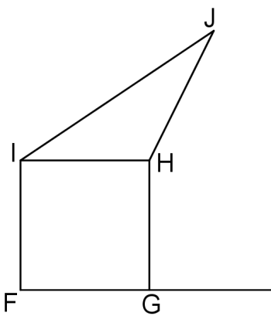
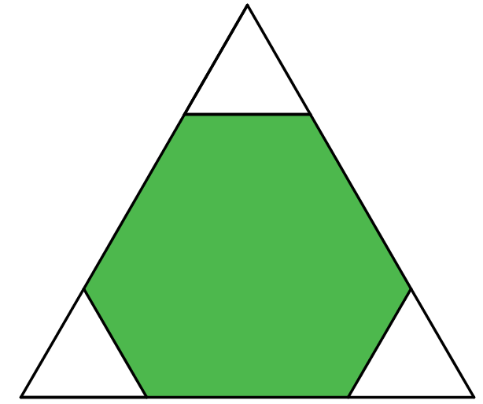
- Corner cut
Three small equilateral triangles of the same size are cut from the corners of a larger equilateral triangle with sides of length 6cm, as shown.
The sum of the perimeters of the small equilateral triangles is the same as the perimeter of the hexagon.
What is the side length of one of the small triangles?
- Leaning over
The triangle $HIJ$ has the same area as the square $FGHI$. FG has a length of $4\text{cm.}$
What is the perpendicular distance from $J$ to the extension of the line FG, or does this depend on the position of J?
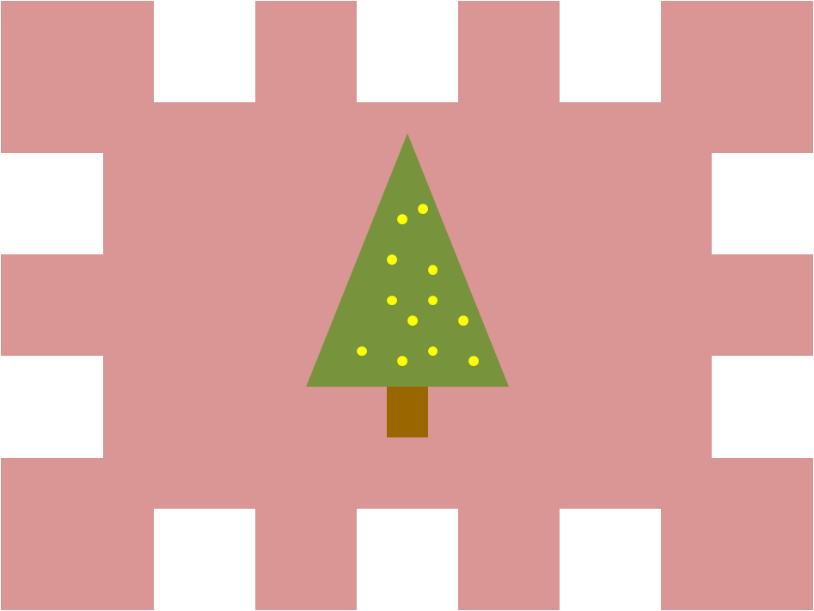
- Christmas cut-out
Sue has a rectangle measuring 40cm by 30cm.
She cuts out ten squares, each measuring 5cm by 5cm from the rectangle to make a Christmas decoration.
In each case, exactly one side of the square lies along a side of the rectangle, and none of the cut out squares touch or overlap.
What is the perimeter of the Christmas decoration?

