Stage 3 ★★
Mixed Selection 4 - Solutions

- Tilted tank
The water in the tank is in the shape of a triangular prism, as shown, so its volume can be found using length × area of cross-section.
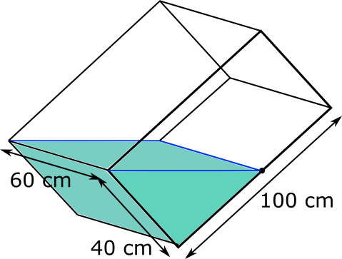
The cross-section is the triangle on the original diagram, shown again below with the sides labelled.
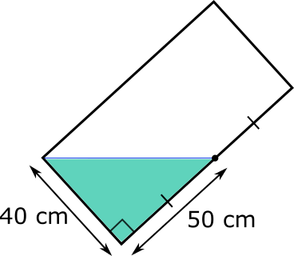
Because the two sides which are labelled are perpendicular, they can be considered to be the base and height of the triangle, so its area is $\frac{1}{2}×40×50=1000 cm^{2}$. So the volume of water in the tank is $60×1000=60000 cm^{3}$.
When the tank is resting on its base, as shown below, the volume of water in the tank is given by $100×60h=6000h cm^{3}$.
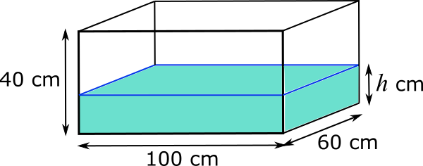
But the volume of water in the tank must also still be 60000 cm3, so $6000h=60000$. So $h$ must be 10.
So the height of the water is 10 cm.
A fuller solution is available at: http://nrich.maths.org/12782/solution
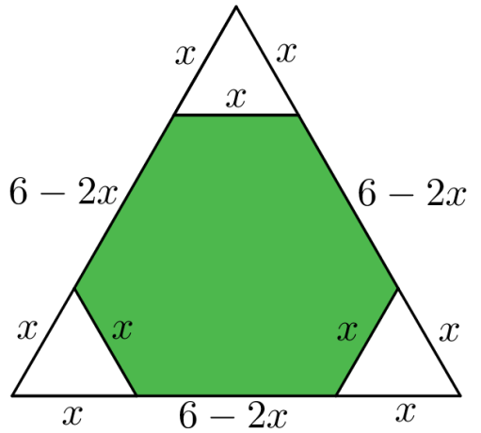
- Corner cut
Suppose the small equilateral triangles have sides of length $x \text{cm}$. Then, each of these has perimeter $3x$, and there are three of these, so the total perimeter is $3×3x=9x$.
The hexagon has three sides where the triangles have been cut from, each of length $x$. The other sides are the sides of the larger triangle, less two sides of the smaller triangles. They, therefore, have length $6-2x$. There are three of each of these, so the perimeter of the hexagon is $3x+3(6-2x)$.
Since the hexagon has a perimeter equal to the sum of the three small triangles, we get: $9x=3x+3(6-2x)$
Then, expanding the bracket gives: $9x=3x+18-6x$.
Collecting like terms: $9x=18-3x$.
Adding $3x$ to each side: $12x=18$.
Dividing by $6$: $x=1.5$.
Therefore, the small equilateral triangles have sides of length $1.5\text{cm}$.
- Leaning over
The triangle $HIJ$ has a base ($HI$) of $4\text{cm}$, the same as the side of the square.
The area of the square is $4×4=16{\text{cm}}^{2}$, so this is also the area of the triangle.
If the perpendicular height of $HIJ$ is $h$, then $12×4×h=16$. This means $2h=16$, so $h=8\text{cm}$.
$J$ is therefore $8\text{cm}$ above the top of the square, which is $4\text{cm}$ above the base, making a total of $12\text{cm}$.
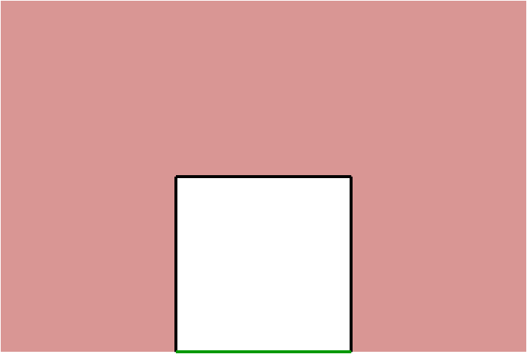
- Christmas cut out
The original rectangle had a perimeter of $2×30+2×40=140cm$.
Each of the new squares that is cut out adds three sides of 5cm each (shown in black on the diagram), and removes one portion of length 5cm (shown in green).
This means the overall effect of cutting out each square is to increase the perimeter by 10cm. Since are ten squares, the overall increase is $10×10cm=100cm$.
Therefore the final perimeter is $140cm+100cm=240cm$.

