Stage 3 ★★
Mixed Selection 3

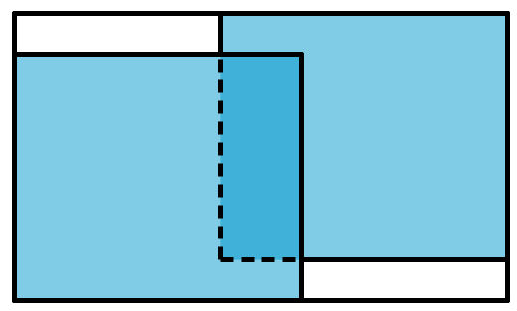
- Double cover
A sheet of paper is exactly the same size as a rectangular table top. The paper is cut in half and the two halves are placed on the table as shown.
What is the ratio of the area of table left uncovered to the area that is covered twice?
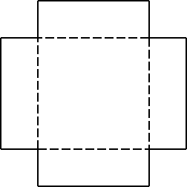
- Open the box
A square piece of card has a square of side $2\text{cm}$ cut out from each of its corners. The remaining card is then folded along the dotted lines shown to form an open box whose total internal surface area is $180{\text{cm}}^{2}$.
What is the volume of the open box?
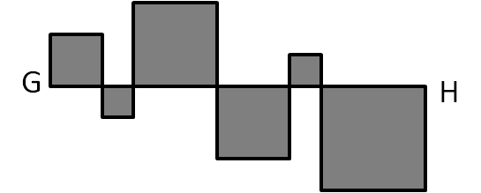
- Line of squares
In the diagram on the right, each of the squares touches adjacent squares at the corners and the line $GH$ along one of the edges.
If the length of $GH$ is 24cm, what is the total perimeter of all the squares?
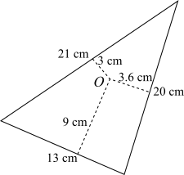
- Scalene area
The diagram shows a scalene triangle with side
lengths 13 cm, 20 cm and 21 cm.
From a point O inside the triangle, line segments
can be drawn at right angles to each of the sides.
The lengths of these line segments are 9 cm,
3.6 cm and 3 cm.
What is the area of the triangle?

