Stage 3 ★★
Mixed Selection 3 – Solutions
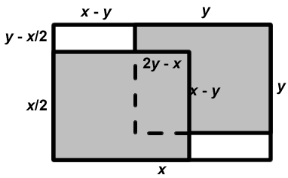
- Double cover
We start by placing the two halves on the table so that the whole table is covered. Then we move them to overlap as in the question.
The area of the table covered by the paper has decreased by the two uncovered areas. The area covered by the paper has decreased by the amount covered twice. These two areas must both be the same, so the ratio must be $1:1$.
Alternatively, let the sheet of paper have length $x$ and width $y$. Then the uncovered area consists of two congruent rectangles of length $x-y$ and width
$y-12x$. So the uncovered area is
$2(x-y)(y-12x)$, that is, $(x-y)(2y-x)$.
The area covered twice is a rectangle of length $y-(x-y)$, that is, 2y−x, and width $12x-(y-12x)$, that is, $(x-y)$. So the area covered twice is also $(x-y)(2y-x)$.
- Open the box
The original square has area $180 + 4 × 4 = 196$, so it has side length $14\text{cm}$. Therefore, the dimensions of the box are $10 ×10 × 2$. Hence, the volume is $200{\text{cm}}^{3}$.
Alternatively, the base of the open box is a square. Let its side be of length $x$ cm. Then the total surface area of the box in ${\text{cm}}^{2}$ is $x^{2}+4×2x=x^{2}+8x$. Hence, $x^{2}+8x=180$, that is $x^{2}+8x-180=0$. Therefore, $(x+18)(x-10)=0$which gives $x=-18$ or $x=10$.
As $x$ must be positive, it must be the case that $x=10$. Now the open box has dimensions $10 \text{cm} × 10 \text{cm} × 2 \text{cm}$. So its volume is $200{\text{cm}}^{3}$.
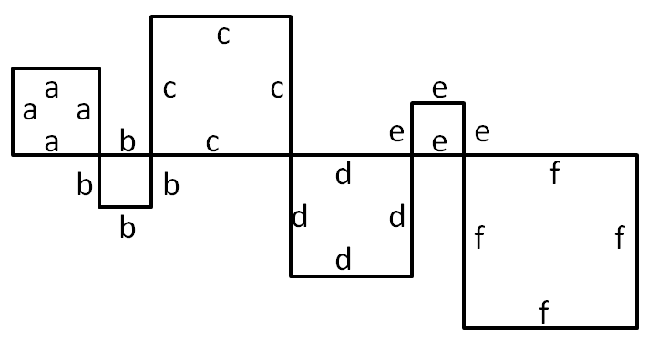
- Line of squares
Each square has exactly $\frac{1}{4}$ of its perimeter as part of the line, and together these form the whole line. This means the total perimeter is $4×24\text{cm}=96\text{cm}$.
Algebraically, the diagram on the left shows that the line has length $a+b+c+d+e+f=24\text{cm}$. The total of the perimeters is then:
$$4a+4b+4c+4d+4e+4f=4\left(a+b+c+d+e+f\right) \\ =4×24\text{cm} \\ =96\text{cm}$$
- Scalene area
Drawing lines from O to each vertex splits the triangle into three smaller triangles, as shown below.
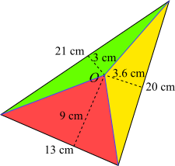
For each smaller triangle, the ‘base’ and ‘height’ are shown (the 'bases' are the sides of the original triangle, which are not horizontal). So, using $Area =\frac{1}{2} base×height$, the areas of the smaller triangles can be found:
Red triangle area $\frac{1}{2}×13×9=58.5 cm^{2}$
Yellow triangle area $\frac{1}{2}×20×3.6=36 cm^{2}$
Green triangle area $\frac{1}{2}×21×3=31.5 cm^{2}$
So the total area of the triangle is
$58.5cm^{2}+36cm^{2}+31.5cm^{2}=126cm^{2}$.
A fuller solution is available at: https://nrich.maths.org/12760/solution

