Stage 3 ★★
Mixed Selection 2

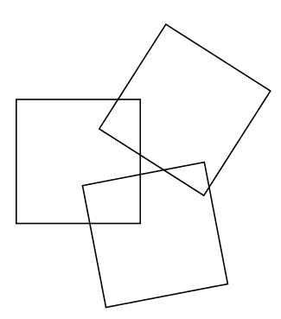
- Intersecting squares
Three congruent squares overlap as shown.
The areas of the three overlapping sections are $2{\text{cm}}^{2}, 5{\text{cm}}^{2}$and$8{\text{cm}}^{2}$ respectively.
The total area of the non-overlapping parts of the squares is $117{\text{cm}}^{2}$.
What is the side length of each square?
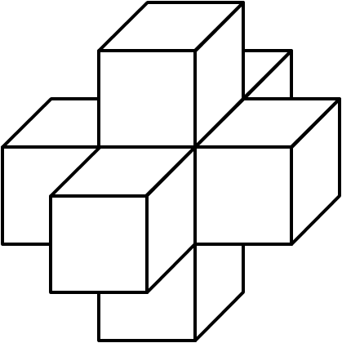
- Cubic masterpiece
A solid wooden cube is painted blue on the outside. The cube is then cut into $27$smaller cubes of equal size.
What fraction of the total surface area of these new cubes is blue?
- Cubes on a cube
A cube has each of its faces covered by one face of an identical cube, making a solid as shown. The volume of the solid is $875{\text{cm}}^{3}$.
What, in ${\text{cm}}^{2}$, is the surface area of the solid?
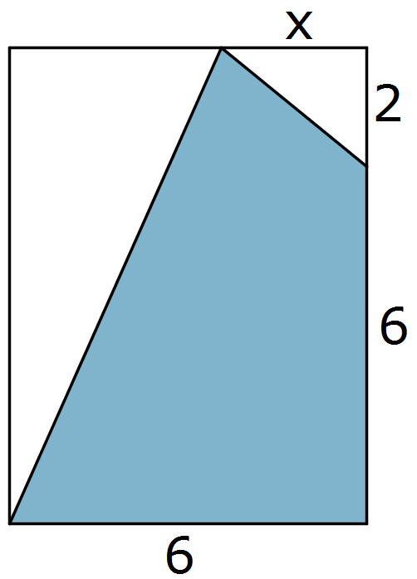
- Sideways ratio
A rectangle with area $125{\text{cm}}^{2}$has sides in the ratio $4:5$.
What is the perimeter of the rectangle?
- Exactly three-quarters
Three-quarters of the area of the rectangle has been shaded.
What is the length of $x$?

