Stage 3 ★★
Mixed Selection 1
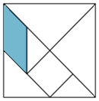
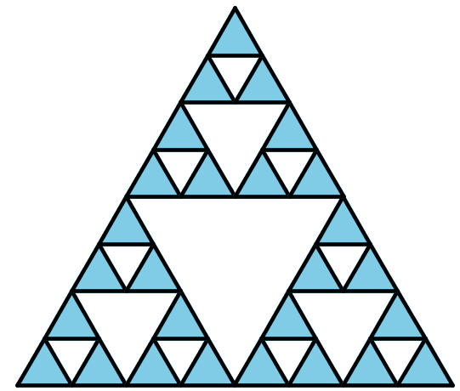
- Tangram area
The seven pieces in this $12$cm$×12$cm square make a Tangram set.
What is the area of the shaded parallelogram?
- Triangles' triangle
The perimeter of the large triangle is $24$cm.
What is the total length of the black lines used to draw the figure?
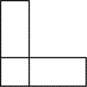
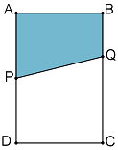
- L-emental
Two identical rectangular cards are glued together as shown, to form an 'L' shape. The perimeter of this 'L' shape is $40 \text{cm}$.
What can you say about the length and width of the original rectangles?
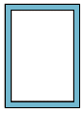
- Guillotine
$ABCD$ is a rectangle. $P$ is the midpoint of $AD$; the length of $BQ$ is one third the length of $BC$.
What fraction of the area of the rectangle is the area of the shaded quadrilateral $ABQP$?
- Margins
A $30\text{cm} × 40\text{cm}$ page of a book includes a $2\text{cm}$ margin on each side, as shown.
What percentage of the page is occupied by the margins?

