Stage 3 ★
Mixed Selection 2
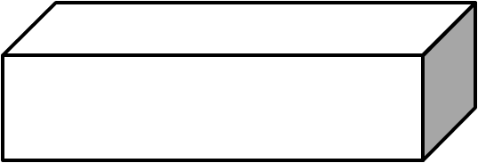
- Shaded end
The diagram shows a cuboid in which the area of the shaded face is one quarter of the area of each of the two visible unshaded faces.
The total surface area of the cuboid is $72{\text{cm}}^{2}$.
What is the area of one of the unshaded faces of the cuboid?
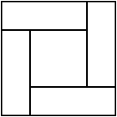
- Square ratio
A square is divided into four congruent rectangles and a smaller square, as shown in the diagram.
The area of the small square is $\frac{1}{4}$ of the area of the whole square.
What is the ratio of the length of a short side of one of the rectangles to the length of a long side?
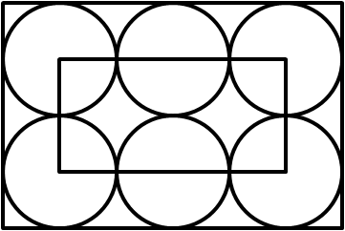
- Six circles
In the diagram, six circles of equal size touch adjacent circles and the sides of the large rectangle. Each of the corners of the small rectangle is the centre of one of the large circles.
The perimeter of the small rectangle is $60cm$.
What is the perimeter of the large rectangle?
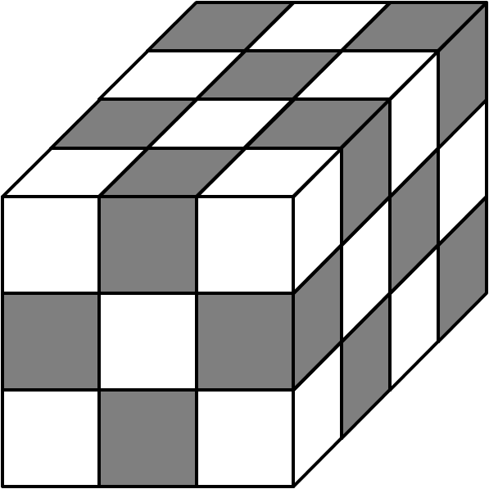
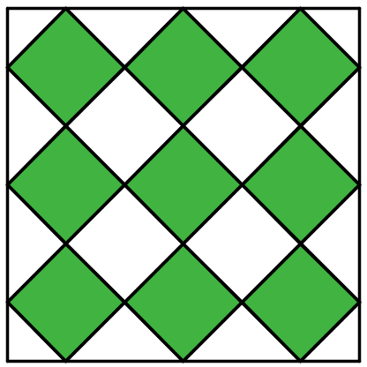
- Squares in a square
In the diagram, all the small squares are of the same size.
What fraction of the large square is shaded?
- Chequered cuboid
A cuboid is made from cubes of equal size, coloured alternately white and black as shown.
What fraction of the surface area of the cuboid is coloured black?

