Stage 3 ★
Mixed Selection 2 – Solutions

- Shaded End
There are four faces that are the same size as the unshaded ones, and two that are the same as the shaded face.
Since each unshaded face is four times the size of the shaded one, the surface area of the cuboid is $4×4+2×1=18$ times the area of the shaded face.
Since this total area is $72{cm}^{2}$, the shaded face has area
$72÷18=4{cm}^{2}$
Each unshaded face therefore has area $4×4=16{cm}^{2}$

- Square ratio
Let the length of a short side of a rectangle be $x$ and the length of a long side be $y$. Then the whole square has side of length $(y+x)$, whilst the small square has side of length $y-x$.
As the area of the whole square is four times the area of the small square, the length of the side of the whole square is twice the length of the side of the small square.
Therefore $y+x=2(y-x)$, i.e., $y=3x$ so $x:y=1:3$.

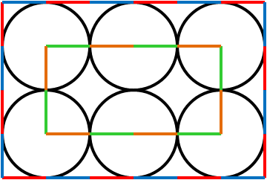
- Six circles
The small rectangle consists of $12$ of the radii of the circles, each connecting a point of contact to the centre of the relevant circle. These are shown in green and orange in the diagram on the right.
Since this has a total length of $60\text{cm}$, each radius is of length
$60\text{cm}÷12=5\text{cm}$.
The large rectangle can also be broken down into segments of this length. These are shown in blue and red on the diagram. There are $20$ of these, so the perimeter of the large rectangle is
$5\text{cm}×20=100\text{cm}=1\text{m}$.

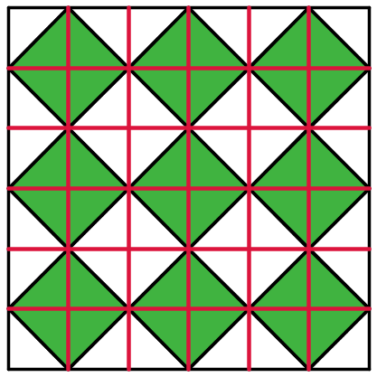
- Squares in a square
There are a number of ways of solving this problem. One method is to count the unshaded squares in the diagram. There are $4$ complete squares, $8$ half squares and $4$ quarter squares, which is a total of $4×1+8×\frac{1}{2}+4×\frac{1}{4}=4+4+1=9$.
Therefore there are nine shaded squares and nine unshaded squares, so half the area is shaded.
Alternatively, consider dividing the square up into the smaller red squares, shown in the diagram to the right. Each of the red squares is divided into two halves, one of which is shaded.
This means that half of the complete shape is shaded.
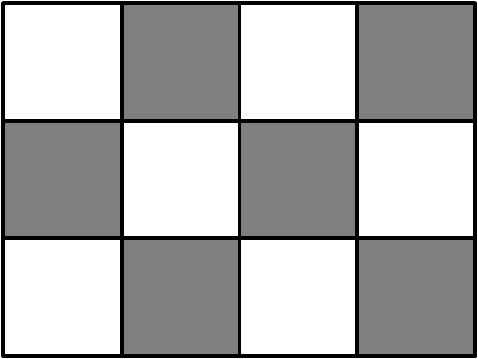
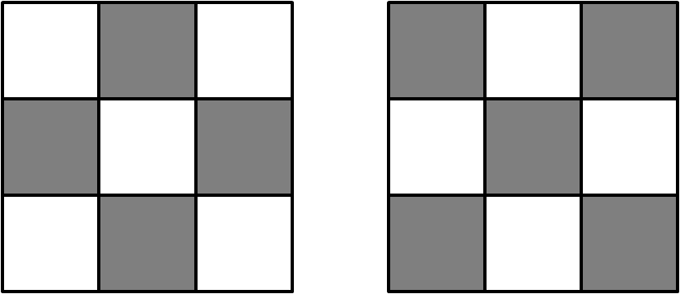
- Chequered cuboid
Consider the different faces of this cuboid. The faces on the ends of the cuboid will look like these diagrams on the right. Between them they have $9$ black squares and $9$ white squares.
The other four faces all look like the diagram below. This contains $6$ white squares and $6$ black squares.
Therefore, between the four faces there are $6×4=24$ white squares and $6×4=24$ black squares.
Therefore, overall there are $9+24=33$ white squares and
$9+24=33$ black squares, so half12 of the squares are coloured black.

