Stage 3 ★
Mixed Selection 1

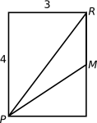
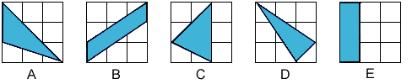
- 3x3 areas
Which of the following shaded regions has an area different from the other shaded regions?
- Mid-point area
$M$is the midpoint of the side of the rectangle.
What is the area (in square units) of the triangle $PMR$?
- Rectangle cutting
Tom and Jerry started with identical rectangular sheets of paper. Each of them cut his sheet in half. Tom obtained two rectangles, each with a perimeter of $40 \text{cm}$ while Jerry obtained two rectangles, each with a perimeter of $50 \text{cm}$.
What was the perimeter of Tom's original sheet of paper?
- Hexa-split
The three regular hexagons are all the same size. X, Y and Z denote the values of the shaded areas in the hexagons as shown.
Which of these areas are equal to each other?
