Stage 3 ★
Mixed Selection 1 – Solutions

- 3x3 areas
All but D have an area of 3 square units. D has an an area half a unit less than the other shapes.
- Mid-point area
$M$ is the midpoint of the side of the rectangle, so $RM$ has length $2$ units.
$$\text{Area of triangle PRM} = \frac{1}{2}×\text{base}×\text{height} \\ = \frac{1}{2}×2 \text{units × }3\text{units } \\ = 3 \text{square units}$$
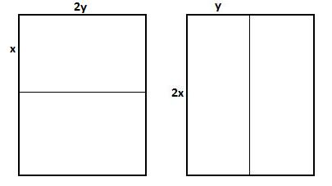
- Rectangle cutting
Tom and Jerry must each cut their piece of paper in half. Suppose the sides of the original piece of paper have length $2x$ and $2y$, with $x≥y$.
Then $2x+4y=40$ and $4x+2y=50$ which implies that $6x+6y=90$, therefore the perimeter of the original piece, $4x+4y=60$.
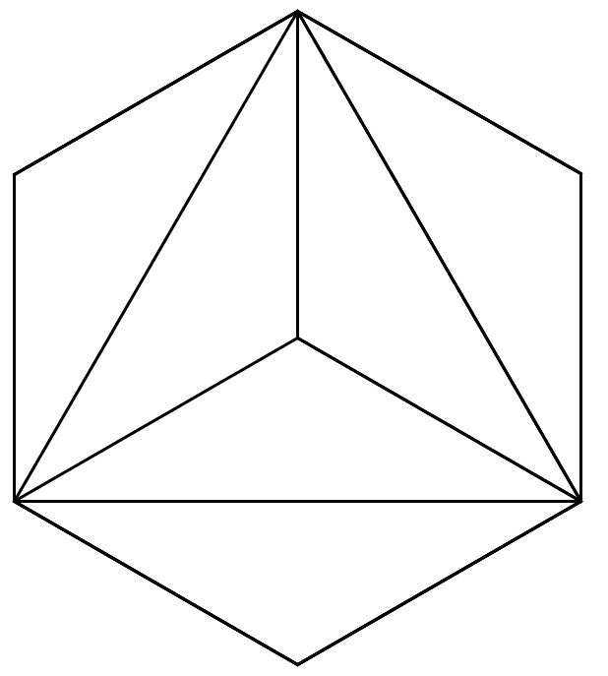
- Hexa-split
All the areas of the three figures are equal
(X = Y = Z).
The shaded area in Y is clearly half the area of the hexagon and the diagram below demonstrates why the shaded areas in X and Z are also both equal to half the area of the hexagon.

