Stage 4
Mixed Selection 2

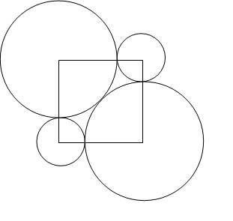
- Centre square
The diagram shows two identical large circles and two identical smaller circles whose centres are at the corners of a square.
The two large circles are touching, and they each touch the two smaller circles. The radius of the small circles is 1cm.
What is the radius of the large circles in centimetres?

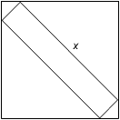
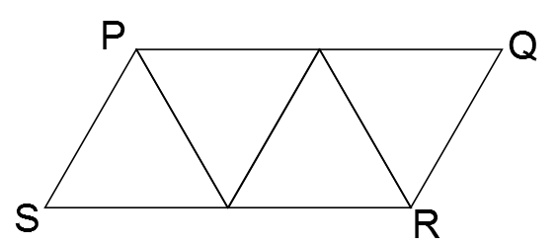
- Crane arm
The parallelogram PQRS is formed by joining together four equilateral triangles of side 2 units, as shown.
What is the length of the diagonal SQ?
- Walk the plank
The diagram shows a 1 by $x$ rectangular plank which fits neatly inside a 10×10 square frame.
What is the value of $x$?
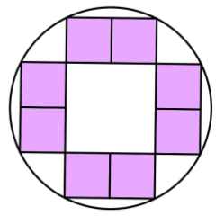
- Indigo interior
The diagram shows a pattern of eight equal shaded squares inside a circle of area $π$ square units.
What is the area (in square units) of the shaded region?

