Stage 4
Mixed Selection 1
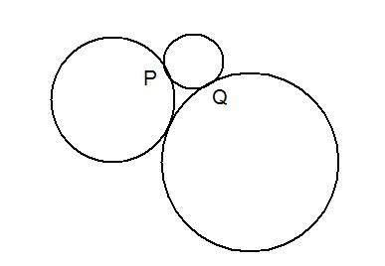
- Circle time
Three circles ${\text{C}}_{\text{1}}$, ${\text{C}}_{\text{2}}$ and ${\text{C}}_{\text{3}}$, of radii 1 cm, 2 cm and 3 cm respectively touch as shown. ${\text{C}}_{\text{1}}$ meets ${\text{C}}_{\text{2}}$ at $\text{P}$, and meets ${\text{C}}_{\text{3}}$ at Q.
What is the length in cm of the longer arc of circle ${\text{C}}_{\text{1}}$ between P and Q?
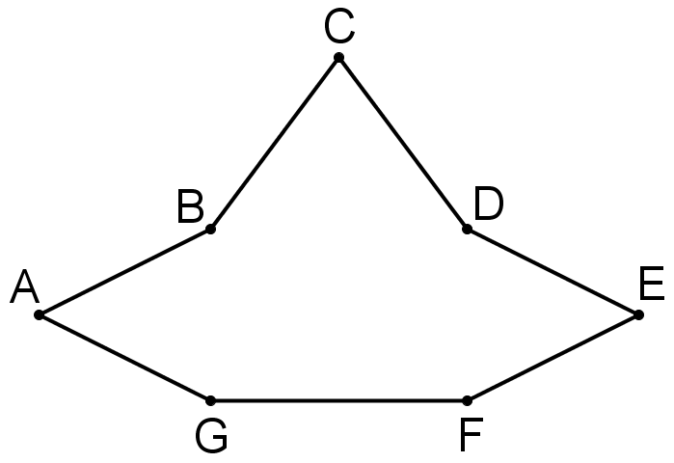
- Unusual polygon
The diagram shows a polygon ABCDEFG, in which FG=6 and GA=AB=BC=CD=DE=EF.
BDFG is a square, and the area of the whole polygon is exactly twice the area of BDFG.
What is the perimeter of the polygon?
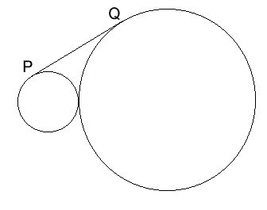
- Common tangent
Two circles with radii 1cm and 4cm touch. The point P is on the smaller circle, Q is on the larger circle, and PQ is a tangent to both circles.
What is the length of PQ?
- Triangular teaser
The triangle T has sides of length 6, 5, 5. The triangle U has sides of length 8, 5, and 5.
What is the ratio area T : area U?

