Stage 4
Mixed Selection 1 – Solutions

- Tetromino diagonal
By Pythagoras’ theorem the length of the diagonal is $\sqrt{2^{2}+3^{2}}=\sqrt{13}$
- Out of the window
By Pythagoras Theorem, the diagonal of the window is 100 cm, which exceeds the length or breadth of all the sheets.
So the first three pieces can go through the window either way and the 90 x 105 cm piece can also go through the window, provided the 90 cm edge goes first.
- Folding in half
By Pythagoras' Theorem, the hypotenuse of the original triangle is $\sqrt{\text{200}}\text{=10}\sqrt{\text{2}}\text{ cm}$, and hence the difference between the perimeters of the two triangles is $\left(\text{10+10+10}\sqrt{\text{2}}\right)\text{-}\left(\text{5}\sqrt{\text{2}}\text{+5}\sqrt{\text{2}}\text{+10}\right)\text{=10cm}$
Alternatively: let the length of the shorter sides of the new triangle be x cm, shown below. Then the perimeter of the original triangle is $(20+2x) \text{cm}$ and the perimeter of the new triangle is $(10+2x)\text{cm}$. Hence the difference between the perimeters of the two triangles is 10cm.
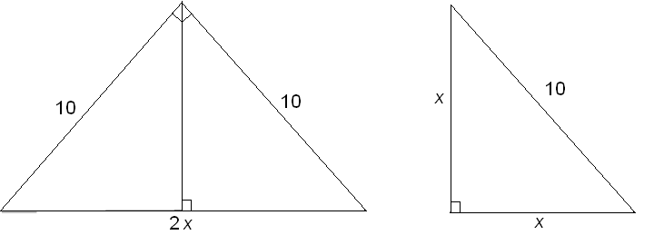
- Right angled possibilities
The hypotenuse is the longest side of the triangle, so the 5cm side cannot be the hypotenuse. This gives two possibilities:
  - The hypotenuse is 6cm, giving the other length as
$\sqrt{6^{2}-5^{2}}=\sqrt{11}$
  - The 6cm side is the other short side, giving the hypotenuse as$\sqrt{6^{2}+5^{2}}=\sqrt{61}$
- Rectangle Rearrangement
The two pieces will fit together to form a right-angled triangle which has a base 8 and height 6.
The length of the hypotenuse is $\sqrt{6^{2}+8^{2}}=10$, so the perimeter of the triangle is 24.

