Stage 4 ★
Mixed Selection 1 - Solutions

- Pencil turning
Let AB have length 3r. The distance moved by A is then the circumference of a semicircle radius 3r (3πr). C moves along a circle of radius 2r (2πr), followed by a semicircle of radius r (πr). The total distance moved by C is therefore also 3πr.
Hence, the ratio is 1:1.

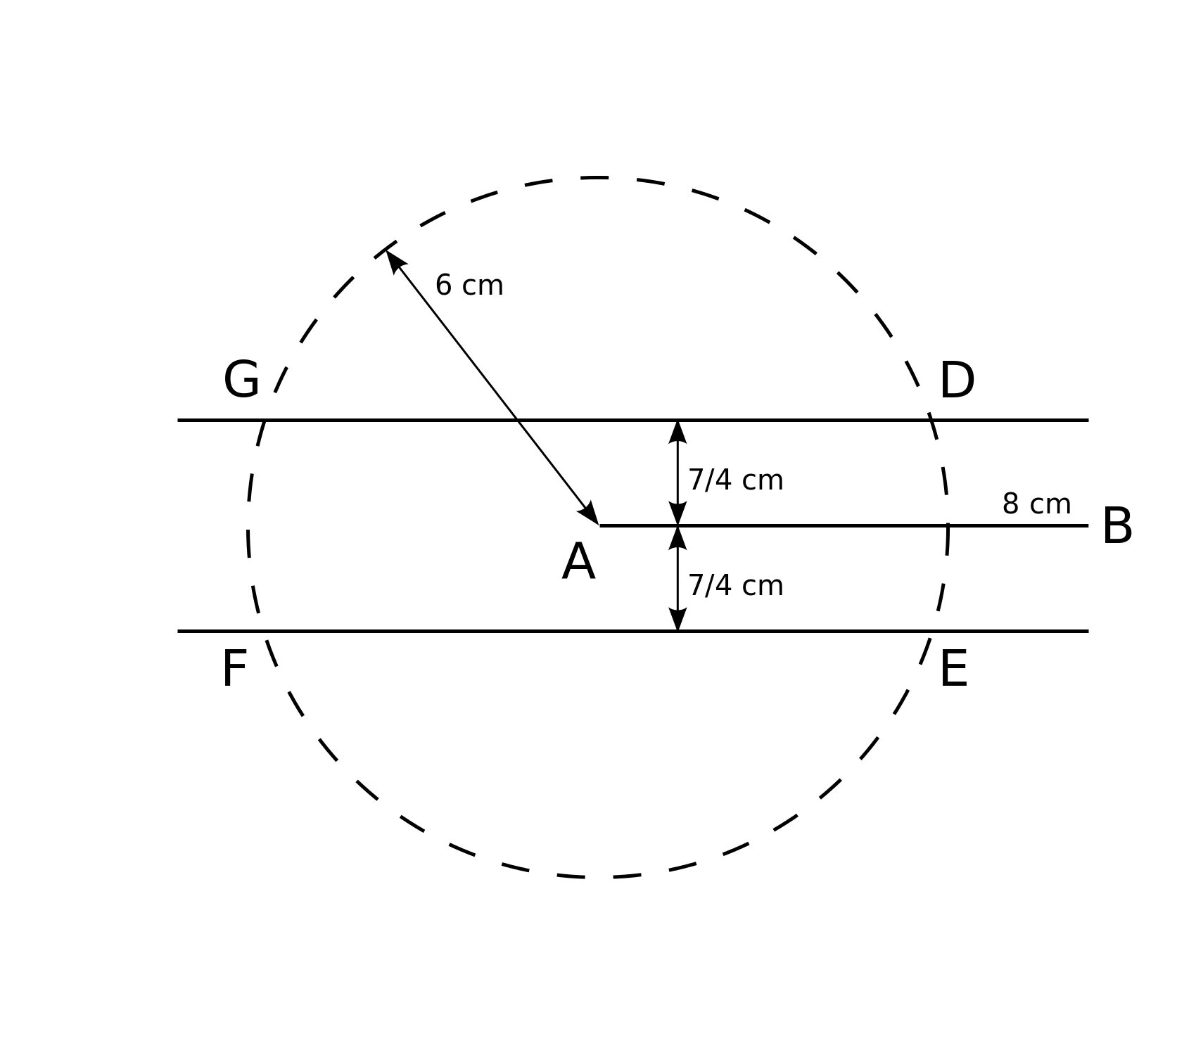
- 3-sided
Let the base AB of the triangle be the side of length 8cm and AC be the side of length 6cm. So C must lie on the circle of centre A and radius 6cm shown. The area of the triangle is to be 7$\text{c}{\text{m}}^{\text{2}}$, so the perpendicular from C to AB must be of length $\frac{7}{4}\text{cm}$.
The diagram shows the four possible positions D, E, F and G of C. However since the angles BAG = BAF, BAD = BAE, there are exactly two choices for the length of the third side AC, shown below.
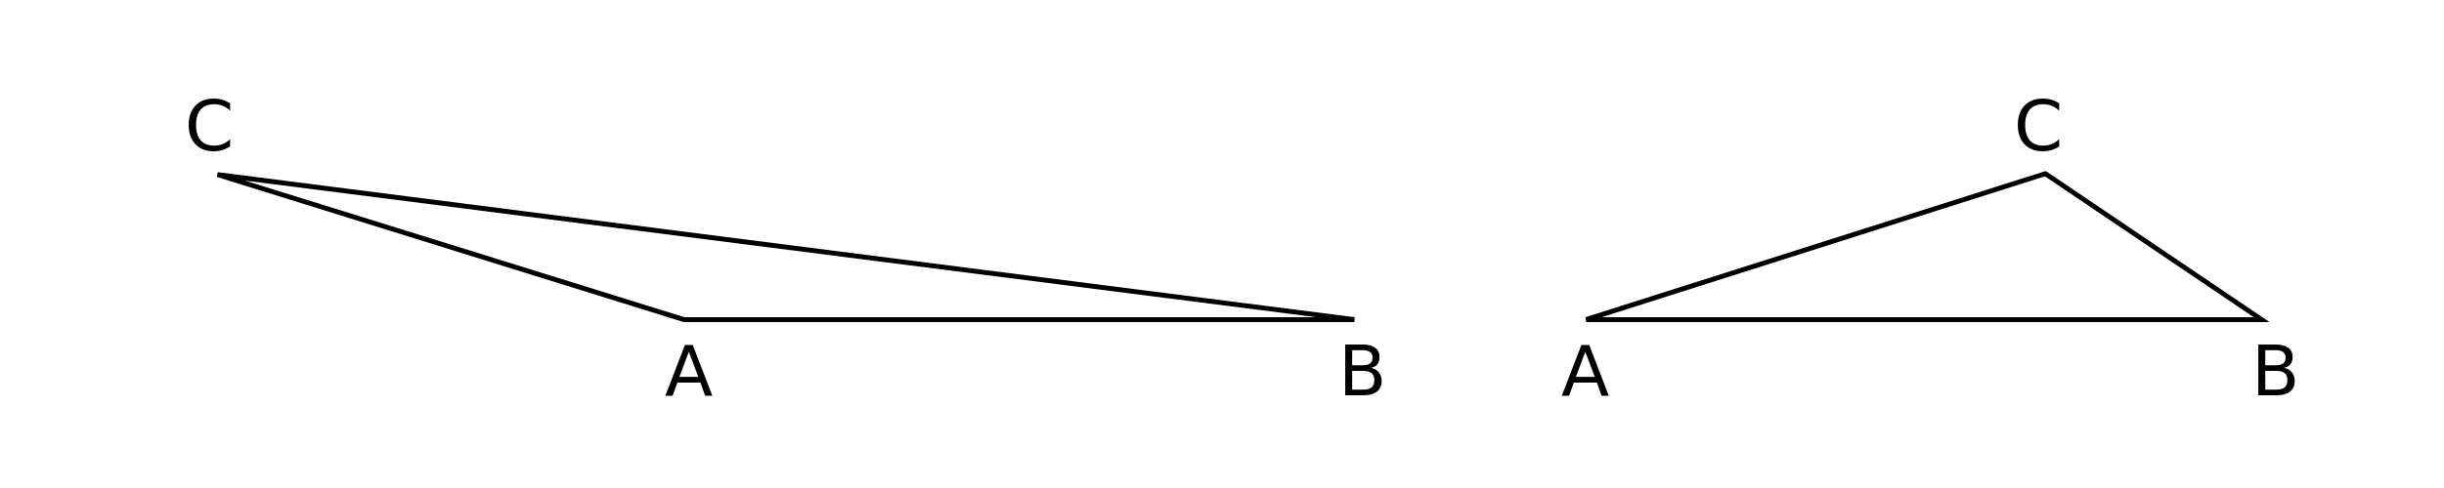

- Snail’s pace
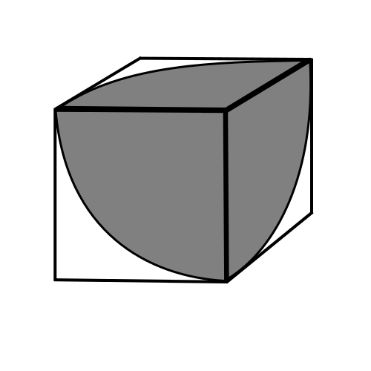
In one hour, the snail can reach points within 1m of the corner at which it starts. So it can reach some of the points on the three faces which meet at that corner, but none of the points on the other three faces.
On each of the three reachable faces, the points which the snail can reach form a quarter of a circle of radius 1m.
So the required fraction is $\frac{3×\frac{1}{4}π×1×1}{6×1×1}=\frac{π}{8}$.

- Triangular wheel
In each rotation which C makes, the radius of the arc it describes is 1 unit. In the first rotation, C turns through an angle of $120°$, so it moves a distance $\frac{1}{3}×2π×1$ units, that is $\frac{2π}{3}$ units.
As it is the centre of the second rotation, C does not move.
In the third rotation, C again turns through an angle of 120°, so the total distance travelled is $2×\frac{2π}{3}=\frac{4π}{3}$ units.

